Application of Geometric Drawing
Sketch this figure below in AutoCAD
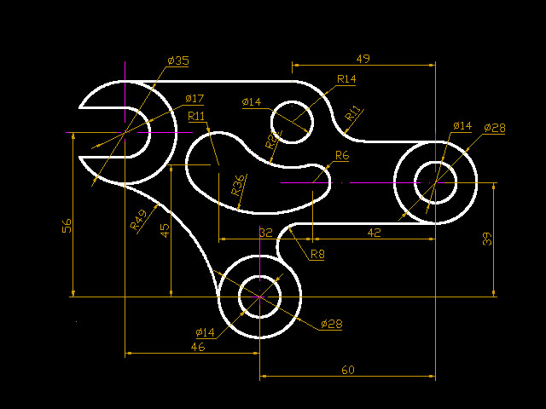
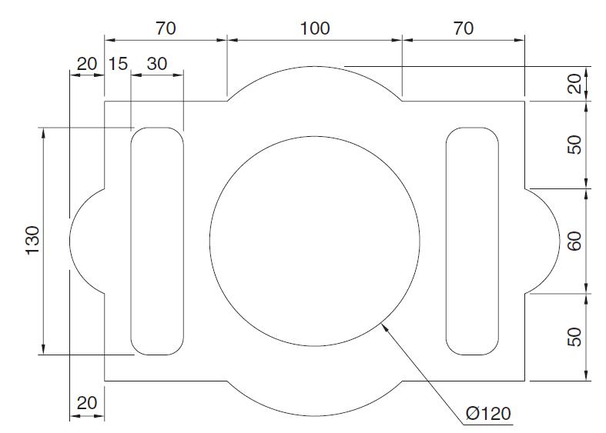
References:
http://www.computeraideddesignguide.com/simple-exercise-autocad-beginners/
Access Date : 31.01.2016

