ELECTROCHEMISTRY

EXPERIMENT NO : 14
EXPERIMENT NAME : Potentiometric Titration and Determination of pH by Kinhidron Electrode Potentiometric Titration
PURPOSE : The purpose of this experiment is to determine the turning point of the reaction in the cell by measuring the electromotor force (EMF) of a galvanic cell composed of a reference and an indicator electrode.
CHEMICALS : • Solution of solid iron (II) ammonium sulfate salt in H2SO4
  - 0.017 M potassium bichromate (K2Cr2O7) solution
  - Saturated KCl solution
MATERIALS : • Potentiometer
  - Reference electrode
  - Indicator electrode
  - Salt bridge
  - Beherglas
  - Buret

Information

Potentiometric titration is based on measuring the potential after each addition of the reagent. The solution to be titrated is connected to the reference electrode by means of a salt bridge. Immerse the indicator electrode into the solution and measure the electromotor force (EMF) of the solution. Since the potential of the reference electrode remains constant during the measurement, the change in EMF is only changed by the addition of the reagent. This change is due to the change in the potential of the indicator electrode. This method can be applied to any color, colorless and type solution.

EXPERIMENTAL PROCEDURE
A 10-15 mL of acid (II) ammonium sulfate solution taken into a beherglas is diluted 1/5. The indicator electrode is immersed into the beaker and is connected to the reference electrode (Calomel Electrode) by means of a salt bridge.
The EMF of the cell is read before any reagent is added. Then add 1 mL of reagent and read the EMF by mixing the solution thoroughly. As the turning point is approached, the volume of reagent added should be reduced to 0.5 mL and the turning point should be correctly. It is important to

mix and add 1-2 minutes after each addition. The turning point is determined by the sudden increase in EMF. This process is continued until the turning point exceeds 4-5 mL.
In this experiment, a redox reaction is occured in the solution after each addition of the reagent. This redox event continues until the turning point. Since there is no ion to be oxidized from this point, the redox event ends. The schema of the galvanic cell used and the redox reaction during the titration in this cell, respectively, are as follows.
𝑃𝑡| 𝐹𝑒⁺³, 𝐹𝑒⁺²|| 𝐾𝐶𝑙 𝑠𝑜𝑙𝑢𝑡𝑖𝑜𝑛 (𝑠𝑎𝑡. )|𝐾𝐶𝑙(𝑠𝑎𝑡. ), 𝐻𝑔2𝐶𝑙2(𝑠), 𝐻𝑔(𝑙𝑞) 6𝐹𝑒⁺² + 𝐶𝑟2𝑂⁻² + 14𝐻⁺ → 2𝐶𝑟⁺³ + 6𝐹𝑒⁺³ + 7𝐻2𝑂
7

Evaluation of Results

Three different graphs are derived from each other in order to find the turning point with the evaluation of the data obtained.
a. 𝐸(𝑝𝑜𝑡𝑒𝑛𝑡𝑖𝑎𝑙) − 𝑣(𝑎𝑑𝑑𝑒𝑑 𝑟𝑒𝑎𝑐𝑡𝑖𝑣𝑒 𝑣𝑜𝑙𝑢𝑚𝑒)
b. ∆𝐸/∆𝑣(𝑓𝑖𝑟𝑠𝑡 𝑑𝑖𝑓𝑓𝑒𝑟𝑒𝑛𝑡𝑖𝑎𝑙) − 𝑣𝑎𝑣𝑒𝑟𝑎𝑔𝑒
c. ∆²𝐸/∆𝑣²(𝑠𝑒𝑐𝑜𝑛𝑑 𝑑𝑖𝑓𝑓𝑒𝑟𝑒𝑛𝑡𝑖𝑎𝑙) − 𝑣𝑎𝑣𝑒𝑟𝑎𝑔𝑒

The sensitivity of the method depends on the exact location of the turning point.
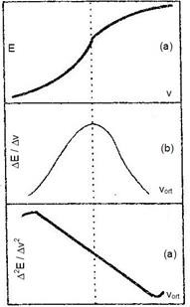
The slope of the titration curve is greatest at the equivalence point. If the slope is small, the equivalence point cannot be determined exactly (a). In such cases, the slope of the curve is plotted against the average of the added reagent volume (b). This curve is called the first derivative curve. The peak of this curve is the equivalence point. The presence of both turning points is based on the symmetrical curves around the equivalence point. However, this may not always be seen. In this case, the second derivative of the change of the potential with the volume is taken. This is
called the second derivative curve. The point

where the 22E/∆v2–vort line drawn from here intersects the horizontal axis is the point of equivalence (c).
Fig. 5. First and second derivative curves obtained from the potential-volume curve

Drawing of the second derivative curve from the first derivative curve
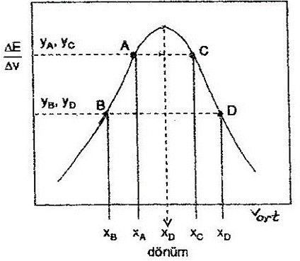
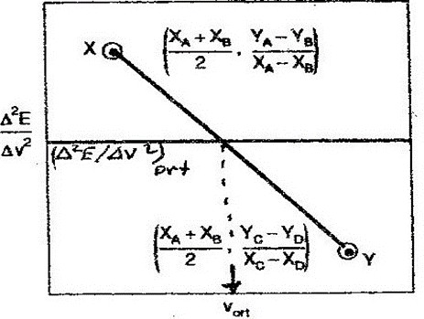
Fig. 6. First derivative curve Fig. 7. Second derivative curve

Two points are selected from the left and right side of the curve as shown in Fig. 6 (A, B, C, D) Using the points that are read from the chart of these points Δ2E / Δv2 ve vaverage respectively.
∆²𝐸/∆𝑣² = (𝑌𝐴 − 𝑌𝐵)/(𝑋𝐴 − 𝑋𝐵) 𝑣𝑒 ∆²𝐸/∆𝑣² = (𝑌𝐶 − 𝑌𝐷)/(𝑋𝐶 − 𝑋𝐷),

𝑉𝑜𝑟𝑡 = (𝑋𝐴 + 𝑋𝐵)/2 𝑎𝑛𝑑 𝑉𝑜𝑟𝑡 = (𝑋𝐶 + 𝑋𝐷)/2
are calculated from equations. The X and Y points found using these calculated points are marked as shown in Fig. 7, the point where the line joining these points crosses the horizontal axis is found.

Determination of pH by Kinhidron Electrode

PURPOSE : The electrode potential is the determination of the pH of the solution by the quinhydron electrode, which is dependent on the hydrogen ion activity.
CHEMICALS : Saturated solution of quinhydron in water

MATERIALS : • Potentiometer
  - Reference electrode
  - Indicator electrode
  - Salt bridge
  - Thermometer
  - Buret

EXPERIMENTAL PROCEDURE
The saturated solution of the quinhydron is prepared and the Pt electrode immersed into this solution and combined with the calomel electrode with a salt bridge.
The EMF of the cell is read from the potentiometer. Also, read the temperature by immersing a thermometer into the solution.
An equimolar amount of quinone (Q) and quinhydron (QH2) is released by dissolution of the quinhydron in water. This reaction is a reversible redox reaction.
The electrode potential of the reaction is as follows.
𝜃 𝑅𝑇 ln 𝑎(𝑄)𝑎(𝐻30⁺)²

𝐸𝑄 = 𝐸𝑄/𝑄2 + 2𝐹
𝑎(𝑄𝐻2)

in the oversaturation state is to be a(Q) = a(QH2) from the last equation
𝐸 𝐸^{𝜃} + 𝑅𝑇 2,303 log 𝑎 (𝐻 𝑂)⁺
𝑄= 𝑄/𝑄2 𝐹 3

equality is obtained.

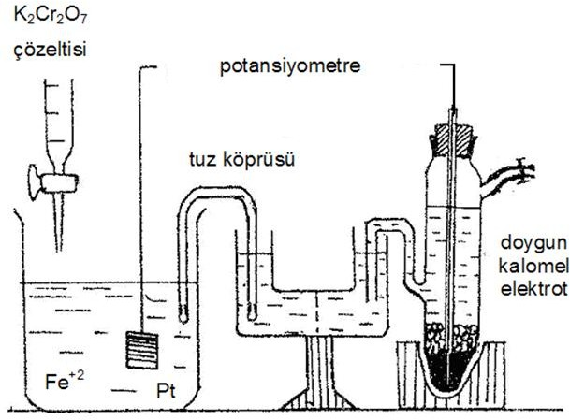

Evaluation of Results

Since EQ and ESCE are depened on temperature, the temperature read from the thermometer is replaced by the following values. these values are found in the following relations.
Ekin = 0,6994 - 7,36x10-4 (t-25) Ekal = 0,2425 – 76x10-4 (t-25)
Electromotor, E, in a cell
E = 𝐸𝑐𝑎𝑡ℎ𝑜𝑑 – 𝐸𝑎𝑛𝑜𝑑𝑒 = 𝐸𝑟𝑖𝑔ℎ𝑡 – 𝐸𝑙𝑒𝑓𝑡

the following equations are written for the EMF and pH value of the above mentioned cell respectively.
𝐸 = 𝐸𝑄 − 𝐸𝑆𝐶𝐸
𝐸 = 𝐸⁰ + 𝑅𝑇 2,303 log 𝑎 (𝐻 𝑂⁺) − 𝐸⁰

𝑄 𝐹
3 𝑆𝐶𝐸

𝐸 = 𝐸⁰ − 𝑅𝑇 2,303 𝑝𝐻 − 𝐸⁰

𝑄 𝐹
𝑆𝐶𝐸

𝑝𝐻 = (𝐸⁰ − 𝐸⁰ − 𝐸)⁄(2,303 𝑅𝑇⁄𝐹)
𝑄 𝑆𝐶𝐸

The E value read from the potentiometer and the calculated EQ / ESCE values are calculated in the equation above and the pH of the solution is calculated.

QUESTIONS

- Explain what is the EMK, reference electrode, indicator electrode, anode, cathode.

- Describe the Faraday laws verbally and mathematically.
- Since the mass of Au³⁺ ions in the gold electrodes is electrolyzed for 10 minutes with a constant current, as the mass of the cathode increases by 1,314 g, find the current number and current intensity of the electricity passing through the circuit.
- What are the duties of the Salt Bridge?
- What are the advantages of potentiometric titration?
- Before the turning point in potentiometric titration, explain the sudden potential change in the turning point by typing the reactions that are going on at the turning point and after the turning point.
Potansiyometrik titrasyonda dönüm noktasından önce, dönüm noktasında ve dönüm noktasından sonra yürüyen tepkimeleri yazarak dönüm noktasındaki ani potansiyel değişimini açıklayınız. Why does the potential remain nearly constant after the turning point?
- What is the relationship between concentration and activity?
- Derive the Nernst equation.

- What is observed when the opposite EMF is applied directly to the systems with and without self-galvanic cells?
- What are the differences between an electrolysis cell and an galvanic cell?
- Calculate the theoretical decomposition voltage of water.

- Pb(s) | PbSO4 (s) | Na2SO4.10H2O (sat. sol.) | Hg2SO4 (s) | Hg (lq) the standard electromotor force of this cell was 0.9647 V, while the rate of change of the electromotor force with

temperature at constant pressure was measured as 1.74 × 10⁻⁴. a) Write down the reduction reactions in the semi-cells and the total reaction in the battery. b) For the reaction in the battery, find the standard reaction free enthalpy, the standard reaction entropy, the standard reaction enthalpy, the reversible heat exchange and the equilibrium constant.

