Deney No: 13
Deneyin Adı: Change in Vapor Pressure With Changing Temperature
Deneyin Amacı: The aim of this experiment is to determine the enthalpy of evaporation by monitoring the vapor pressure of a liquid by temperature change.
Kullanılan Kimyasallar: • Polar protic liquids with low boiling temperatures
Kullanılan Malzemeler: • Isoteniscope
  - manometer
  - condenser
  - heater
  - waterbath

Deneyin Yapılışı

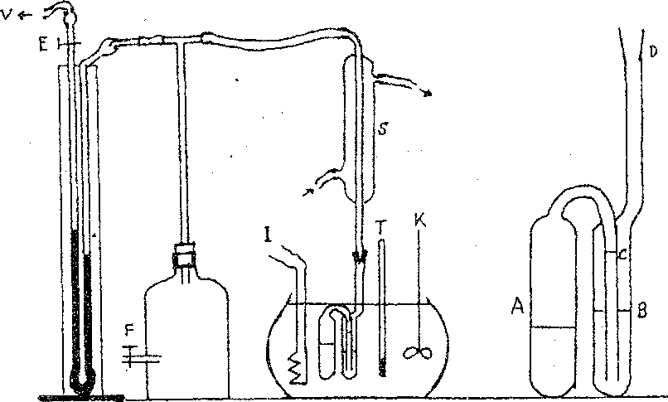
With the help of an isoteniscope, the vapor pressures of liquids at different temperatures can be measured and the enthalpy of evaporation can be calculated. The device used in the experiment is shown in Figure 4.1.
The B part of the isoteniscope is filled with liquid and moved up and down to allow the liquid to pass in an equal volume to the A chamber. The isoteniscope is placed in the water bath and the condenser is connected. When the two-way tap F is open to the air, the tap E is pulled from the tap E until the mercury in the pressure

gauge is just over the tap and the tap is closed.
Şekil 4. İzoteniskop

After the manometer is prepared for the experiment, the pump is operated and the system is vacuumed by means of the two-way tap F. After the mercury level remains constant, it is continued to vacuum for a while and the air in tube A is removed. It should be observed that the mercury levels in the manometer are approximately equalized and remain constant. After closing tap F, the vacuum pump is also switched off.

If the mercury levels are not constant, the system may have leakage and the system must be shut down. After there is no leakage, the mixer is operated and the bath temperature is read. Air is slowly inflated to the system until the fluid reachs to C level. When levels B and C are equalized, the difference in mercury levels in the manometer gives the vapor pressure at the measured bath temperature of the test liquid. After this first reading, the heater and the mixer are activated together and the vapor pressures are read in a similar way at the manometer.
NOTE: The most important point to be considered when equalizing B and C levels is opening the tap F carefully and giving air to the system carefully. Otherwise, air is escaped into tube A and the value read from the manometer is not equal to the vapor pressure. Also, it is not allowed to boil the liquid in the tube to prevent air leakage into tube A.

Sonuçların Değerlendirilmesi

The test results are evaluated by plotting p-T and ln p-1 / T plots. The slope of the graph matching the Classius-Clappeyeron equation is ΔHsb. Then according to the Trouton rule, the evaporation entropy is determined. As a result, the type of examined liquid is determined according to the enthalpy of evaporation value.

SORULAR

- Explain the concepts of vapor pressure, steam, gas, critical point and triple point.
- What is the chemical potential? What thermodynamic quantification is indicated?
- What is the Trouton rule? What is its effect, on the interaction of the molecules?
- In the p - T diagram of water, how you explain the negative fluid curve.
- What are the other methods used to determine the vapor pressure?
- Explain the equilibrium conditions between phases.
- Derive Clapeyron and Clasius-Clapeyron equations.
- Explain the temperature dependence of the enthalpy of evaporation.
- Can a pure substance have more than 1 triple point? Please explain.

- The temperature change of the vapor pressure of the liquid benzene is given as ln (p / Nm-
2) = -3883 / T + 22,516. Find the molar evaporation entropy, the normal boiling temperature and the entropy of evaporation at this temperature. Compare the enthalpy and enthalpy of vaporization with the results you will find in the Trouton rule.

