POLYMER CHEMISTRY

Deney No: 16
Deneyin Adı: Polymer Synthesis and Determination of Viscosity Average Molecular Weight of a Polymer

Conversion of Polymerization and Polymerization Rate

Deneyin Amacı: The aim of this experiment is to determine the percentage of polymerization and polymerization rate by weighing the polymer formed in a certain period of time in the reaction system.

Kullanılan Kimyasallar: • Acrylamide
  - Benzoyl peroxide (Bz2O2)
  - Distilled water
  - Acetone
  - Methyl alcohol
Kullanılan Malzemeler: • glass rod
  - beher glass
  - watch glass
  - pipette (10 mL ve 25 mL)
  - roun bottom flask (polymerization tube)
  - Waterbath

Bilgi

In this experiment, the chain polymerization of acrylamide will be examined. Polyacrylamide polymer formation from acrylamide;
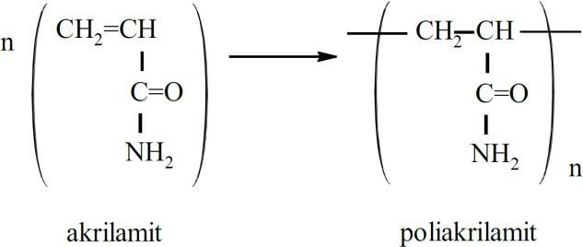

is occurred with chain polymerization.

Deneyin Yapılışı

0.71 g of acrylamide and 18 mL of distilled water are added to the reaction vessel and placed in a thermostatized water bath at 75 ° C. It is waited until temperature equilibrium is established (10 minutes). After the temperature equilibrium is established, a solution of 0.0484 g of Bz2O2 in 2 mL of acetone is added to the reaction vessel. From this moment on, the time is recorded and the mixture is allowed to polymerize for 1.5 hours. At the end of this period, the reaction mixture is cooled and the polymerization is stopped. The solution is decanted into the beaker. After cooling has been completed, the methanol is slowly added by mixing with a glass rod and the polyacrylamide is precipitated. The upper part of the solution is discarded and the polyacrylamide baguette on the bottom is dried and then dried. Dried polyacrylamide is weighed and the polymer conversion (%) and polymerization rate are calculated.

Sonuçların Değerlendirilmesi

The conversion of polymerization P % is calculated from the following relations as m g polymer is formed at the end of t minute with mo monomer mass.:
% P= (m/mo)x100 (16.1)

Concentration of monomer [M] o and rate of polymerization rp

[M]o= (mo/Mo)1000/v (16.2)

rp/molL-1dk-1= (%P)x[M]o/100 t (16.3)

can be calculated, respectively. Here, Mo is the molecular weight of monomer, v is the total volume of the solution and t show the polymerization duration.

