POLYMER CHEMISTRY

Deney No: 16
Deneyin Adı: Polymer Synthesis and Determination of Viscosity Average Molecular Weight of a Polymer

Determination of Viscosity Average Molecular Weight of a Polymer

Deneyin Amacı: The aim of this experiment is to determine the viscosity average molar weight of the polymer by measuring the viscosity of dilute solutions of a polymer with unknown molar wieght.
Kullanılan Kimyasallar: • poly(acrilamide) – (PAam)

Kullanılan Malzemeler: • Waterbath
- Heater
- Ubbelohde viiscometer

Deneyin Yapılışı
- stopwatch
- puar

Dilute solutions of PAAm with unknown molecular weight are prepared less than 1 g / 100 mL. Measurements are taken at the same temperature as the Ubbelohde viscometer. The advantage of using the Ubbelohde viscometer in the experiment is that the dilution of the polymer solution is carried out in the viscometer.
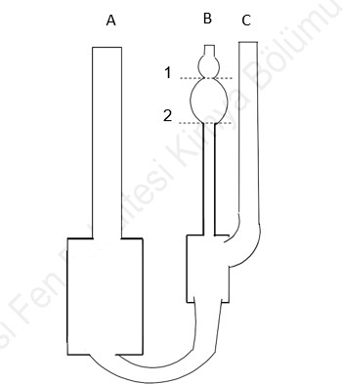
The viscometer is placed in a fixed water bath at 25 ° C. Transferring 10 mL of solvent through the A tube allows a short time to set the temperature balance. The puar is then inserted into tube B (Fig. 9).The mouth of the C-pipe is closed with the finger and is pulled up with the help of the pin until the solvent passes to the first bubble in the B-pipe.The finger that closes the hole on the pad and the finger in the C pipe are pulled at the same time. Thus, the free flow of solvent from the capillary tube is provided.
Şekil 9. Ubbelohde Viskozimetresi

The stopwatch is run while the solvent level is at full 1. The stopwatch is stopped while passing through level 2. Thus to is measured. Then the solvent is discharged. 8 ml of a 1% polymer solution is placed in the viscometer and placed in a 25 ° C water bath. t1 is measured as in the determination of solvent flow time .Without pouring the 1% polymer solution through the viscometer, the second dilute solution is prepared by adding an appropriate amount of solvent (pure water) from the A- tube.

Polimer çözeltisi derişimi/g(100 cm-3)
İlave edilen çözücü miktarı/mL

Viskozimetre içindeki çözücü miktarı/mL

1 |  | 8
0,8 | 2 | 10
0,6 | 3 | 13
0,5 | 3 | 16
0,4 | 4 | 20

while determination of the flow time of the solvent and polymer solutions (t1, t2, t3, ...), each measurement must be taken at least 3 times.

Dilution should be done properly. After the addition of solvent, tube C should be closed and thoroughly mixed with air through the viscometer.
Once the test is completed, the viscometer should be drained and thoroughly rinsed, especially with the capillary solvent removed, and then dried.

Sonuçların Değerlendirilmesi

Using the data obtained from the experiment, the following quantities are calculated.

relative viscosity = ηb = η/η0 = t/to (16.4)

spesific viscosity= ηsp=ηb-1 (16.5)

Limit (intrinsic) viscosity= [η]= (ηsp/c)c=0 (16.6)

Herer, η0 and η are the viscosity values of the solvent and solution, (ηsp/c)c=0 is the ratio of ηsp/c obtained while concentration is close to zero.
The relation betwen the viscosity average molar weight of the lineer polymers, <Mv> with limit viscosity is given below:
[η]= k <Mv>α ( Mark-Houwink equation) (16.7)

Here, k and α are constants depend on polymer, type of solvent and temperature. At T = 30 °C the Mark-Houwink constants of PAAm are given as:
k dL/g | α
12,5x10-5 | 0,78

In the Polimer- solvent system, the change of ηsp/c with c is given with ηsp/c= [η] + kc equation.
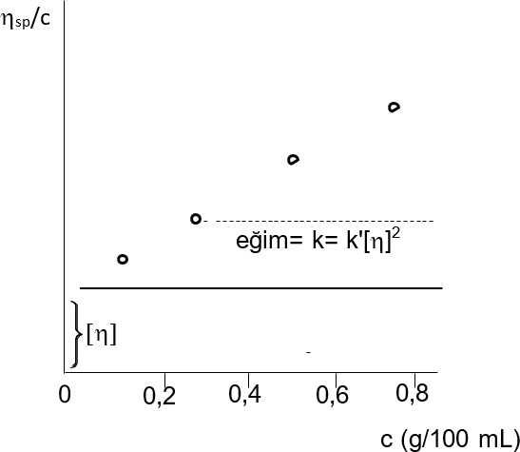

Şekil 10. Change of ηsp/c with c

We can briefly summarize the ways to determine the viscosity average molar mass as follows:
- ηsp / c values are plotted against c.
- It is extrapolated to zero concentration and read from the y axis [η].
- The k and α values are found in the tables for the same polymer, solvent and temperature at which the viscosities are measured.
- Mark-Houwink equation <Mv> is calculated.

SORULAR
- Explain the concepts of initiator, monomer, mer, polymer, copolymer.
- What is condensation and chain polymerization? Please explain. Give examples of polymers synthesized in both ways.
- What is the initiator? Specify the name and the open formula of an initiator you know.
- How is branching in the polymer chain?
- Specify the name, open formula and properties of a polymer we use in daily life.
- Write the initiation, growth and termination reactions for the radical polymerization of a suitable monomer with the help of a suitable initiator.
- Why does the mean mean mass of moles be used for polymers?
- What are the molar masses of polymers?

- Write the synthesis reactions of the 3 addition and condensation polymers you know and the names of the substances in the reactions.
KİM 357 Fizikokimya Laboratuvar Föyü 2018-2019

