Simple Present: Affirmative Statements
- READ the article about Doctor Bugs. Notice the words in bold.
Doctor Bugs
Most people don’t like bugs, but Doctor Mark Moffet loves
them! In fact, his nickname is Doctor Bugs. He’s a photographer
and an entomologist. An entomologist studies bugs.
Doctor Moffett’s favorite bug is the ant. He goes all over the
world to study ants. He watches them as they eat, work, rest,
sleep, and fight.
He takes photographs of the ants. He lies on the ground with
his camera and waits for the right moment. The ants and other
bugs often bite him, but that doesn’t stop Doctor Bugs. He has an
interesting and unusual job, and he loves it!

- CHECK. Read the list of verbs in the chart. Who does each action? Check (✓) the correct
column.
Verbs | Doctor Moffett | Ants
1. studies
2. fight
3. waits
4. bite

- DISCOVER. Complete the exercises to learn about the grammar in this lesson.
A. Look at the list of verbs in exercise 2. Find other verbs in the article from exercise 1.
Doctor Moffett | Ants
goes | eat

B. Look at the charts from exercise 2 and exercise A. Choose the correct answer complete
each statement. Then discuss your answers with your cl mates a teacher
1. The verbs under Doctor Moffett end in -s / do not end in -s.
2. The verbs under Ants end in -s / do not end in -s.
SIMPLE PRESENT: AFFIRMATIVE STATEMENTS

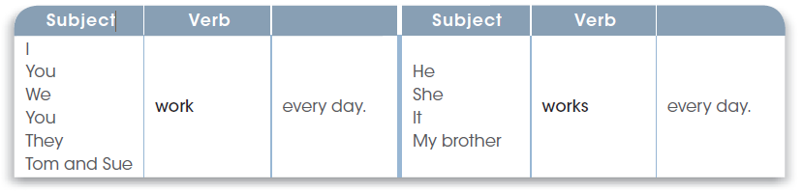
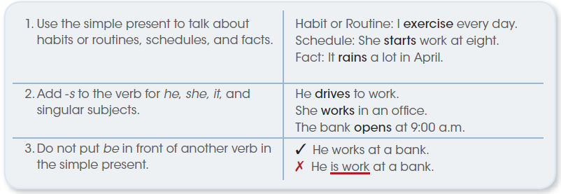
Circle the correct form of the verb to complete each sentence.
1. Doctor Moffett love / loves his job.
2. He study / studies ants.
3. A salesperson sell / sells products for a company.
4. You and Anita work / works on weekends.
5. Nurses help / helps people.
6. We write / writes science books.
7. Our office close / closes at 7:00 p.m.
8. She take / takes classes at the business school.
9. You walk / walks to work every day.
10. I start / starts work at 8:00 a.m. every morning.
Complete each sentence with the correct form of the verb in parentheses.
1. A zookeeper feeds (feed) animals.
2. Computer programmers (write) software.
3. Photographers (take) photos.
4. A chef (cook) food.
5. A firefighter (fight) fires.
6. Musicians (play) instruments.
7. A farmer (work) on a farm.
8. A dancer (dance).

Simple Present Spelling Rules: -s and -es Endings
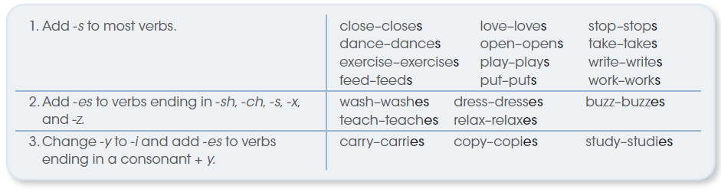
Write each verb with the correct -s, -es, or -ies ending.
1. study studies 8. help
2. fish 9. miss
3. pass 10. fly
4. worry 11. fix
5. explore 12. watch
6. bite 13. like
7. buy 14. pay

