Aromatic Electrophilic Substitution Reactions (S_{E}Ar)

Electrophilic aromatic substitution is a chemical reaction in which an electrophile substitutes an atom that is bound to an aromatic network (usually hydrogen).
Efficiency in Aromatic Electrophilic Substitution
The ring function is significantly affected by an aromatic ring-bound substituent, so that the SEAR reaction of the substituted benzene takes place in a shorter or longer time, under mild or stronger conditions than benzene.
Whether the ring is more or less effective in the S_{E}AR reaction depends on the qualitative properties of its substituents.

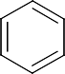

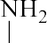
p-Iodoaniline: Experimental Organic Chemistry, page: 496

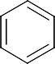

p-Bromonitrobenzene: Experimental Organic Chemistry, page:777


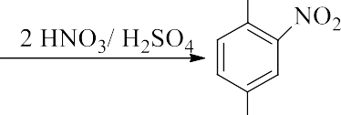
2,4-Dinitrobromobenzene:Experimental Organic Chemistry, page:779

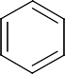
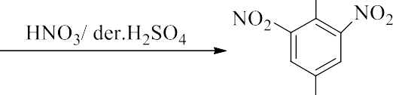
Picric acid: Experimental Organic Chemistry, page:782

