Evaluation of Transfer Coefficients: Engineering Correlations
FLOW PAST A SINGLE SPHERE
If we immerse a sphere in an infinite fluid flow, we may consider two cases which are exactly the same:
- The spherical object is stagnant, the fluid flows over this spherical object or,
- There is a stagnant fluid, the spherical object moves through the fluid.

Newton’s second law of motion states that the balance of forces acting on a single spherical object with a diameter of Dp, which falls within a stagnant fluid with a constant terminal velocity Vt, can be expressed in the form
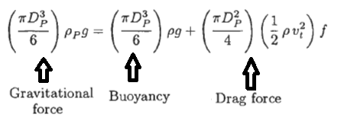
Newton’s second law of motion can be turned into a form, which is expressed by using dimensionless number such as Reynolds number and Archimedes number.
where Reynolds number and Archimedes number can be expressed as followings:
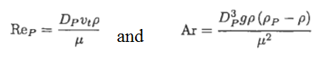
Engineering problems related with the motion of spherical objects within a fluid are grouped as followings:
- If the terminal velocity is unknown, and if the viscosity of fluid and the spherical object diameter are known.
- If the object diameter is unknown, and if the viscosity of fluid and the terminal velocity are known.
- If the viscosity is unknown, and if the terminal velocity and the object diameter are known.

- Friction Factor Correlations
Lapple and Shepherd at 1940 expressed their experimental data in the form of f versus Rep for the flow of a spherical object within a stagnant fluid. Their data are expressed as followings:
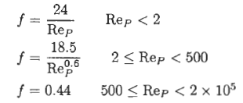
Turton and Levenspiel at 1986 worked on a single comprehensive equation for the friction factor that covers the entire range of Rep.
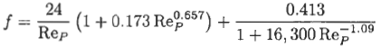

Case 1: If the terminal velocity is unknown, and if the viscosity of fluid and the spherical object diameter are known.
Turton and Clark at 1987 worked on an expression relating the Archimedes number to the Reynolds number as followings:
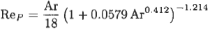

The terminal velocity can be calculated by using the following procedure:
a) the Archimedes number needs to be calculated,
b) the Reynolds number can be calculated using the Turton and Clark equation,
c) After determination of the Reynolds number, the terminal velocity can be calculated
from the Reynols number.
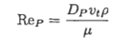
Case 2: If the object diameter is unknown, and if the viscosity of fluid and the terminal velocity are known.
Tosun and Aksahin at 1992 worked on an expression relating Y to the Archimedes number as followings:

The object diameter can be calculated by using the following procedure:
a) Y needs to be calculated,
b) the Reynolds number can be calculated using the “Y” expression,
c) After determination of the Reynolds number, the object diameter can be calculated
from the Reynols number.
Case 3: If the viscosity is unknown, and if the terminal velocity and the object diameter are known.
Tosun and Akşahin at 1992 studied on an expression relating X to the Reynolds number as followings:
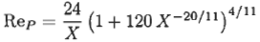

The fluid viscosity can be calculated by using the following procedure:
a) X needs to be calculated,
b) the Reynolds number can be calculated using the “X” expression,
c) After determination of the Reynolds number, the fluid viscosity can be calculated
from the Reynols number.
Deviations from ideal behavior
Newtons second law of motion is only valid for a single spherical object falling in an unbounded fluid. The presence of container walls and other objects as well as any deviations from spherical shape affect the terminal velocity of particles.

References:
İ. Tosun, “MODELLING IN TRANSPORT PHENOMENA A Conceptual Approach”, Elsevier, 2002.

