Engine Efficiency

The term is universally employed for the evaluation of the performance of fuel-consuming energy devices and processes.

Generally, efficiency is used to relate the output to the corresponding input of a commodity or the yield to the cost involved.

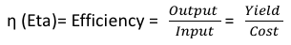

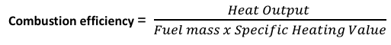

When expressed as a percentage, the thermal efficiency must be between 0% and 100%.
Due to inefficiencies such as friction, heat loss, and other factors, thermal engines' efficiencies are typically much less than 100%.

- For example, a typical gasoline automobile engine operates at around 25% efficiency,
- A large coal-fueled electrical generating plant peaks at about 46%,
- The largest diesel engine in the world peaks at 51.7%.

Second Law of Thermodynamics states that the heat naturally flows from regions of higher temperature to regions of lower temperature, but it will not flow naturaly the other way.

When heat is added, some of the heat is from that input heat is used to perform work. The rest of the heat is removed at relatively low temperature. Efficiency of a heat engine

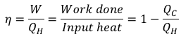

Carnot (French physicist - the father of thermodynamics) principle

How can an engine achieve its maximum efficiency?

It must operate using reversible process such as Carnot engine

Carnot engine is the ideal engine

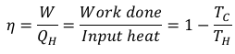

A real engine can never achieve the efficiency of Carnot engine. Carnot concluded that the efficiency of an ideal engine depends only on the temperature of the hottest and coldest parts, not on the substance that drives the mechanism.

Reversible processes vs. Irreversible processes

Heat Pumps

Heat pump is a device which applies external work to extract an amount of heat Q_{C} from a cold reservoir and delivers heat Q_{H} to a hot reservoir.

Reference: Ghazi A. Karim, Fuels, Energy and the Environment, 1st Edition, CRC Press.

