Internal combustion engines

They are the prime devices at present for the production of work through fuel combustion. They are the most significant invention that changed human life.

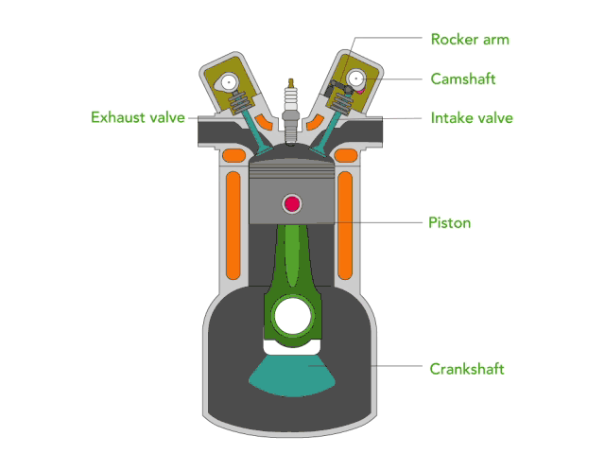

Internal combustion engine gains its energy from heat released during the combustion of nonreacted working fluids, the oxidizer mixture.

This process occurs within the engine and is part of the thermodynamic cycle of the device.

Useful work generated by an internal combustion engine results from the hot gaseous products of combustion acting on moving surfaces of the engine, such as the face of a piston, or turbine blade.

Steady combustion engines are continuous equipments that are characterized by a steady flow of a fuel and oxidizer into the engine. A stable flameis maintained within the engine.

Fuel | Form of supply to the equipment | Main application
Coal | Lumps or pulverized particles | Furnace and boilers
Kerosene | Vapor or spray | Furnaces and jet engines
Fuel oil | Spray | Furnace and boilers
Liquid propellant | Spray | Rocket engines

Unsteady combustion engines are characterized by a periodic ignition of air and fuel. They are commonly referred to as reciprocating engine. Discrete volumes of air and fuel are processed in cycles.

Fuel | Form of supply to the equipment | Main application
Gasoline | Spray and vaporized | Spark ignition engine, SI
Diesel | Spray | Compression ignition engine, CI
Gaseous Fuel | Spray | SI or CI engine

With the exception of rockets internal combustion engines ingest air, then either compress the air and introduce fuel into air or introduce fuel and compress the fuel-air mixture. Then, common to all internal combustion engines, the air-fuel mixture is burned, work is extracted from the hot gaseous products of combustion, and eventually these hot products are released through exhaust system.

Compression ignition engine operates on the basis of autoignition. A typical example is diesel engines.

Reference: Ghazi A. Karim, Fuels, Energy and the Environment, 1st Edition, CRC Press.

