MASS TRANSFER COEFFICIENT

If we suspend a flat plate in a uniform stream of velocity v, and species A concentration CA as shown in Figure 1, and if the concentartio of A at the surface of the plate is kept constant at CAwall, the total rate of mass transfer from the plate to the flowing stream can be calculated by integrating the total mass flux at the wall over the surface area.
The total mass flux at the wall is:
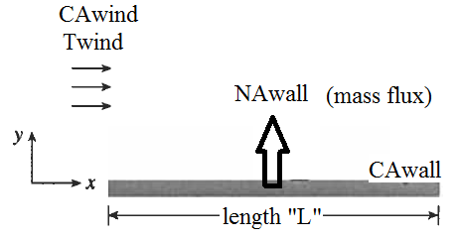
Figure 1. Wind flow over a flat plate at CAwall
The flux expression can be expressed by usig the following equation, consists of molecular mass flux and convective mass flux terms.
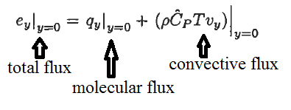
where the convective mass energy flux at the wall is not equal to zero since Vy is not equal to zero. There is diffusion in y-direction, which results a net characteristic flow in the y-direction. As an assumption, the convective mass flux terms can be taken as zero. Hence, total mass flux is equal to molecular mass flux, only. The total mass transfer can be calculated by integrating the molecular mass flux at the wall over the surface area.
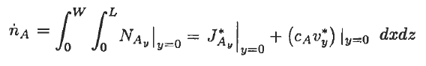
Determination of the expresion requires the calcalution of the concentration profile at the interface of the Wall. The concentartion profile is not easy to be determined. Hence, the molecular mass flux at the interface can be expressed in terms of the convection mass transfer coefficient, kc, by using the following expression:
Where “kc” is the mass transfer coefficient, in units of m/s. The mass transfer coefficient depends on the fluid flow mechanism and the following fluid properties:
- Density
- Viscosity
- Diffusion coefficient

The total mass transfer can be calculated by integrating the molecular mass flux at the wall over the surface area by using given expression above:
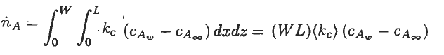
where (kc) is the average mass transfer coefficient and WL is the mass transfer area.

- Physical interpretation of mass transfer coefficient
The Fick’s first law of diffusion, which is the molecular mass flux at the Wall, is expressed as following:
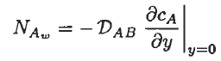
If we equate the Fick’s first law of diffusion to the given expression above:
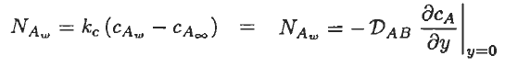
The mass transfer coefficient can be expressed as given below:
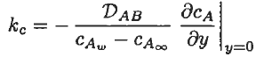
The mass transfer coefficient can be obtained if the concentartion profile at the wall inteface is known. Since the concentration profile at the wall interface is not easy to be determined, the actual concentartion profile is idealized as shown in Figure 2.
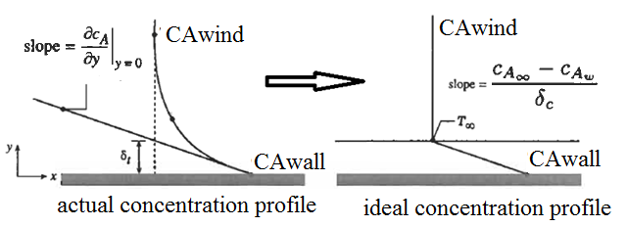
Figure 2. The film model for actual and ideal mass transfer from the Wall surface

The entire mass resistance from the Wall to the air is assumed to be due to a thin stagnant film
in the fluid next to the Wall surface. The thickness of the thin film provides the same resistance to mass transfer as the resistance that exists for the actual condition.

Then the convective mass transfer coefficient can be expressed as a fuction the film thickness and the diffusion coefficient:
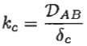
Equation given above indicates that the thickness of the stagnant film determines the value of the convective mass transfer coefficient “kc”.

References:
İ. Tosun, “MODELLING IN TRANSPORT PHENOMENA A Conceptual Approach”, Elsevier, 2002.

