The Reaction Rate
The reaction rate measures how fast a number of moles of one chemical species are being consumed to form another chemical species. The chemical species can be thought as any kind chemical component or chemical element.
Chemical reactions can take place when an observable number of molecules of one or more chemical species have lost their character and turn into a new form by a change in the type or number of atoms in the compound and/or by a change in structure or configuration of these atoms. In terms of the conservation of quantity, it is assumed that the total mass is neither created nor destroyed when a chemical reaction takes place.
The rate at which a given chemical reaction takes place can be illustrated in different ways.
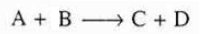
The reaction rate is the number of moles of A reacting or disappearing per unit time per unit volume (mol/dm3.s).
Homogeneous reacions involve only one phase. Heterogeneous reactions involve more than one phase. In heterogeneous reaction systems, the reaction rate is usually given in measures other than volume like surface area or catalyst weight. For a gas-solid catalytic reaction, the gas molecules must interact with the solid catalyst surface for the reaction to take place.
The chemical reaction rate law is an algebraic equation containing concentration, not a differential equation. The algebraic form of the rate law for the reaction:
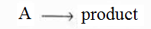
This form of the equation might be a linear function of concentration
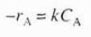

The General Mole Balance Equation
To design a mole balance on any given system, the system boundaries must first be specified first of all. The volume enclosed by these boundaries is known as the system volume. In order to make a mole balance on species j in a system volume, at which species j identifies the particular chemical species.
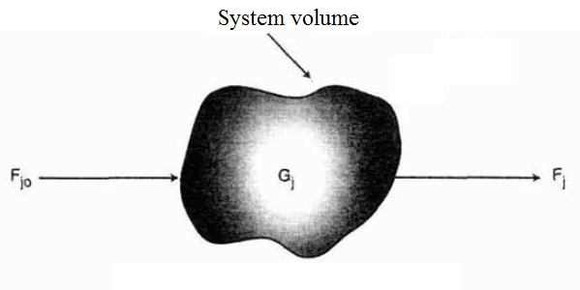
Figure 1. The mole balance on species j in a system volüme

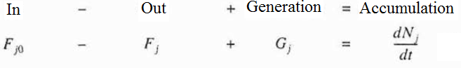
At which Nj, refers to the number of moles of species j in the given system at time t. If the system variable like temperature, catalytic activity, concentration of the chemical species are spatially uniform throughout the system volume, the generation rate of species j, Gj,. is the product of the system volume “V” and the rate of formation of species j, rj as given below:
We can replace Gj, in the given equation above:
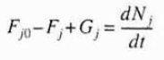
The integral form to the generation rate can included into the given equation above:
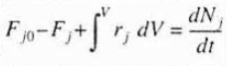
By using this general mole balance equation we can develop the design equations for the various types of industrial reactors like batch reactor, semibatch reactor and continuous- flow reactor.

Batch Reactors
The batch reactor is not a continuous reactor and the batch reactor is used mostly for small-scale chemical reactions or for testing new processes. The reactor can be charged or filled through the holes at the top of the batch reactor as shown in the figure below:

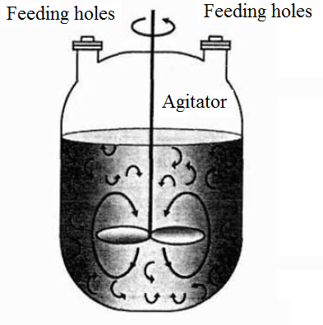
Figure 2. The batch reactor configuration

The batch reactor results high conversion compared continuous reactors. The batch reactor configuration is also simple. It is easy to work on this kind of reactor. Prior to the start of the reaction, all reactants are fed into the batch reactor. With turning of the stirrer, the reaction starts to take place. It is also easy to control the process parameters of the chemical reaction, taking place within the batch reactor. At the end of the reaction, the products and the reactants, which have not reacted, are taken from the batch reactor. The disadvantages of the batch reactor is the high labor costs-per batch, the variability of products and the difficulty of large-scale production.
There is neither inflow nor outflow of reactants or products while the reaction takes place. Hence, the resulting general mole balance equation on species j is given below:
If the reaction mixture is perfectly mixed so that there is no variation in the rate of reaction throughout the reactor volume. we can write the mole balance in the form as shown below:
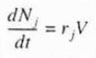
The integral form of the mole balance equation on a batch reactor can be illustrated as shown below:
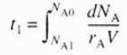

References:
- H. Scott Fogler, “Elements of Chemical Reaction Engineering”, Prentice Hall Professional Technical Reference, Fourth Edition.

