Multiple Reactions
There are four basic types of multiple reactions:
- Series reactions,
- Parallel reactions,
- Complex reactions,
- Independent reactions
The given multiple reactions can occur by themselves, in pairs, or all together. When there is a combination of parallel and series reactions, they are often referred to as complex reactions.

- Parallel reactions: This type of reactions are also known as competing reactions. The reactants are consumed by two different reaction pathways to form different products as followings:
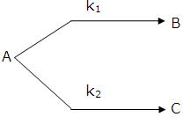
An example for the industrially significant parallel reactions is given below:
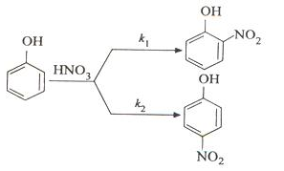
- Series reactions: This type of reactions are also known as consecutive reactions. The reactants forms an intermediate product, reacting further to form another products as shown below:
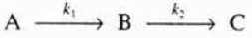
An example for the industrially significant series reactions is given below:
- Complex reactions are a type multiple reactions, invoIving a combination of both series and parallel reactions as shown below:
An example for the industrially significant complex reactions is shown below:
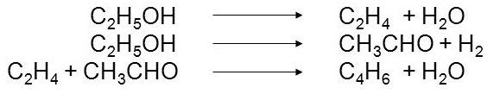
- Independent reactions: These are reactions, occurring at the same time but neither the products nor the reactants react with themselves or one another.
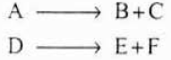
An example for the industrially significant independent reactions is illustrated below:
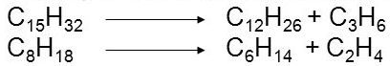

Desired and Undesired Reactions
Desired reactions result the formation desired product and as expected undesired reactions result the formation of the undesired product in a competing or side reaction.
In the parallel reaction given below:
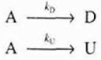
In the series reaction shown below:
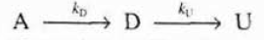
It is almost aimed to minimize the formation of the undesired product “U” and to maximize the formation of the desired product “D” since the greater the amount of undesired product result in a following cost of separating the undesired product “U” from the desired product “D”.
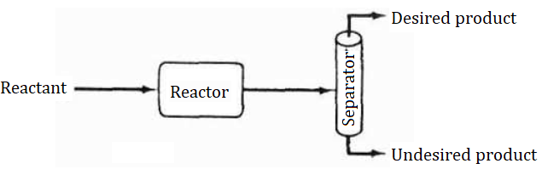
Efficient reactor may result in formation of very little of undesired product “U”. Hence, the separation cost of the all process goes down. Inefficient reactor (inexpensive reactor) can produce the desired product with substantial amount of the undesired product “U” with low cost. But, the separation cost of the all process goes up as shown in the figure below:
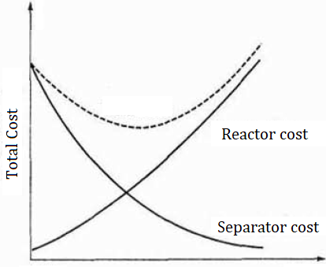
Figure 1. Efficieny of a process system in term of cost

Selectivity means that one of the products is favored over another when we have multiple reactions. It can ben quantify The formation of the desired product “D” with respect to the undesired product “U” can be quantified by defining the selectivity and yield of the system. The instantaneous selectivity of the desired product “D” with respect to the undesired product “U” is the ratio of the rate of formation of the desired product “D” to the rate of formation of the undesired product “U”.
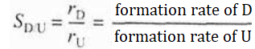
Selectivity can also be defined in terms of the ratio of the flow rate of the desired product “D” to the flow rate of the undesired product “U”.
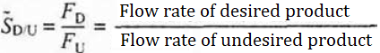
For a batch reactor, the overall selectivity is given in terms of the number of moles of the desired product “D” and the number of moles of the undesired product “U” at the end of the reaction time.
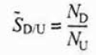

References:
- H. Scott Fogler, “Elements of Chemical Reaction Engineering”, Prentice Hall Professional Technical Reference, Fourth Edition.

