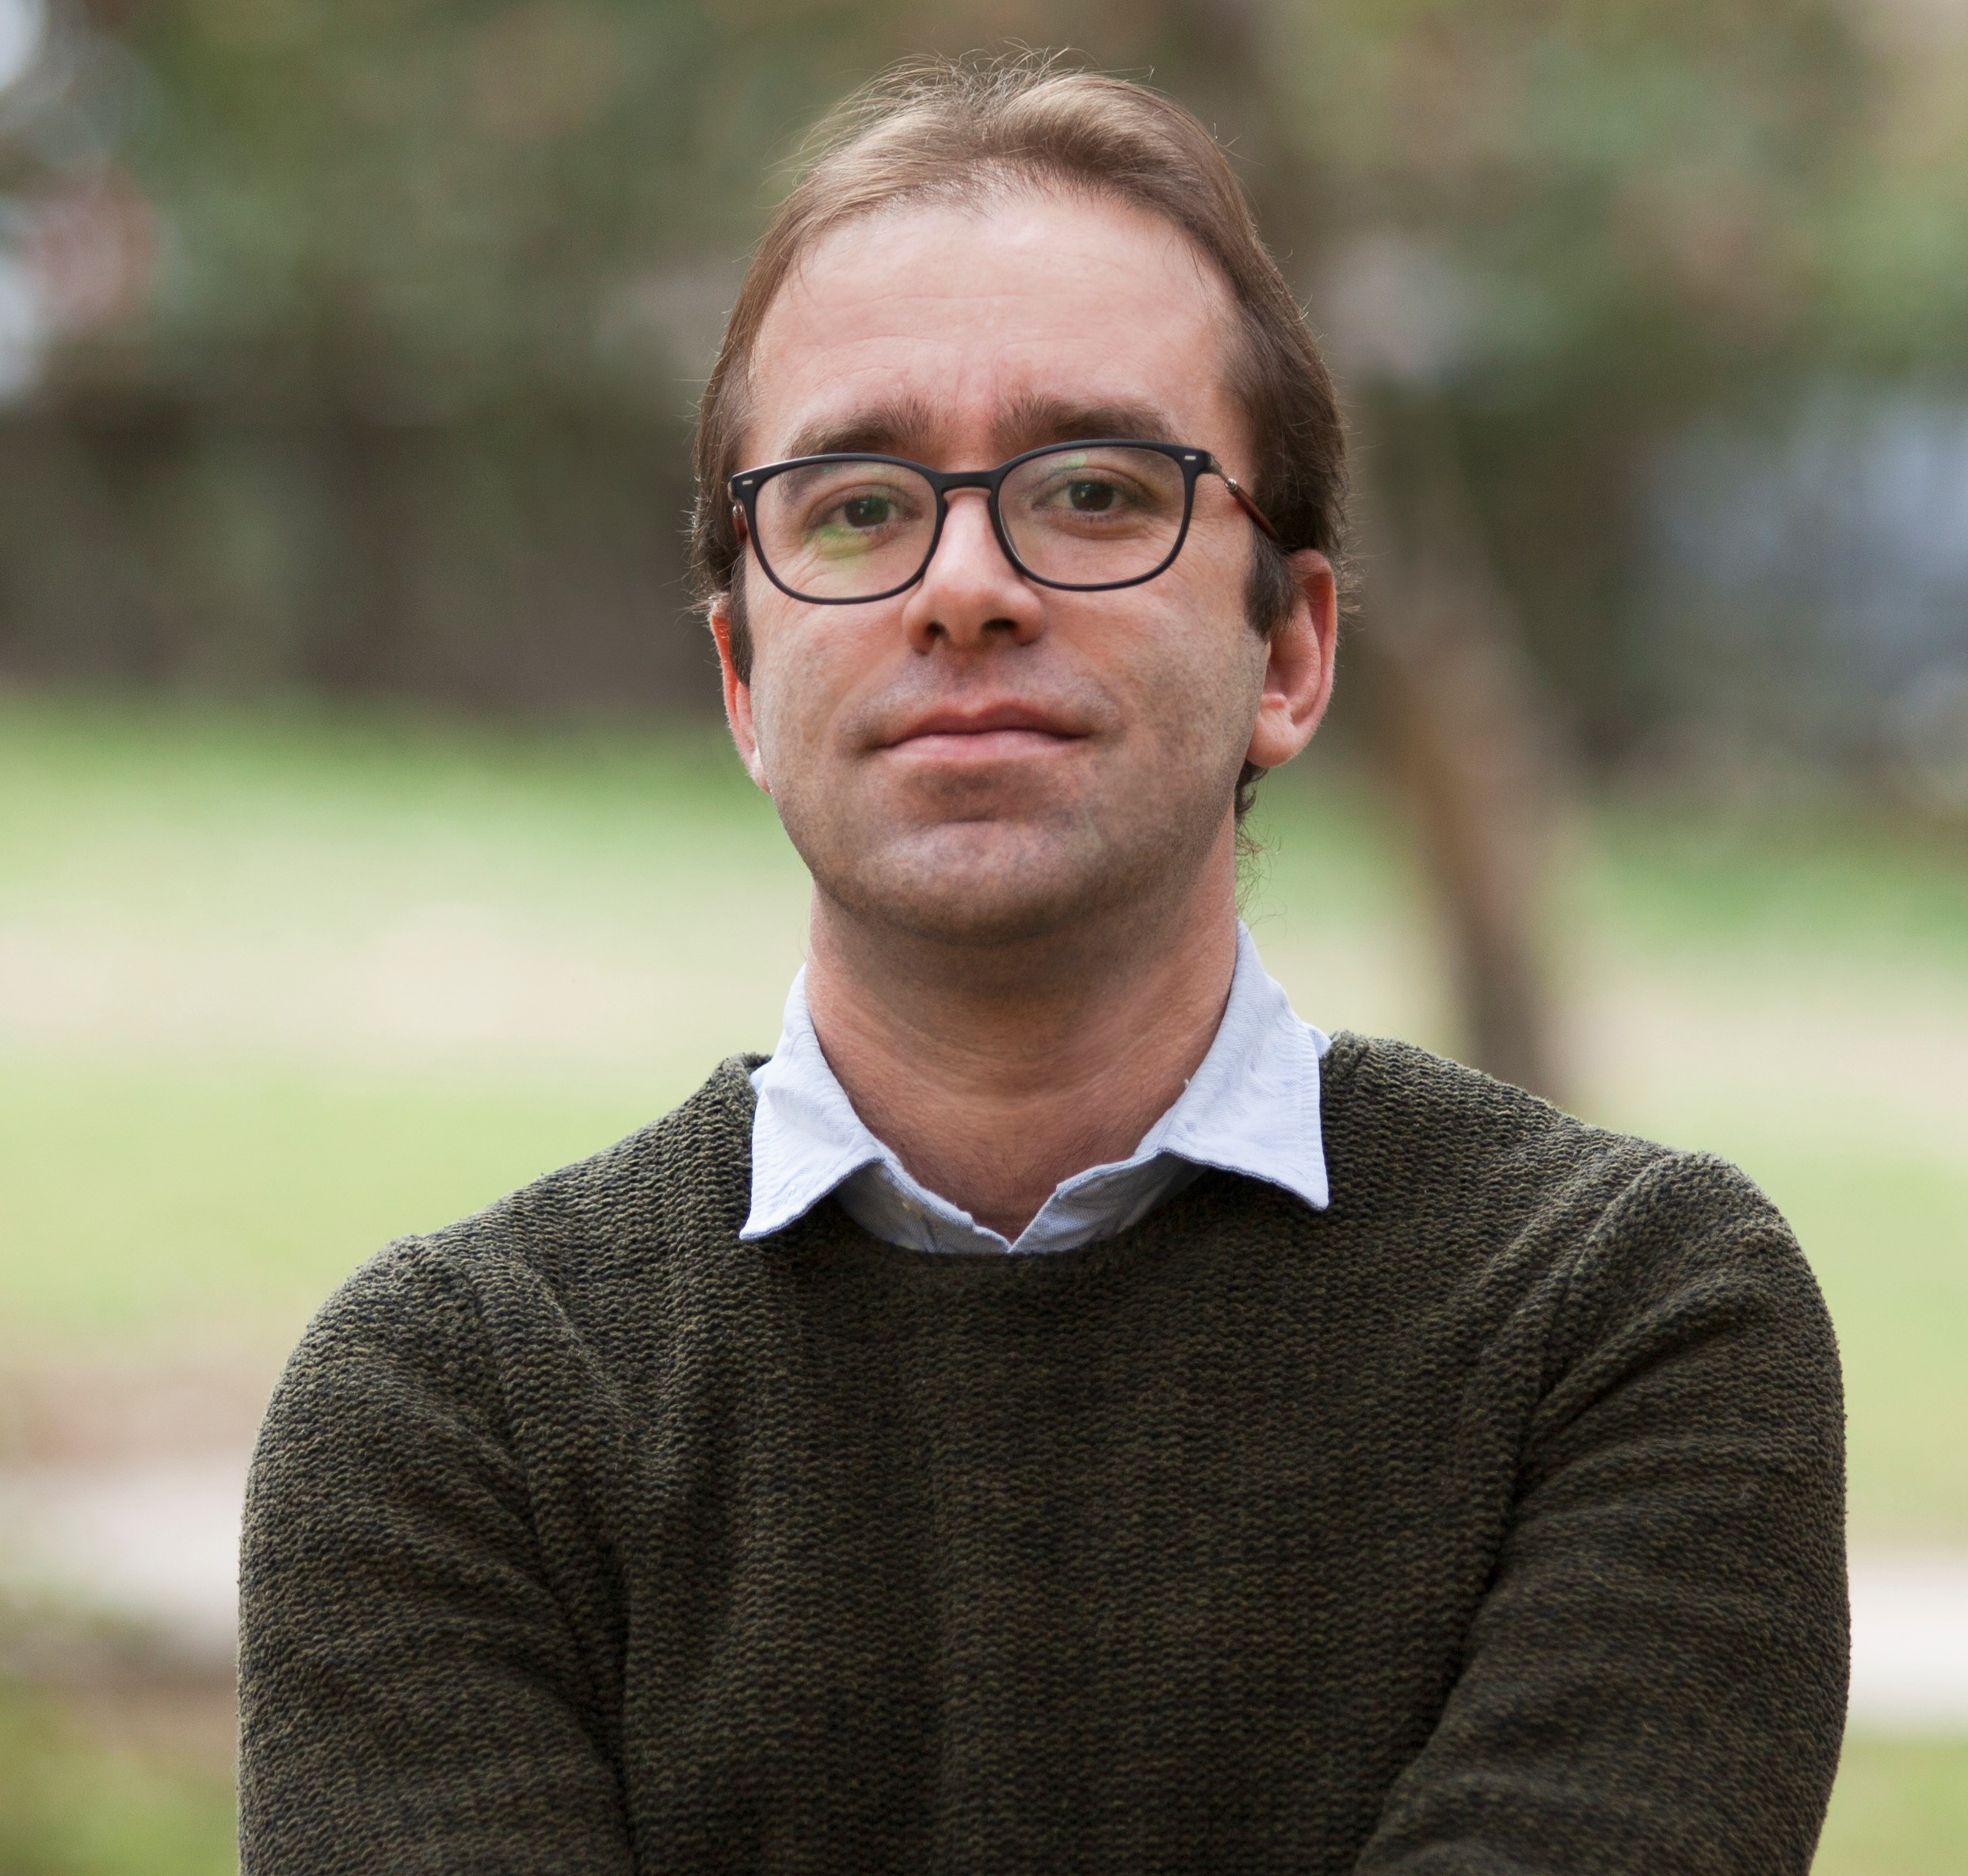
Name: Cenk Saraçoğlu (Assoc. Prof. Dr.)
Date of Birth: 9 November 1979
E-mail address: cenksaracoglu@gmail.com
Mailing Address: Ankara University, Faculty of Communication, Cebeci, Cankaya, Ankara.

EDUCATION
2008: PhD
University of Western Ontario, Department of Sociology, London. Ontario, Canada

2003: M.A.,
University of Western Ontario, Department of Sociology, London, Ontario, Canada

2002: B.A.
Bilkent University, Department of International Relations, Ankara, Turkey

TEACHING AND RESEARCH INTERESTS
Migration, urban transformation, nationalism and racism, political and social theory, social inequality, labor studies, Turkish politics, Turkish foreign policy.

PROFESSIONAL EMPLOYMENT

2014 Associate Professor (2017)
Ankara University, Faculty of Communication, Department of Journalism
(current position)

2012 Assistant Professor
Başkent University, Department of Political Science and International Relations

2009 Assistant Professor
Middle East Technical University, Northern Cyprus Campus.
Programme of Political Science and International Relations.

PUBLICATIONS

Books

2016 (edt.) Political Life in Turkey From the Ottoman Empire to Contemporary Times [Osmanlı'dan Günümüze Türkiye'de Siyasal Hayat] (Yordam Kitap: İstanbul) with Ateş Uslu ve Gökhan Atılgan.

2011 The City, Middle Class and the Kurds: From Denial to Exclusive Recognition [Şehir, Orta Sınıf ve Kürtler: İnkar’dan Tanıyarak Dışlama’ya] (İletişim: İstanbul)

2011 Kurds of Modern Turkey: Migration, Neoliberalism and Exclusion, (I.B.Tauris, London).

Refereed Articles

2019 “Loss and Xenophobia in the City: Contextualizing Anti-Syrian Sentiments in Turkey, Izmir”, Patterns of Prejudice, 53: 4, 363-383, DOI:10.1080/0031322X.2019.1615779, in press, with Prof. Daniele Belanger

2018 “The Governance of Syrian refugees in Turkey: The State-capital Nexus and Its Discontents, Mediterranean Politics, DOI: 10.1080/13629395.2018.1549785 with Prof. Danièle Bélanger

2018 “Mekan Yer ve Şehir: Türkiye’deki Suriyeli Karşıtlığının Kentteki Görünümleri (Space, Place and City: The Urban Facets of Anti-Syrian Sentiments in Turkey)”, Eğitim Bilim Toplum, 16(62): 46-73, with Prof. Daniele Belanger.

2018 “The Syrian Conflict and the Crisis of Islamist Nationalism in Turkey”, Turkish Policy Quarterly 16: 4, s. 17-26

2017 “Sağ Popülizm ve Faşizm Üzerine Yöntemsel Bir Tartışma: Küresel Örüntüler ve Ulusal Özgüllükleri Birlikte Anlamak”, Praksis 44-45, 1081-1105

2015 “Nationalism and Foreign Policy Discourse in Turkey under the AKP Rule: Geography, History and National Identity”, British Journal of Middle Eastern Studies, 42: 3, 301-319. (with Özhan Demirkol)

2015 "Ideological Transformation of Turkey after the June 2013: On the Methods of Understanding Gezi Uprising", (Haziran 2013 Sonrası Türkiye’de İdeolojiler Alanının Dönüşümü: Gezi Direnişini Anlamanın Yöntemleri Üzerine), Praksis, 37, s. 229-321.

2014 "Disasters as an Ideological Strategy for Governing Neoliberal Urban Transformation in Turkey: Insights from Izmir", Disasters , 38:1, 178-201 (with Neslihan Demirtaş-Milz)

2013 "AKP, Foreign Policy and Nationalism: Strategic Depth as a Doctrine of Nationalism" (AKP, Dış Politika ve Milliyetçilik: Bir Milliyetçilik Doktrini Olarak Stratejik Derinlik) Alternatif Politika, April 2013, 5:1, 52-68

2010 “The middle-class Perception of Kurdish Migrants in Turkish Cities: the Changing Image of the Kurds in Turkey” Patterns of Prejudice, 44:3, 239-250.

2009 “The Perception of the Kurds among Middle Class People in Izmir: Space, Class and Urban Life" (İzmirli Orta Sınıfta Kürt Algısı: Mekan, Sınıf ve Kentsel Yaşam), Praksis, 21, s. 17-46.

2009 “Exclusive Recognition: The New Dimensions of the Question of Ethnicity and Nationalism in Turkey” Ethnic and Racial Studies, 32: 4, 640-658.

2007: "The Ethnicization of Antipathy towards Migrants in Turkey" (Tanıyarak Dışlama: Türkiye Kentlerinde Göçmen Antipatisinin Etnikleştirilmesi), Toplum ve Bilim, 110: 247-262

2007: “Cold War and the Historiography of Soviet-Turkish Relations" (Türk Tarihyazımında Soğuk Savaş ve Türkiye-SSCB ilişkileri) Praksis, 17: 57-69

2004: "Nihal Atsız as the Subconsciousness of the Ultra Nationalist Movement in Turkey" (Ülkücü Hareketin Bilinçaltı Olarak Nihal Atsız)” Toplum ve Bilim, 100: 100-114

Chapters in Books

2019 “"The Syrian Refugees and Temporary Protection Regime in Turkey: A Spatial Fix for Turkish Capital in Integration through Exploitation: Syrians in Turkey, edts. Gaye Yılmaz, Tolga Törenli and İsmail Doğa Karatepe, pp. 96-110. (with Daniele Belanger)

2019 "Syrian Refugees and Turkey: Whose Crisis", in Oxford Handbook of Migration Crises edt. Cecilia Menjívar, Marie Ruiz, and Immanuel Ness (Oxford University Press: New York), pp. 279-294. (with Daniele Belanger)

2017 “Building an Alternative to Mainstream Social Movement Theories: Totality and Antagonism” in Where Have All the Classes Gone: A Critical Perspective on Struggles and Collective Action der. Balashova et. al (Rainer Hampp Verlag: Münih), 12-29.

2016 “The Gezi Uprising as a Turning Point for Ideological Struggles in Turkey” in The Road to Gezi: Resistance and Counter Publics in 21st Century Turkey. edt. Gamze Yücesan-Özdemir, (Red Quills: Ottawa) pp. 27-46 (with Melih Yeşilbağ)

2016 “Turkey under the AKP Rule: Under the Shadow of Minaret and Construction" [AKP Döneminde Türkiye: Minare ile İnşaat Gölgesinde] in Osmanlı’dan Günümüze Türkiye’de Siyasal Hayat edt. Gökhan Atılgan, Cenk Saraçoğlu ve Ateş Uslu, pp. 877-959.

2016 “1980-2002: Neoliberalism through Caterpillar Tread” in Osmanlı’dan Günümüze Türkiye’de Siyasal Hayat, edt. Gökhan Atılgan, Cenk Saraçoğlu ve Ateş Uslu, pp. 753-868.

2015 “Space, Capitalism and Kurdish Migrants in İzmir: An Analysis of Kadifekale’s Transformation in The Kurdish Issue in Turkey: A Spatial Perspective, der. Zeynep Gambetti ve Joost Jongerden (London: Routledge), pp. 185-212. (Neslihan Demirtaş-Milz ile)

2014 “The Urban Transformation in Kadifekale, İzmir: The Crossroads of Neoliberalism and Internal Displacement”, Rethinking Migration and Incorporation in the Context of Transnationalism and Neoliberalism içinde der. Ahmet İçduygu ve Zeynep Gülru Göker (İstanbul:, ISIS Press), pp. 177-227. (with Neslihan Demirtaş-Milz)

2012 “Turkish Right, AKP and the Kurdish Question" (Türk Sağı, AKP ve Kürt Meselesi), in Türk Sağı: Mitler, Fetişler, Düşman İmgeleri içinde edts. İnci Özkan Kerestecioğlu ve Güven Gürkan Öztan (İstanbul: İletişim, 2012), s. 243-283

2007 “The Canonization of Marx, Weber and Durkheim as a Social and Historical Process” in Medeniyet ve Klasik (Bisav: İstanbul), 417-431

2005 “Theoretical Reflections on Nationalism and Ethnicity: The Kurdish Question in Turkey from 1923 to 1980” in Ethnicity and Nationalism: Caribbean and Extra-Caribbean Dimensions içinde,. der. Anton Allahar, Lexington: New York, pp. 199-227.

Book Reviews in Scholarly Journals

2015 “Book Review of Challenging Neoliberalism at Turkey’s Gezi Park: From Private Discontent to Collective Class Action”, Working USA: The Journal of Labour and Society, 18:3, s. 518-521

2013 “Book Review of Anna-Grabolle Çeliker’s Kurdish Life in Contemporary Turkey: Migration, Gender and Ethnic Identity”, New Perspectives on Turkey, 49, 181-4.

2012 “Book Review of Nicole Watt’s Activists in Office”, International Journal of Turkish Studies, 18: 1-2, s. 190-4.

PROJECTS

2019-2021 Researcher: Türkiye’de Sanat Alanının Dönüşümü: Kültürel Ayrım ve Muhafazakâr Beğeni (The Transformation of the Field of Art in Turkey: Cultural Distinction and the Conservative Taste) (TUBİTAK, Turkey).

2017-2020 Co-Investigator: Syrian Refugees and Turkish Host Communities: A Study of Informal Actors (Social Science Research Council, Insight Development Grant, Canada)

2009-2010 Principal Investigator: The Urban Renewal in Kadifekale, İzmir: The Crossroads of Neo-liberal Restructuring of Urban Space and Migration Through Internal Displacement, MIREKOC (Migration Research Center at Koc University), (Dr. Neslihan Demirtaş ile birlikte)

