Allen Ginsberg Briefly
(1926-1997)
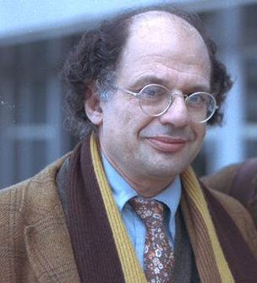

- Jewish, homosexual, activist and libertarian, obviously found “dangerous” in his life time: a good label for a poet.
- One of the leading figures of the Beat Generation alongside his fellow writers Kerouac, Ferlinghetti, Borroughs and Snyder.
- He had a problematic childhood and had to deal with his mother’s issues.
- His early poems were influenced by William Carlos Williams and Walt Whitman -particularly in length of his lines. He says his long lines are in accordance with his breath and he has a long breath.
- He got the public attention when his “Howl” was sued for obscenity. The trial was good advertisement as Ferlinghetti, his publisher, too, declared.
- He is spiritually a complicated person: his poetry relies on Zen Budhism as well as traditional Judaism.
- For more https://www.poetryfoundation.org/poets/allen-ginsberg

