Biological Molecules

Introduction
(Modified from http://www.biology101.org/biologystudyguides/buildingblocksoflife.php)

Biological systems are made up of four major classes of macromolecules: carbohydrates, lipids, proteins, and nucleic acids (nucleic acids will be covered separately later).

Carbohydrates

Carbohydrates are the most abundant macromolecules on earth, and the source of immediate energy needs in living systems. Carbohydrates also participate in defining the structure of cells and living systems. There are 3 general chemical grouping for carbohydrates: monosaccharides, disaccharides, and polysaccharides.

Monosaccharides, also referred to as simple sugars, are made up of a single sugar molecule. The major example of a monosaccharide is glucose (C₆H₁₂O₆). Other monosaccharides include isomers of glucose, such as fructose and galactose. Monosaccharides are transported in the blood of animals, broken down to produce chemical energy inside the cell, and can also be found within other macromolecules, such as nucleic acids.
Disaccharides are composed of two single monomers of sugar linked together. Examples of disaccharides are maltose (glucose + glucose) and sucrose (glucose + fructose). Disaccharides are broken down into their subunits for use inside living systems.

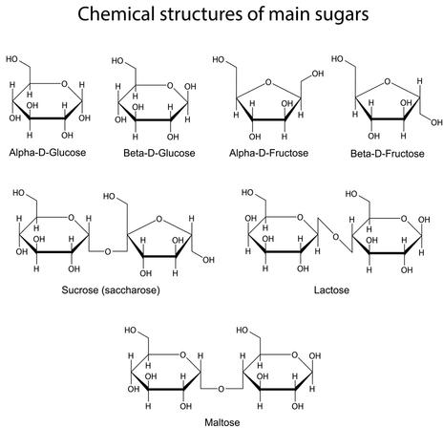
Polysaccharides are polymers, or long chains of sugar monomers linked together, and they are stored inside the cell for future energy use. In plants, the major storage polysaccharide is starch, while in animals it is glycogen. Plants also contain cellulose, which is the most abundant of all carbohydrates. Cellulose is the found in the plant cell wall, where it provides structure and support to the plant cell.

Lipids

Lipids are nonpolar macromolecules; thus they are insoluble in water. They include oils and fats, phospholipids, and steroids. Fats and oils are triglycerides, and are composed of glycerol and 3 fatty acids. A fatty acid is a long chain of carbon-hydrogen (C-H) bonds, with a carboxyl group (-COOH) at one end. Fatty acids can be classified as saturated or unsaturated. Fatty acids are saturated when they do not contain any double bonds between the carbons, and unsaturated when they contain double bonds. An example of a saturated fat is butter, while an example of an unsaturated fat is vegetable oil.
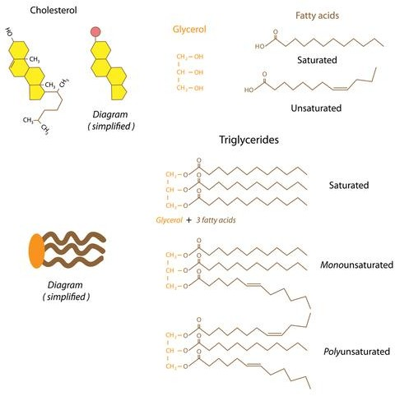
Phospholipids are found primarily in the cell membranes of living systems, of which they are the major component. Structurally, a phospholipid contains a hydrophilic head and a hydrophobic tail. The head of the phospholipid contains a phosphate group, while the tail is typically a diglyceride. The cell membrane is a double layer of phospholipids, in which the tails are turned inwards and the heads are exposed to the intracellular and extracellular environments.

Steroids are lipids which are typically made up of fused hydrocarbon rings. Each type of steroid is different in the type of chemically active functional groups that it contains. Examples of steroids include cholesterol, estrogen, and testosterone. Cholesterol in found in the cell membrane of animals, where it provides structural support.
Cholesterol is also the precursor for other steroids, such as testosterone and estrogen. Some vitamins, such as Vitamin D, are also classified as steroids.

Proteins

Proteins are polymers of amino acids. Amino acids are small molecules that contain an amine (-NH₂), a carboxyl acid (-COOH), and a side chain (R). There are twenty naturally occurring amino acids, and each amino acid has a unique side-chain or R-group. Amino acids are connected by peptide bonds to form protein polymers. This gives rise to different levels of structure for proteins. The primary (1°) structure of a protein is a made up of a string of amino acids connected via peptide bonds. The secondary (2°) structure of a protein is formed by the coiling and folding of the 1° structure, due to hydrogen bonding. At this level, structures called alpha-helices and beta-sheets are visible. The tertiary (3°) structure of a protein is formed by interactions between the components of the 2° structure. Some proteins have quaternary (4°) structure, which includes the assembly of multiple individual subunits to form the functional protein.

Proteins have numerous biological functions. The common types of proteins that are found in biological systems are enzymes, antibodies, transport proteins, regulatory proteins, and structural proteins.

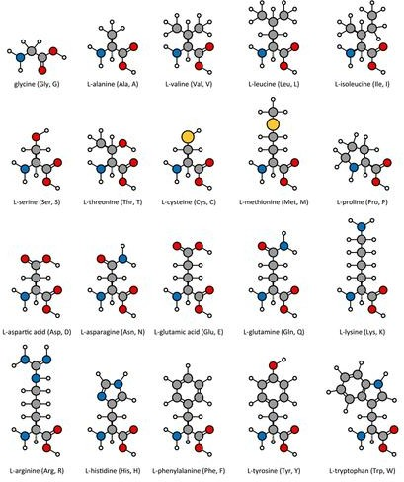

Part 1: Testing for simple sugars
Benedict’s solution turns orange-brown in the presence of simple sugars
Test samples: distilled water, glucose, starch, orange juice, regular soda, diet soda, unknown
*Shake the starch before using it.
- Fill a beaker about halfway with water and bring it to a gentle boil on the hot plate
- Label tubes
- Add ~2 ml sample to the tube (~0.5 inch)
- Add ~2 ml (0.5 inch) Benedict’s solution and swirl to mix. Record the color in table below
- Put the tube in the water and heat for 3 minutes.
- Use test tube clamps to remove tubes from heat and record color.

**Dispose of waste in waste beaker**

tube | sample | initial color | color after heat | conclusion
1 | water
2 | glucose
3 | starch
4 | orange juice
5 | regular soda
6 | diet soda
7 | unknown

Part 2: Testing for starch
Lugol’s reagent (IKI solution) turns dark blue/black in presence of starch
Test samples: distilled water, glucose, starch, orange juice, regular soda, diet soda, unknown
*Shake starch before using
- Label tubes
- Add ~3 ml samples (~0.75 inch) and record color in chart.
- Add 9 drops Lugol’s reagent and swirl to mix.
- Record color in table below.

tube | sample | initial color | color after IKI | conclusion
1 | water
2 | glucose
3 | starch
4 | orange juice
5 | regular soda
6 | diet soda
7 | unknown

Part 3: Testing for lipids
  - Paper test
Paper turns translucent (gets a grease spot) in presence of lipids
Test samples: distilled water, vegetable oil, cream, and unknown.
    - Put a drop of each substance on a brown paper towel. Rub in the cream.
    - Put the towel off to the side and let it sit for 10 minutes.
    - Record the appearance of the bag where you placed the spots in the table below.

sample | appearance after drying | conclusion
water
oil
cream
unknown

Sudan IV test
Two layers form in presence of lipids. Red dye concentrates in top layer.
Test samples: distilled water, vegetable oil, cream, and unknown.
    - Label tubes
    - Add 3 ml (0.75 inch) distilled water to each tube
    - Add 3 ml (0.75 inch) of sample to the tube (total of 6 ml per tube)
    - Add 9 drops of Sudan IV and shake (must mix well)
    - Add 2 ml (0.5 inch) water
    - Record results in the table below

tube | sample | appearance after Sudan IV | conclusion
1 | water
2 | oil
3 | cream
4 | unknown

Part 4: Testing for proteins
Biuret’s reagent turns dark blue-purple in presence of peptide bonds
Test samples: distilled water, starch, egg albumin, glucose, regular soft drink, unknown
*Shake starch before using
- Label tubes
- Add 1 ml (0.25 inch) sample to tube
- Add 10 drops Biuret’s and swirl to mix
- Wait 2 min, then record color

**Dispose of Biuret waste in container**

tube | sample | initial color | color after Biuret | conclusion
1 | water
2 | starch
3 | egg albumin
4 | glucose
5 | regular soda
6 | unknown

Unknown
Look back over the results for the unknown sample from each of the previous tests. Based on the data, what combination of macromolecules is present in the unknown mixture?

Questions
  - The monomers that make up carbohydrates are:

  - The monomers that make up proteins are:

  - Which test could you use to distinguish between diet and regular soda? What would the test detect?

  - What is the Biuret test actually detecting? Be as specific as possible.

  - Each test included a sample that was just water. Why is it important to include a water-only sample for each test?

