Risk Management in Sport
Developing and implementing risk management strategy is one of the most important tasks of the Sports Administrator. In some cases this task maybe just a matter of following on from the good work done by previous administrators while in other cases the work has to start from scratch.
The following is a list of common strategies that should be present in any risk management program:
- Ensuring coaches are appropriately accredited under the national coaching accreditation scheme.
- Ensuring that the club/organisation has people with first/aid training on standby when events are occurring.
- Maintaining playing facilities (pitches, courts, indoor halls, etc) at a high level to reduce hazards
- Creating an emergency management plan i.e. who does what if an emergency occurs
- Enforcing rules about the wearing of personal safety equipment or protective equipment (e.g. cricket helmets) in sports where this is applicable
- Implementing rules and procedures for inclement weather
- Provision of training in risk management to club/organisation administrators
- Using health/medical surveys to screen new membership
- Checking sports equipment is in good working order where this is applicable
- Matching participants/teams in terms of body dimensions, age and or level of skill.
Structure of an event management team

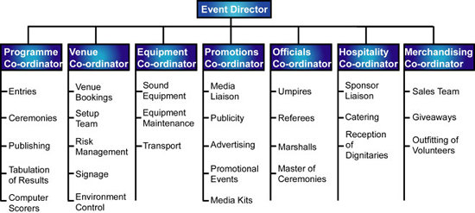

Typical event expenditure
Travel and Accommodation | Costs associated with officials needed to run the event may have to be borne by the event organisers. Event participants are generally responsible for their own travel and accommodation costs. In minor or local events travel and accommodation costs are unlikely.
Trophies, Awards | The cost of medals, trophies and other awards requires detailed knowledge about the number of competitors, the categories of divisions of the competition and the format of the competition.
Salaries | Applies only events are organised by professional staff.
Postage and telephone | Events usually require considerable communications with participants and the event management team.
Stationery and Photocopying | Special event stationery may be printed but otherwise there is always a lot of photocopying and usage of organisation letterheads to write correspondence.
Medical Fees | Events require persons with at least First Aid training to be in attendance. Larger events may also warrant the employment of a doctor and physiotherapists.
Venue Hire | A critically important aspect of the budget. Information about the probable cost of the venue needs to be obtained as early as possible. Beware that there some hidden costs such as security and supervision costs, and heating and lighting costs.
Insurance | Additional insurance can be taken out to cover risks of injury and/or financial losses associated with events.
Printing | Event programmes, posters, fliers and other promotional documents may need to be printed - especially where quality and colour is required.
Promotion | Expenditure on promotion may be considerable where a significant proportion of the event revenue is likely to be earned through spectators. Promotion covers items such as advertising, give-aways, costs associated with promotional events and sponsors' signage.
Equipment Hire | Includes equipment directly used by participants in the event and also any equipment used by the event management staff including sound systems, computers, mobile phones, two way radios, etc.
Transport | Includes costs of transporting equipment and hire of buses.

