Summer Mastitis

Causes:

Summer mastitis is a term for the type of mastitis which tends to occur during the warmer summer months in dry cows and heifers at pasture. It differs from other types of mastitis in several ways and is not classed under contagious nor environmental origin. It is also known as ‘August Bag’.

Essentially it is caused by bacteria and spread by flies.
The main vector for the causal pathogens is the sheep head fly, Hydrotaea irritans. There are various bacteria that can cause summer mastitis, usually working in synergy. The most significant are Streptococcus dysgalactae and
Arcanobacterium pyogenes.

The flies live in bushes and trees, can only fly during mild, damp, humid conditions and cannot fly in high wind speeds. Pastures surrounded by wooded areas or high hedgerow are the usual factors which predispose a certain area to become problematic with head fly. Rivers and streams are also important reservoirs for flies.

The exact means of infection is not entirely understood. It is likely to be more complex, with a mixture of routes and other anaerobic bacteria such as Peptococcus indolicus implicated in this.

In addition to potential external routes of infection via skin or teat canal, particularly if damaged, there is possibility of infection originating internally with bacteria spreading from other parts of the body, via the blood, into the udder. Once a quarter is affected, spread can then occur via infected material between quarters and even between animals.

Summary:
· Occurs in summer
· Spread by flies
· Affects dry cows, heifers and young calves
· Acute disease of the non-lactating mammary gland
· Caused by many bacteria, of which a few are usual suspects – e.g. the Sheep Head Fly

Symptoms

Initial symptoms are…
· Swollen and painful teat/quarter
· Flies particularly gathering on one teat/quarter
· Foul-smelling yellow/green discharge
· Enlargement in length and diameter of the affected teat
· Frequent kicking at the udder

The affected quarter is swollen, hard, painful and hot, with a grossly enlarged teat. The udder secretion is thick and clotted (like grains of rice) with foul-smelling green/yellow pus. Affected animals may abort and may die if prompt treatment is not administered. Even after prompt treatment, the affected quarter is permanently damaged.

Illness leads to the birth of weakly calves which have a high
mortality rate. Colostrum from another cow is strongly recommended for these calves.

Advanced signs, particularly when the infection becomes systemic, are…
· Swelling of the hind legs and joints
· Lethargy
· Loss of body condition
· Separation, anxiety and isolation
· Abortion
· Death

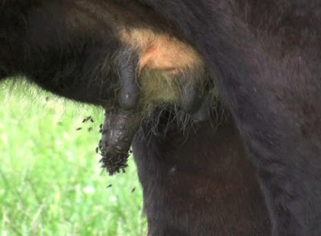

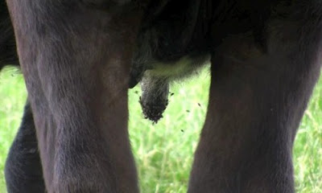

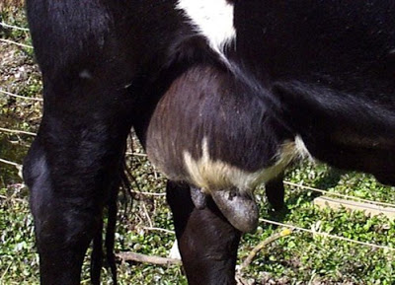

Summary:
· Look out for isolated animals that appear lame, anorexic or dull.
· Swollen teats and quarters
· Congregation of flies on one particular quarter
· Thick foul smelling discharge

Treatment and Control

Very few mastitis affected quarters will recover, so any treatment is purely salvage and the main goal should be to avoid the disease, or at least minimise its incidence. The main problem with treatment is that often the disease has already progressed to a stage at which it cannot recover from by the time the stockman has noticed the presence of the disease.

Treatment is most often via regular and repeated stripping of the affected quarter, to remove as much affected material as possible, followed by intra-mammary antibiotics and an antibiotic injection to counter the systemic effects of the bacterial toxins. Heifers and cows with summer mastitis are best isolated to prevent the spread of the illness.

Your veterinary surgeon will consider various drugs including parenteral antibiotic injections such as procaine penicillin, potentiated sulphonamides or tylosin, and intramammary antibiotics (penicillin or intramammary erythromycin tubes).
Non-steroidal anti-inflammatory drugs (NSAID injections) for three consecutive days reduce pyrexia, swelling and pain; corticosteroids reduce joint effusions much more effectively but will induce abortion and therefore should not be used.

Stripping of the udder should be undertaken as often as is practical but is resented by the animal due to the painful and oedematous teat/gland and kicking is common.

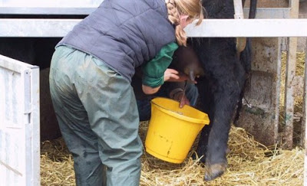

Amputation of the affected teat is often requested by farmers to facilitate drainage but there is the risk of considerable haemorrhage and the teat amputation site rapidly seals over.

Summary:
· Antibiotics to combat infection
· Anti-inflammatories to counter swelling and reduce temperature
· Applying fly control
· Strip affected quarter

Prevention
· Having effective dry cow therapy, including the use of long-term intra-mammary antibiotics, teat end sealants and good hygiene measures at drying-off. In some circumstances, intra-mammary antibiotics may require re-administration during the dry period, although care should be taken with the milk withdrawal periods.
· Implementing measures to control and minimise exposure to flies. Flying insects should be controlled from early on in the fly season by the use of pour-on anti-parasitic treatments, the use of fly ear tags, and the application of teat fly repellents to teats.
· Maintaining good teat condition pre-drying off, having good dry cow nutrition and observing/checking cattle on a regular basis.
· Avoiding areas where the flies are particularly active. This includes pastures near and kind of water source, high hedges or next to forests/woods.

Dry cow therapy remains the most effective means of preventing summer mastitis both in cows at drying-off, and in susceptible pregnant heifers during the summer months. As a general rule, the longer duration dry cow antibiotic preparations should be used but only after consultation with your veterinary surgeon. In herds with a severe summer mastitis challenge re-tubing cows, or more commonly at-risk heifers, at three week intervals has proven successful but is considered cost-prohibitive in beef cattle. Care must be exercised when infusing intramammary antibiotic preparations in heifers whereby the nozzle of the tube is held at the teat orifice, but not forced into the teat canal lest damage occurs. The teats must be swabbed with surgical spirit before tubing and a teat dip used afterwards. Cattle should not be tubed in wet weather or in unhygienic conditions because of increased risks from introducing infection into the udder. If in any doubt, consult your veterinary surgeon regarding this important aspect of dry cow management.

For more information on drying cows off before calving, visit my blog post on dry cow therapy *follow this link*

Summary:
· Long-lasting antibiotic cover when drying cows off
· Repeat infusions for susceptible cows
· Good aseptic hygiene when milking and when drying off
· Teat sealants can be used as a physical barrier
· Impregnated fly tags, pour on solutions; avoid high fly population fields

· Make fields less habitable for flies.

