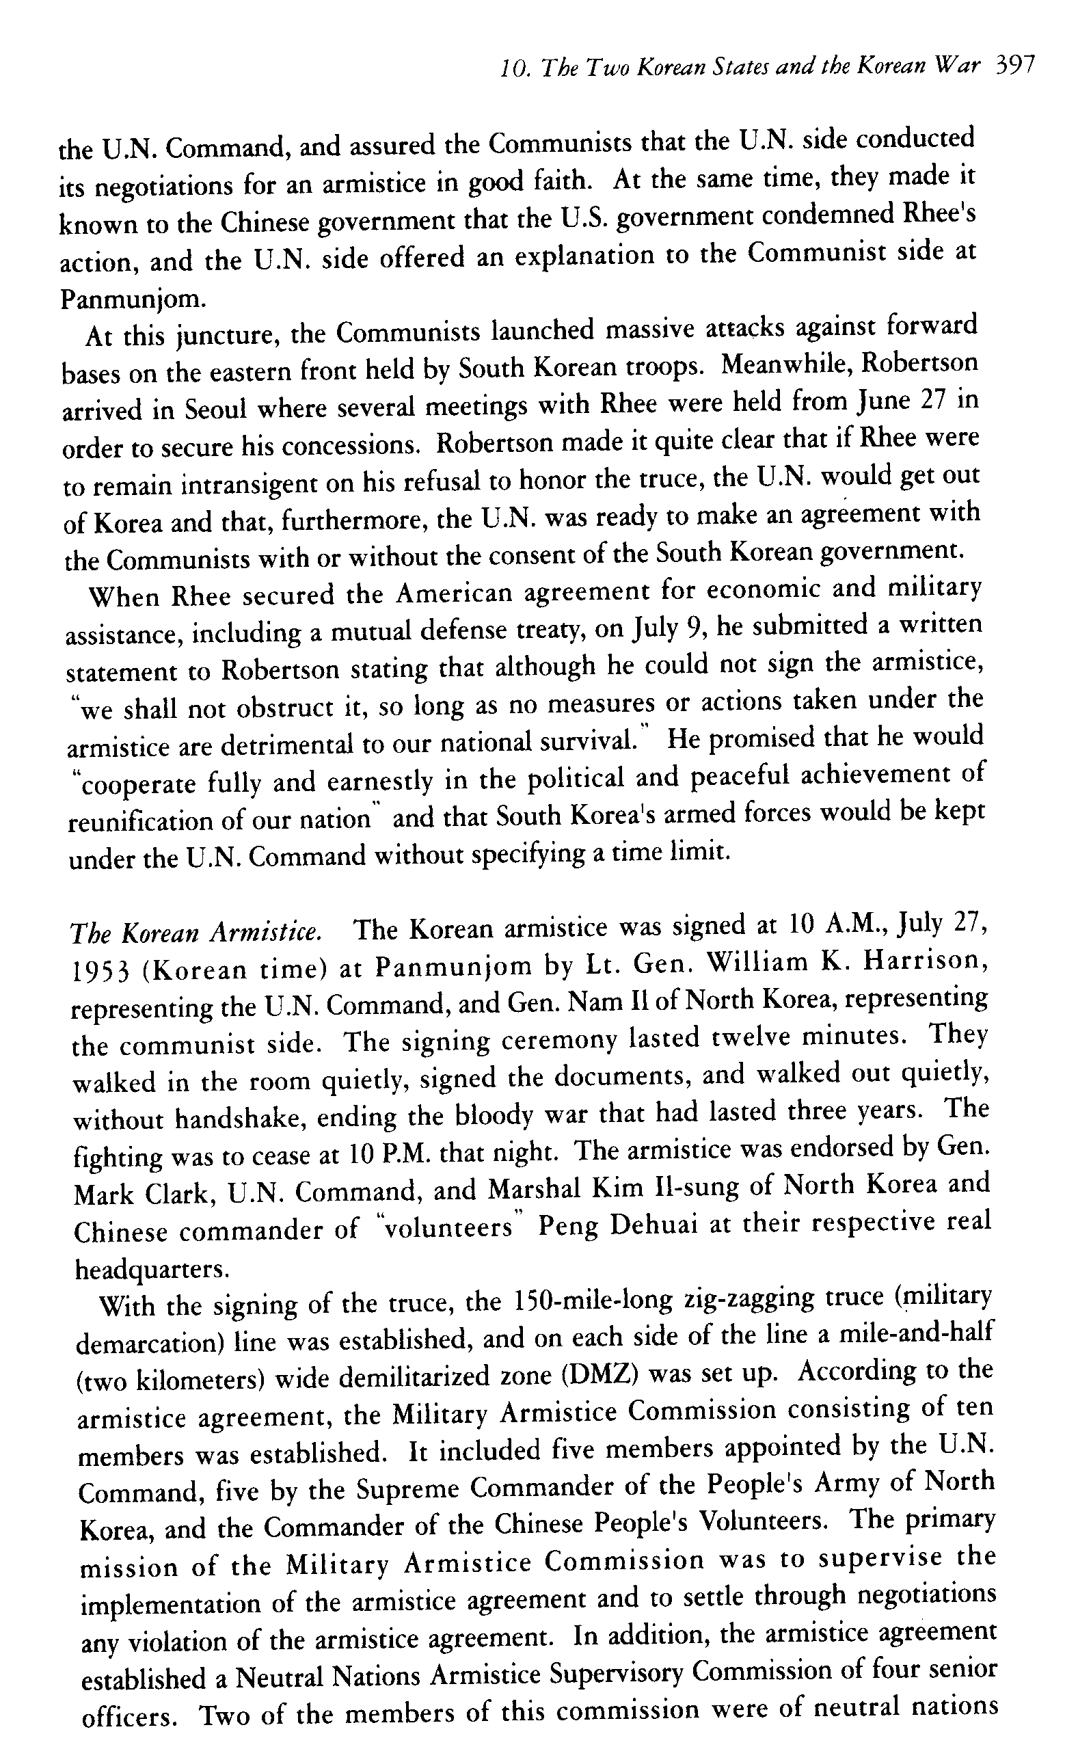
Resim 1 Nahm, A. C. 2004. Korea: Tradition and Transformation - A History of the Korean People.Seoul: Hollym
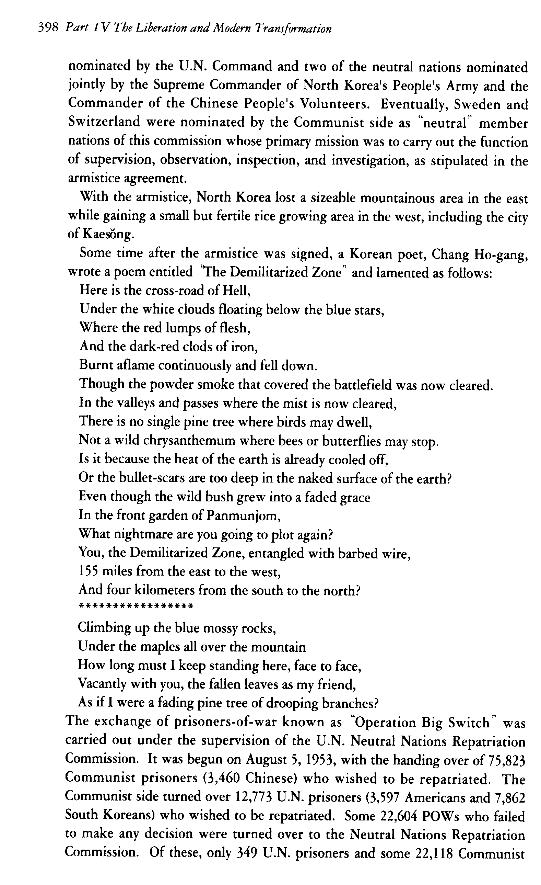
Resim 2 Nahm, A. C. 2004. Korea: Tradition and Transformation - A History of the Korean People.Seoul: Hollym
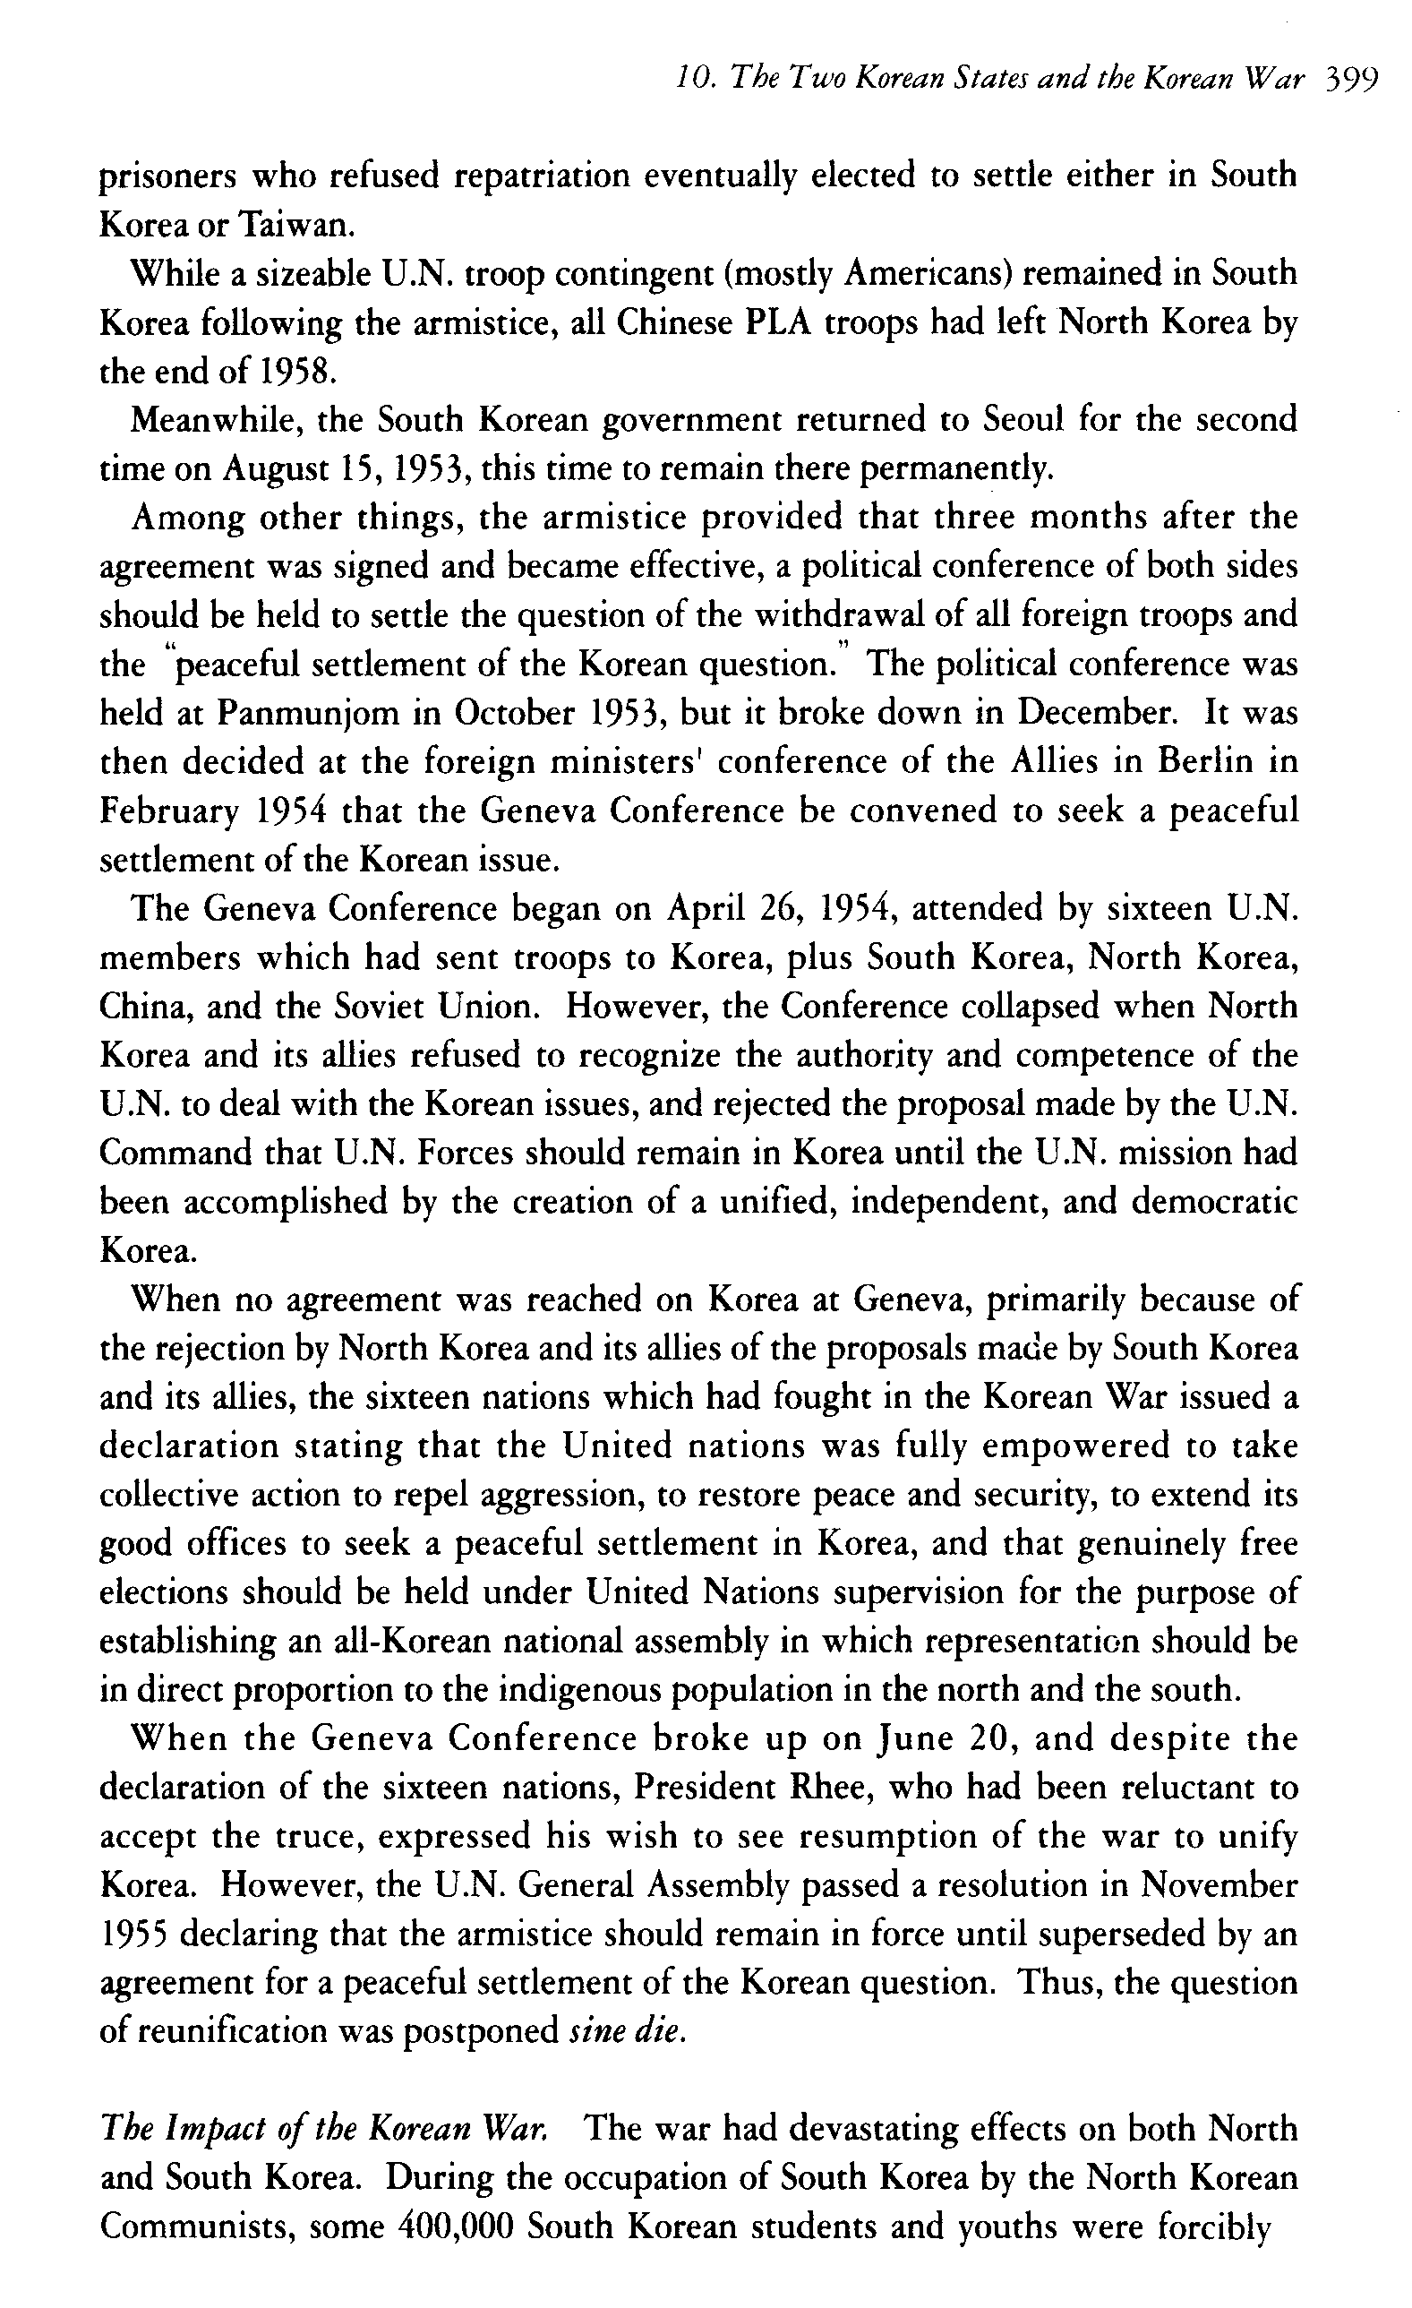
Resim 3 Nahm, A. C. 2004. Korea: Tradition and Transformation - A History of the Korean People.Seoul: Hollym
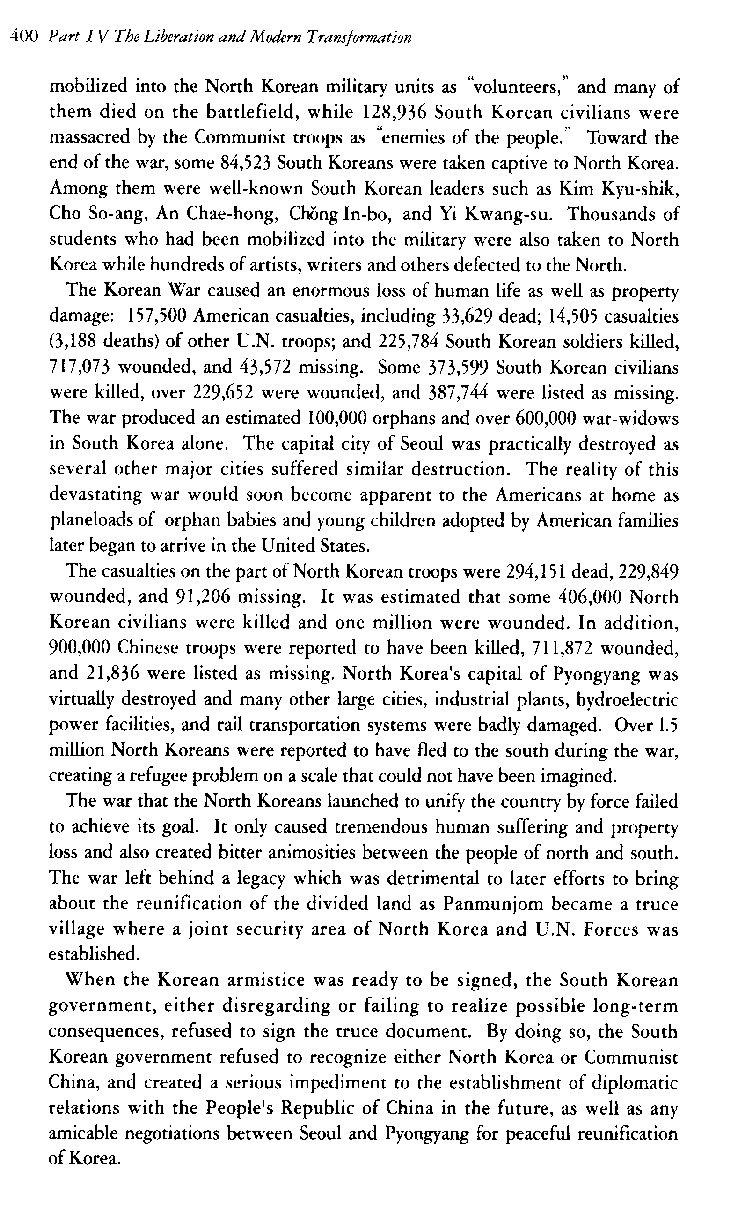
Resim 4 Nahm, A. C. 2004. Korea: Tradition and Transformation - A History of the Korean People.Seoul: Hollym

