PRESENT SIMPLE AND PRESENT CONTINUOUS
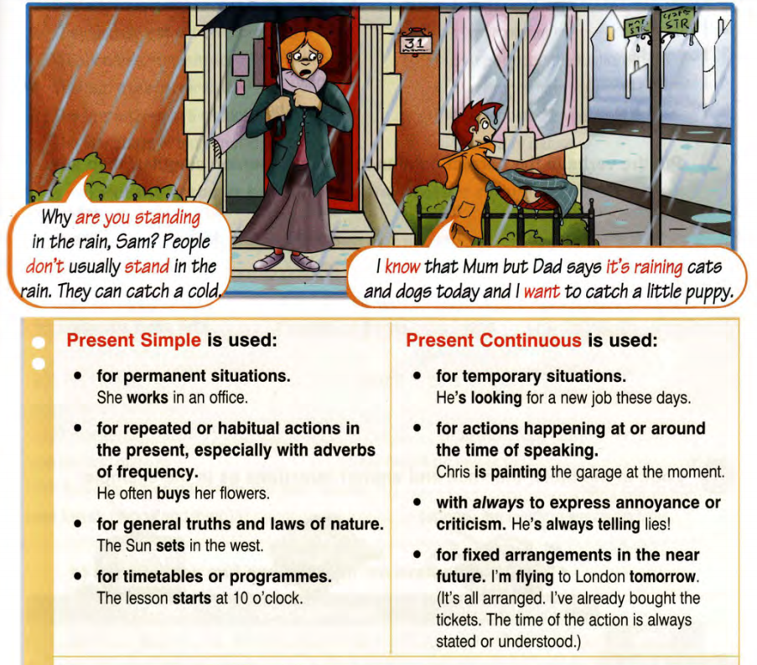
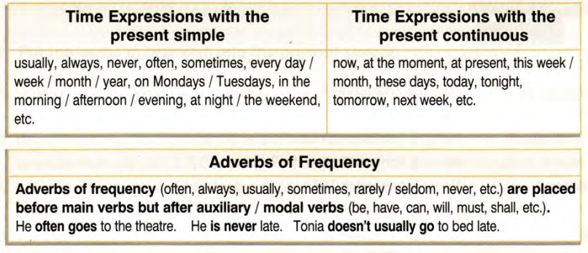
Referans: http://elibrary.bsu.az/books_250/N_124.pdf
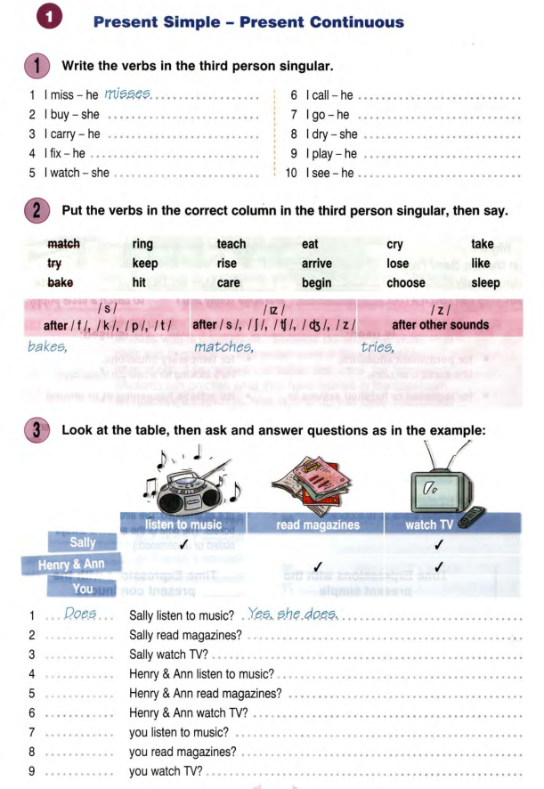
Referans: http://elibrary.bsu.az/books_250/N_124.pdf
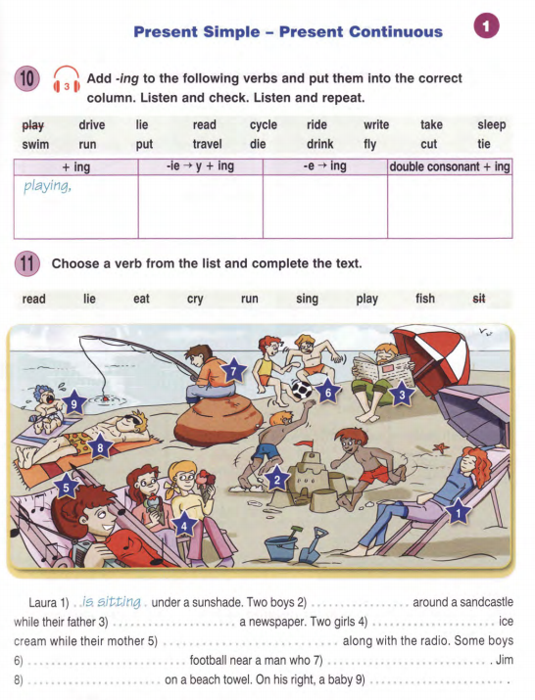

Referans: http://elibrary.bsu.az/books_250/N_124.pdf

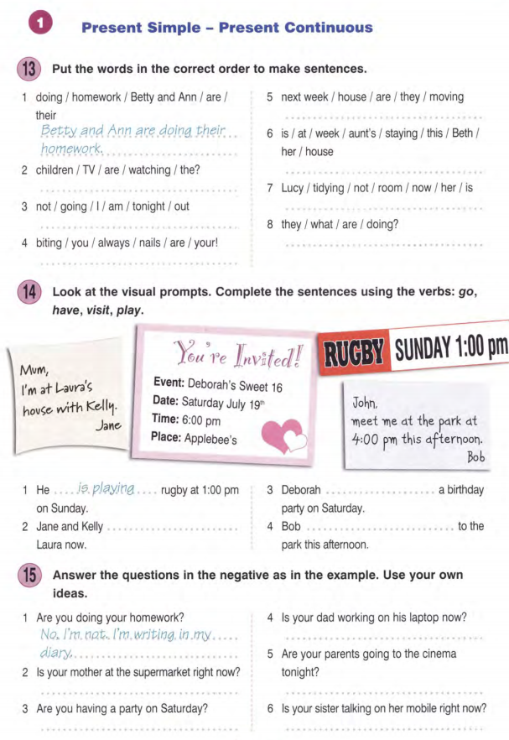
Referans: http://elibrary.bsu.az/books_250/N_124.pdf

