AQUACULTURE-II
INTRO
There is now little doubt that the world’s fisheries are in crisis. Mounting scientific evidence points to dramatic declines in global catches.1,2 Increasingly, many are making the case that farming fish offers a solution to meeting the growing demand for seafood that catching fish cannot provide. Aquaculture now accounts for roughly one-third of the world’s total supply of food fish and undoubtedly the contribution of aquaculture to seafood supplies will increase in the future. Aquaculture has the potential to become a sustainable practice that can supplement capture fisheries and significantly contribute to feeding the world’s growing population. However, instead of helping to ease the crisis in wild fisheries, unsustainable aquaculture development could exacerbate the problems and create new ones, damaging our important and already-stressed coastal areas.
The vast majority of aquaculture takes place in Asia. In 2002, over 70% of worldwide aquaculture production was in China alone.3 Most farmed fish and shellfish are grown in traditional small-scale systems that benefit local communities and minimize the environmental impact. Utilizing simple culture technologies and minimal inputs, these systems have been used for centuries. The net contribution of these traditional aquaculture systems can be great as they offer many benefits, including food security in developing nations.
However, as happened with the “green revolution” of agriculture in the last century, the current “blue revolution” of aquaculture is becoming an industrial mode of food production. An emerging trend is toward the increased development of farming high-value carnivorous fish species using environmentally and socially damaging systems. Farming fish on an industrial scale, especially carnivorous fish is rapidly expanding; the number of different species farmed and geographic regions where they are farmed increases continually. Largely controlled by multinational corporations, industrialized farming of carnivorous fish such as salmon requires the intensive use of resources and exports problems to the surrounding environment, often resulting in environmental impacts and social conflicts.
Some segments of the aquaculture industry are long overdue for reform. What is required is a paradigm shift in how we think about aquaculture, particularly its interaction with natural and social systems. This new paradigm should be based on sustainable development—“the management and conservation of the natural resource base, and the orientation of technological and institutional change in such a manner to ensure the attainment and continued satisfaction of human needs for present and future generations. Such development conserves land, water, plant and genetic resources, is environmentally non-degrading, technologically appropriate, economically viable and socially acceptable.”4 Sustainable aquaculture must consider the ecological, social, and economic aspects of development (Figure 1).
4
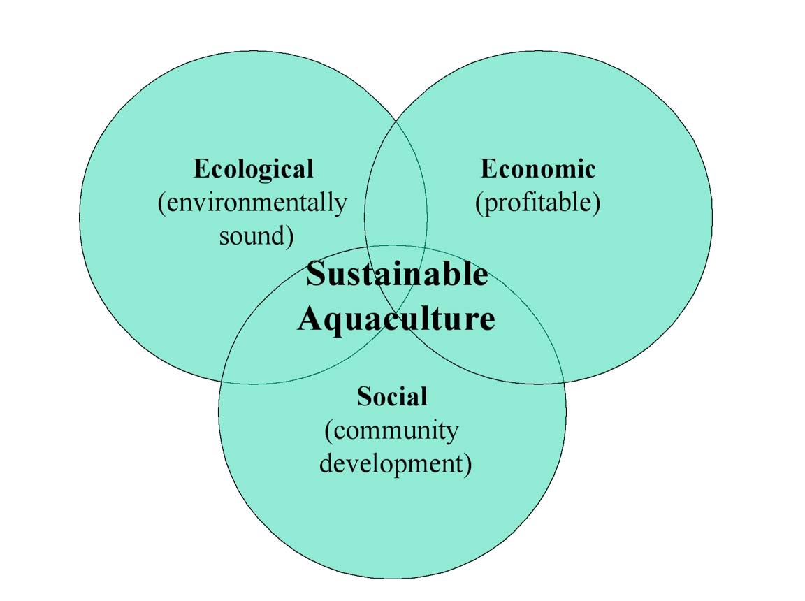
Figure 1: Elements of sustainable aquaculture.
BACKGROUND
Historical overview
As defined by the United Nations Food and Agriculture Organization (FAO), aquaculture is the “farming of aquatic organisms including fish, molluscs, crustaceans and aquatic plants. Farming implies some sort of intervention in the rearing process to enhance production, such as regular stocking, feeding, protection from predators, etc. Farming also implies individual or corporate ownership of the stock being cultivated...” Aquaculture is the fastest growing sector of the world food economy, increasing by more than 10% per year and currently accounts for more than 30% of all fish consumed.
While the world community has only recently viewed aquaculture as a potential solution to the dilemma of depleted oceans, it is by no means a new practice. In fact, the advent of aquaculture dates back millennia, though its exact origins are unknown. It most likely grew out of necessity – foraging and hunting were not sufficient to provide a stable source of food to local communities. While there are many parallels to agriculture, the development of aquaculture has progressed more slowly than terrestrial farming because of the unfamiliar nature of the ocean terrain and characteristics of aquatic organisms.5
5
A large proportion of organisms that humans rely on for protein and sustenance come from the sea. Currently, approximately 16 percent of animal protein consumed by the world’s population is derived from fish, and over one billion people worldwide depend on fish as their main source of animal protein.6 Worldwide consumption of fish as food has risen from 40 million tons in 1970 to 86 million tons in 1998.7
Once thought of as an abundant, inexhaustible resource, the world ocean faces a significant loss of essential diversity. This loss is occurring at an alarmingly rapid rate, due to the combined effects of overfishing, habitat destruction, pollution, and profound ecological and biotic change caused by global warming as well as the human-mediated transfer of marine organisms. According to the FAO “About 47 percent of the main stocks or species groups are fully exploited and are therefore producing catches that have reached, or are very close to, their maximum sustainable limits."8 Clearly, additional means of producing fish must be developed in order to maintain a sufficient supply of food for an ever-growing population. Aquaculture offers one way to supplement the production of wild capture fisheries and it will continue to increase in importance as demand increases in the future.
It was not until after World War II that aquaculture gained much attention as a potentially large- scale industry. A shift in economic conditions in developed nations of the world led to an increase in the demand for fish such as salmon, shrimp, eels, and sea basses, all of which can be produced profitably through aquaculture.9 In the 1960’s, aquaculture became a significant commercial practice in Asia where it had mainly been used as a small-scale means of local community food production for thousands of years.10 In the last few decades, worldwide aquaculture production has increased significantly. In 1970 aquaculture operations composed 3.9 percent of all fish production, compared to 27.3 percent in 2000. Worldwide, total fish production from aquaculture operations has increased steadily at a rate of 9.2 percent per year.11 But, aquaculture has not yet become the large-scale global food replacement for the numerous food-poor areas of the world, as many thought it would be.
Environmental costs
Like other forms of intensive food production, industrial-scale fish farming generates significant environmental costs. These depend on a number of factors and are rarely evaluated before farming begins or before operations are expanded. In presiding over the rules and regulations that govern the establishment of aquaculture ventures, many governments have largely overlooked the environmental problems that may arrive with the advent of large-scale fish production.
The expansion of some forms of aquaculture, particularly salmon and shrimp farms, has proven to be destructive to the natural environment and populations of aquatic animals.12,13,14,15,16 Industrial scale farming of salmon in netpens and shrimp in coastal ponds are the most problematic because they require the intensive use of resources and export problems to the surrounding environment. Unless significant changes are made, the increasing production of high value carnivorous fish promises to be just as unsustainable.17
6
There are environmental concerns with other systems, such as inland ponds, flow-through systems, and closed systems, but they generally have fewer environmental problems overall, especially when properly managed. For a brief overview of the major environmental implications of the different systems, as well as the species commonly cultured in each, please see Appendix I.
Social conflict
The advent of industrial aquaculture has not only been a source of environmental concern, it has also been a source of social concern.18 Intensive practices used by some in the aquaculture industry pose significant threats to traditional, community-centered societies. Shrimp, for example, is a highly valued species in such regions as the United States, Japan, and Europe. However, it is mostly farmed in tropical areas, with production controlled by multinational corporations. Because shrimp production yields such a high profit, foreign or non-local individuals tend to exploit the areas where they can best be grown, without regard for the environmental or social implications, and then market them elsewhere, taking the profits as well as the product out of the region. The ecological impacts of large-scale shrimp production can leave the farming area unsuitable for small-scale production, damage local fisheries, and as a result damage the local economy.19,20
Finfish farming, especially salmon, has been promoted as a means of generating socioeconomic benefits in rural coastal areas. As farming methods have become more intensive, however, employment opportunities have declined. For example, according to the Norwegian government, between 1994 and 2000 the number of people employed raising salmon from hatcheries to harvest declined by 18% while production more than doubled.21 Additionally, as the industry attempts to further reduce costs and increase profits, it likely will become more sophisticated and employment will continue to decline. The industry has also impacted coastal communities where salmon are fished commercially. This became evident in the 1990’s as salmon farms in Chile took advantage of cheap labor to grow and export large quantities of farmed salmon, depressing the prices paid to commercial salmon fishermen in the United States and Canada. Partly as a result, many fishermen along the Pacific Coast of North America lost significant sums of money or went out of business. Between 1990 and 2002, the number of commercial salmon fishermen in Alaska declined from 10,487 to 6,567 and the value of the salmon harvest fell from $559 million to $130 million in 2002.22
Making improvements
Recently, governments and industry have made efforts to curb unsustainable aquaculture activities.23,24,25,26,27 Many have realized that the focus of aquaculture must evolve into the development of an industry that is both environmentally and socially sustainable in the long term.28,29,30,31,32 Positive changes are being made with this growing interest and awareness of improving the sustainability of aquaculture. With the expected expansion of aquaculture in the coming years it will be vital that sustainable practices be implemented and further developed to avoid environmental and social problems.

