Evaluation of Transfer Coefficients: Engineering Correlations
FLOW NORMAL TO A SINGLE CYLINDER

- Friction Factor Correlations
Lapple and Shepherd at 1940 studied on a model for cross flow over an infinitely long circular cylinder. They presented their results in the form of the friction factor “f” as a function of the Reynolds number.
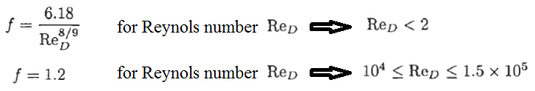
The friction factor “f” is based on the projected area of the cylindrical object with a diameter D. The Reynolds number can expressed as folowings for the flow normal a single cylindrical object.
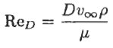
Tosun and Akşahin at 1992 worked on a proposal, includig the whole range of the Reynolds number. Hence, the correlation given below covers the whole range of the flow condition. The friction factor correlation as a function of the Reynolds number is given below:
The drag force can be calculated using the friction factor with the following correlation, known as the drag force equation:
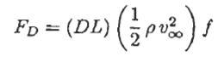
Example: A cylindrical object has an outside diameter of 0.4 m and a height of 10 m. Calculate the drag force exerted by air on the column if the wind speed is 5 m/s.

Solution:
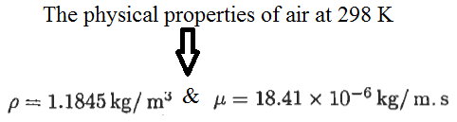
The reynolds number can be calculated using the following correlation:
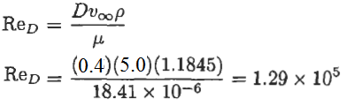
The friction factor “f” can be calculated using the “Tosun and Akşahin” correlation given below:
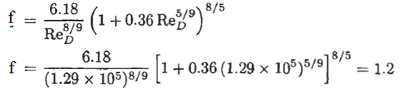
Hence, the drag force can be calculated using the drag force correlation given below:
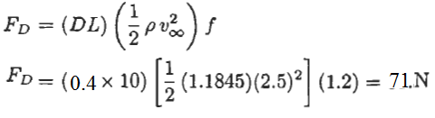
- Heat Transfer Correlations
For the steady-state conduction from a spherical object to a stagnant fluid medium, the Nusselt “Nu” is equal to 2. Hence, we can state that as the Reynolds number goes to zero, the average Nusselt number also approaches to zero as well.
For the case of a single cylindrical object, there is no solution for the case of steady-state conduction. The following correlations were studied for the case of convective flow normal to infinite length cylindrical object.
- Whitaker correlation
Whitaker at 1972 proposed a correlation in the form as shown below:
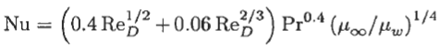
This correlation is valid for the given conditions stated below:
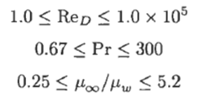
- Churchill-Bernstein correlation
Churchill and Bernstein at 1977 proposed a single comprehensive correlation, covering the entire range of the Reynolds number:
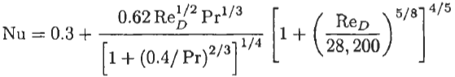
All properties needs to be evaluated at the film temperature. This correlation is valid for the given conditions stated below:
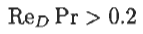
- Calculation of the heat transfer rate
After the average heat transfer coefficient is calculated using the given correlations above, the
rate of heat transferred needs to be calculated using the equation given below:
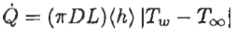
- Mass Transfer Correlations
Bedingfield and Drew at 1950 proposed a correlation for mass transfer for cross-flow and parallel-flow of gases to the cylinder:
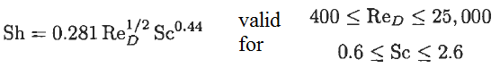
Linton and Sherwood at 1950 proposed a correlation for mass transfer for cross-flow and parallel-flow of liquid to the cylinder:
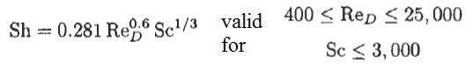
- Calculation of the mass transfer rate
After the average mass transfer coefficient “kc” is calculated using the given correlations above, the rate of mass transferred needs to be calculated using the equation given below:
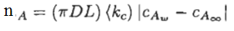
References:
İ. Tosun, “MODELLING IN TRANSPORT PHENOMENA A Conceptual Approach”, Elsevier, 2002.

