Sylvia Plath Briefly
(1932-1963)

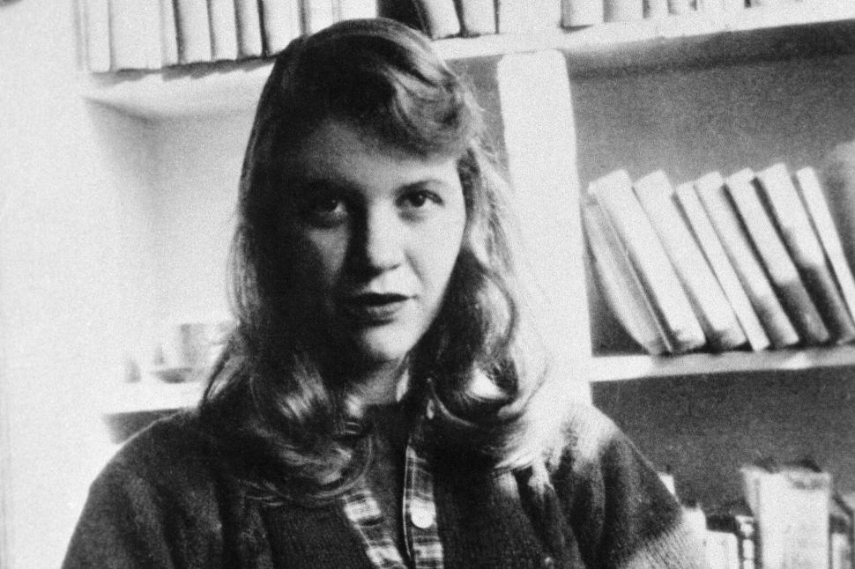

- Plath was one of the most well-known poets of the twentieth century.
- Though she lived a very short life and did not have enough time to write, she had a serious body of admirers in her life time.
- Joyce Carol Oates described Plath as “one of the most celebrated and controversial of postwar poets writing in English.”
- Her poetry was confessional and autobiographical.
- Her marriage to Ted Hughes should have been a blissful event as Hughes was her equivalent in British poetry.
- She went through a number of nervous breakdowns and attempted to kill her herself more than once until she finally succeeded.
- She wrote fiction as well.
- For more https://www.poetryfoundation.org/poets/sylvia-plath

