Collection and Analysis of Raw Data
It is aimed to focus on ways of obtaining and analyzing reaction rate data to get the rate law
for a specific reaction. Especially, two common types of reactors have been studied for obtaining rate data:
- The batch reactor, used primarily for homogeneous reactions,
- The differential reactor, used for solid-fluid heterogeneous reactions.
By using batch type of reactor, certain experimental variables like concentration, pressure, and/or volume have been measured and recorded at different times during the reaction. Experimental data are collected from the batch reactor during transient operation. On the other hand, experimental measurements on the differential reactor have been performed during steady-state operation.
- Batch Reactor Data: Batch type of reactors are used mainly to obtain the rate law parameters for homogeneous reactions. It means that the concentration within the batch reactor is measured as a function of time. Afterwards, the reaction order and the specific reaction rate constant “k” will be calculated using either the differential, integral or nonlinear regression method of data analysis.
Let’s consider an irreversible reaction between two reactants:
A + B → C + D
With a proposed reaction rate law as following:
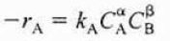
Where α is the reaction order of reactant A and β is the reaction order of the reactant B. Both of them are unknown. In addition, k_{A} is the reaction rate constant. Total reaction order is equal to α+β.
The reaction could first be run in an excess of the reactant B so that the concentration of the specified reactant remains essentially unchanged during the reaction. Hence, the reaction rate can be written as following:
After determination of the reaction order of A, the reaction is carried out in an excess of the reactant A so that the concentration of the specified reactant remains essentially unchanged during the reaction. Hence, the reaction rate can be approximated as following:
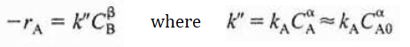
After determination of the reaction order of A and B, the reaction rate constant can be calculated at known concentrations of A and B:
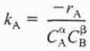
Differential Method of Analysis
For differential method of analysis, a reaction will be carried out isothermally in a constant-volume batch reactor and the concentration will be recorded as a function of time. For this purpose, the rate law and the mole balance equation of the batch reactor will be combined as following:
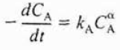
If we take the natural logarithm of both sides of the given equation, we will obtain the following relation:
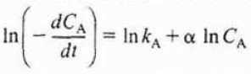
After takin the natural logarithm of the given equation, we will observe that the slope of a plot of In (-dC/dt) as a function of (ln C_{A}) gives us the reaction rate order:

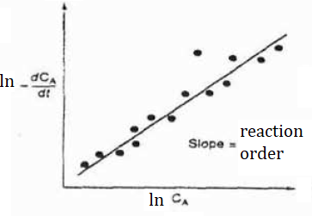
Figure 1. Differential method to obtain the reaction rate order

The reaction rate constant, k, can also be determined using the given graph by choosing the point on the y-axis, which means that we need to determine the point with a value of lnC_{A} = 0 on the graph as following:

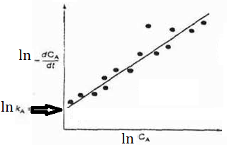
Figure 2. Differential method to obtain the reaction rate constant

Numerical Method
As an alternative, numerical differentiation method can be used when the data points in the
independent variable are equally spaced like:
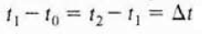
For a given time to concentration measurement:
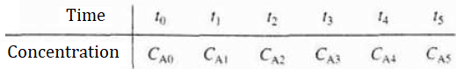
Initial point can be calculated by using the following relation:
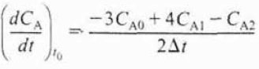
Interior points between the initial point and the last point can be calculated by using the following relation:
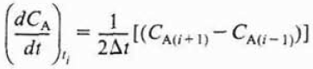
The last point can be calculated by using the following relation:
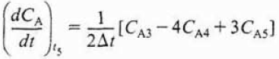
The specified derivation can be used to calculate dC/dt data of the given concentration versus time measurement.

References:
- H. Scott Fogler, “Elements of Chemical Reaction Engineering”, Prentice Hall Professional Technical Reference, Fourth Edition.

