Scientific Method

(Adapted from http://www.biologycorner.com/)

Introduction

The scientific method is central to the study of biology: it is a process of acquiring and verifying information through experimentation. The general steps of the scientific method are depicted in the figure below. The hypothesis, or suggested explanation for the observation, is the basis for setting up
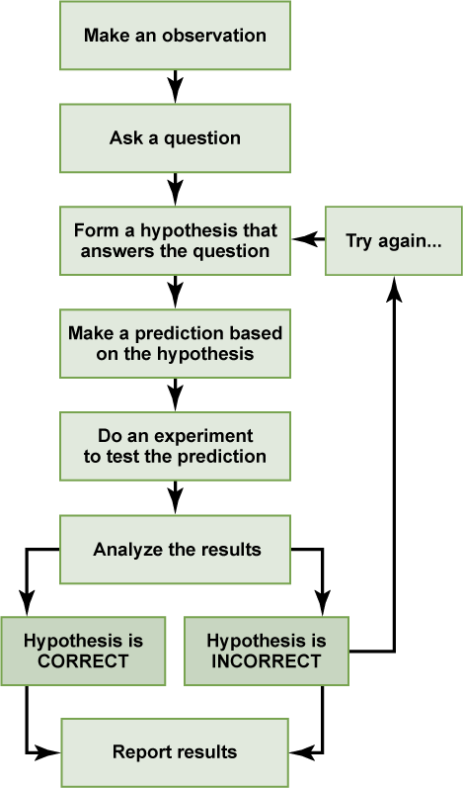
experiments. Good experimental design is essential to the scientific method. A few keys to good experimental design include effective use of controls, reproducibility, a large sample size, and multiple trials. In an experiment, in order to determine that any changes that occur are due to investigator manipulation only, there must be some basis for comparison. A control group is necessary to establish this basis of comparison. In the control group, everything is kept the same as the experimental group except for the independent variable. The experimental group is actually being experimented upon. For example, in a drug trial there will be a group that receives the drug (the experimental group) and a group that receives a placebo (the control group). The drug itself is considered the independent variable and any change(s) that occur because of the drug are considered the dependent variable. In order to ensure that it is only the drug causing changes, all other variables must be tightly controlled (such as diet, exercise, smoking, etc.). These are referred to as controlled variables.

The Scientific Method. Biology. OpenStax College.

Part 1: The Strange Case of BeriBeri

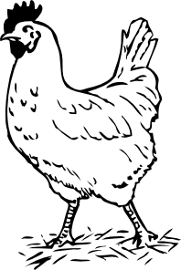
In 1887 a strange nerve disease attacked the people in the Dutch East Indies. The disease was beriberi. Symptoms of the disease included weakness and loss of appetite, victims often died of heart failure. Scientists thought the disease might be caused by bacteria. They injected chickens with bacteria from the blood of patients with beriberi. The injected chickens became sick. However, so did a group of chickens that were not injected with bacteria.

One of the scientists, Dr. Eijkman, noticed something. Before the experiment, all the chickens had eaten whole-grain rice, but during the experiment, the chickens were fed polished rice. Dr. Eijkman researched this interesting case and found that polished rice lacked thiamine, a vitamin necessary for good health.

- State the Problem

- What was the hypothesis?

- How was the hypothesis tested?

- Do the results indicate that the hypothesis should be rejected?

- What should be the new hypothesis and how would you test it?

Part 2: How Penicillin Was Discovered

In 1928, Sir Alexander Fleming was studying Staphylococcus bacteria growing in culture dishes. He noticed that a mold called Penicillium was also growing in some of the dishes. A clear area existed around the mold because all the bacteria that had grown in this area had died. In the culture dishes without the mold, no clear areas were present.

Fleming hypothesized that the mold must be producing a chemical that killed the bacteria. He decided to isolate this substance and test it to see if it would kill bacteria. Fleming transferred the mold to a nutrient broth solution. This solution contained all the materials the mold needed to grow. After the mold grew, he removed it from the nutrient broth. Fleming then added the nutrient broth in which the mold had grown to a culture of bacteria. He observed that the bacteria died which was later used to develop antibiotics used to treat a variety of diseases.

- Identify the problem.

- What was Fleming's hypothesis?

- How was the hypothesis tested?

- Do the results indicate that the hypothesis should be rejected?

- This experiment led to the development of what major medical advancement…?

Part 3: Identify the Controls and Variables

Smithers thinks that a special juice will increase the productivity of workers. He creates two groups of 50 workers each and assigns each group the same task (in this case, they're supposed to staple a set of papers). Group A is given the special juice to drink while they work. Group B is not given the special juice.
After an hour, Smithers counts how many stacks of papers each group has made. Group A made 1,587 stacks; Group B made 2,113 stacks.

Identify the:
- Control Group
- Independent Variable
- Dependent Variable
- What should Smithers' conclusion be?

- How could this experiment be improved?

Homer notices that his shower is covered in a strange green slime. His friend Barney tells him that coconut juice will get rid of the green slime. Homer decides to check this out by spraying half of the shower with coconut juice. He sprays the other half of the shower with water. After 3 days of "treatment" there is no change in the appearance of the green slime on either side of the shower.

- What was the initial observation?

Identify the:
- Control Group
- Independent Variable
- Dependent Variable
- What should Homer's conclusion be?

Bart believes that mice exposed to radio waves will become extra strong (maybe he's been reading too much Radioactive Man). He decides to perform this experiment by placing 10 mice near a radio for 5 hours. He compared these 10 mice to another 10 mice that had not been exposed. His test consisted of a heavy block of wood that blocked the mouse food. He found that 8 out of 10 of the exposed mice were able to push the block away, while 7 out of 10 of the other mice were able to do the same.

Identify the:
- Control Group
- Independent Variable
- Dependent Variable
- What should Bart's conclusion be?

- How could Bart's experiment be improved?

Krusty was told that a certain itching powder was the newest best thing on the market: it even claims to cause 50% longer lasting itches. Interested in this product, he buys the itching powder and compares it to his usual product. One test subject (A) is sprinkled with the original itching powder, and another test subject (B) was sprinkled with the Experimental itching powder. Subject A reported having itches for 30 minutes. Subject B reported to have itches for 45 minutes

Identify the:
- Control Group
- Independent Variable
- Dependent Variable
- Explain whether the data supports the advertisements claims about its product.

- How could this experiment be improved?

Lisa is working on a science project. Her task is to answer the question: "Does Rogooti (which is a commercial hair product) affect the speed of hair growth". Her family is willing to volunteer for the experiment.

Design Lisa's experiment.

