Step 2: Describe your methods of data collection
Once you have introduced your overall methodological approach, you should give full details of the methods you used to conduct the research. Outline the tools, procedures and materials you used to gather data, and the criteria you used to select participants or sources.

Quantitative methods
Surveys
Describe where, when and how the survey was conducted.
- How did you design the questions and what form did they take (e.g. multiple choice, rating scale)?
- What sampling method did you use to select participants?
- Did you conduct surveys by phone, mail, online or in person, and how long did participants have to respond?
- What was the sample size and response rate?
You might want to include the full questionnaire as an appendix so that your reader can see exactly what data was collected.
Experiments
Give full details of the tools, techniques and procedures you used to conduct the experiment.
- How did you design the experiment?
- How did you recruit participants?
- How did you manipulate and measure the variables?
- What tools or technologies did you use in the experiment?
In experimental research, it is especially important to give enough detail for another researcher to reproduce your results.
Existing data
Explain how you gathered and selected material (such as publications or archival data) for inclusion in your analysis.
- Where did you source the material?
- How was the data originally produced?
- What criteria did you use to select material (e.g. date range)?

Quantitative methods example
The survey consisted of 5 multiple-choice questions and 10 questions that the respondents had to answer with a 7-point Likert scale. The aim was to conduct the survey with 350 customers of Company X on the company premises in The Hague from 4-8 July 2017 between 11:00 and 15:00. A customer was defined as a person who had purchased a product from Company X on the day of questioning. Participants were given 5 minutes to fill in the survey anonymously, and 408 customers responded. Because not all surveys were fully completed, 371 survey results were included in the analysis.

Qualitative methods
Interviews or focus groups
Describe where, when and how the interviews were conducted.
- How did you find and select participants?
- How many people took part?
- What form did the interviews take (structured, semi-structured, unstructured)?
- How long were the interviews and how were they recorded?
Participant observation
Describe where, when and how you conducted the observation.
- What group or community did you observe and how did you gain access to them?
- How long did you spend conducting the research and where was it located?
- How did you record your data (e.g. audiovisual recordings, note-taking)?
Existing data
Explain how you selected case study materials (such as texts or images) for the focus of your analysis.
- What type of materials did you analyze?
- How did you collect and select them?

Qualitative methods example
In order to gain a better insight into the possibilities for improvement of the product range, semi-structured interviews were conducted with 8 returning customers from the main target group of Company X. A returning customer was defined as someone who usually bought products at least twice a week from Company X. The surveys were used to select participants who belonged to the target group (20-45 years old). Interviews were conducted in a small office next to the cash register, and lasted approximately 20 minutes each. Answers were recorded by note-taking, and seven interviews were also filmed with consent. One interviewee preferred not to be filmed.

What can proofreading do for your paper?
Scribbr editors not only correct grammar and spelling mistakes, but also strengthen your writing by making sure your paper is free of vague language, redundant words and awkward phrasing.
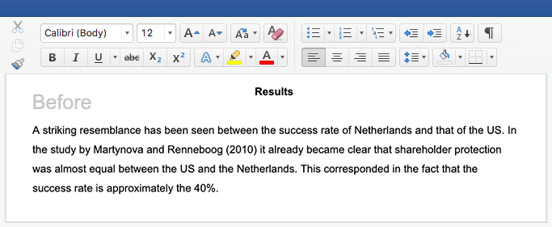
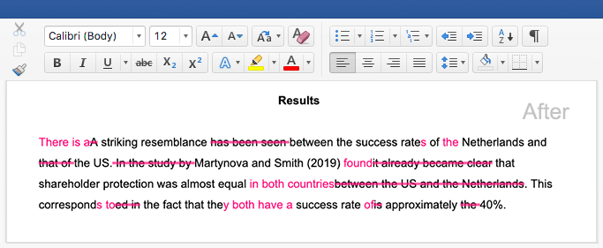
See editing example

