Energy & Enzymes
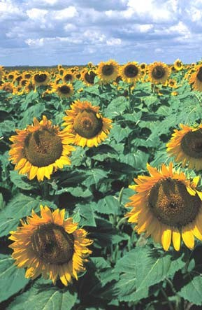

Life requires energy for maintenance of order, growth, and reproduction. The energy living things use is chemical energy.
1

Energy exists in two forms - potential and kinetic.
Potential energy is stored energy. Kinetic energy is the energy of motion.
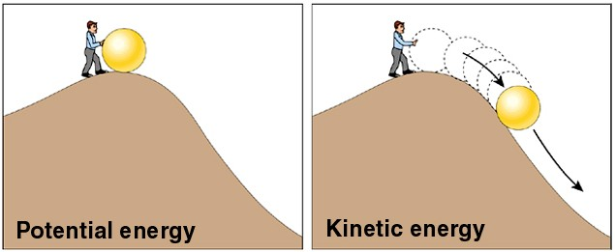

rechargeable battery gasoline
foods
electric fan
a moving vehicle body heat

Potential energy can be released as kinetic energy.
2

Potential energy can be converted from one form to another.
- Light electron position energy chemical bonds
- carbohydrate chemical energy fat chemical energy
- gasoline chemical energy battery chemical energy

- All conversions of potential energy are inefficient
- Gasoline energy can be converted to stored chemical energy of a battery, but there is heat released in the process. Heat is kinetic energy and is a loss of potential energy.
- Conversion of foodstuffs also result in a loss of energy in the form of heat.
- The use of foodstuffs to power muscular movements also results in the production of heat.

3

Heat is molecular motion. Once chemical energy is converted to heat it is lost to living things. It can’t be recovered.
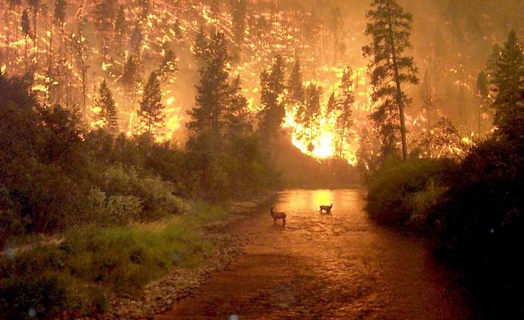
4

Laws of Thermodynamics
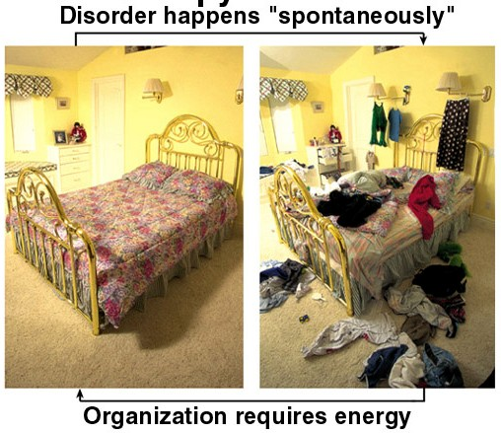
  - Energy can’t be created or destroyed, only converted from one form to another. It can be changed from one form of potential energy to another, or from potential to kinetic energy, but there is no net increase or decrease in total energy. The total amount of energy in the universe is constant.

  - The net tendency of the universe is toward greater disorder (greater molecular motion). Entropy (a measure of disorder) is always increasing.
It requires energy to maintain order.
5

Life is ordered and maintains its order. Increasing disorder is supposed to be the rule.
Does life violate the Second Law of Thermodynamics?

6

Oxidation-reduction (REDOX) reactions are the most important class of energy transfer reactions in living things.
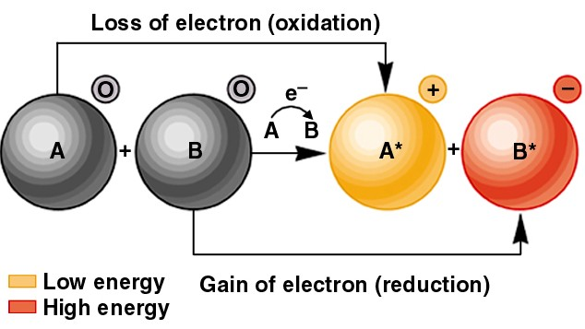

7

Chemical energy in living things is carried by electrons involved in covalent bonds, especially C-H bonds.
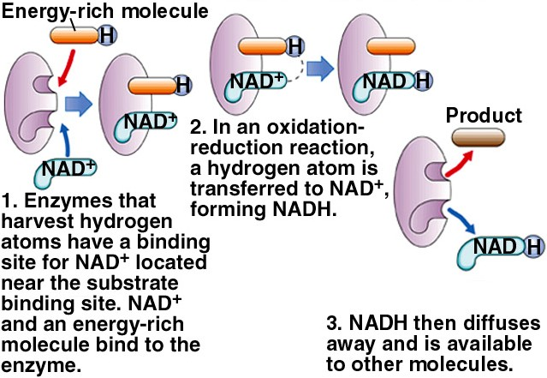
Energy is transferred by moving electrons (and associated protons) from one molecule to another.
NAD is an important molecule in energy transfers
8

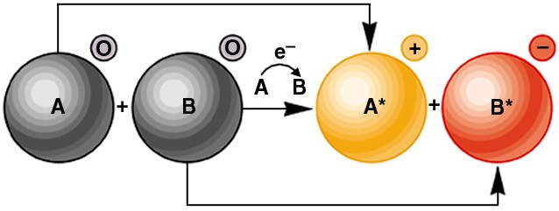
Chemical reactions involve the conversion of one class of molecules into another class of molecules. The starting molecules are called substrates or reactants. The resulting molecules are called products.
Substrates Products

9

In most chemical reactions the products have less total energy than the substrates. In the conversion of substrate to product some energy is lost or released. Such reactions are called exergonic reactions.
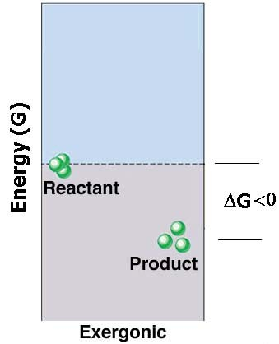G - free energy - a measure of the
energy contained in chemical bonds
In exergonic reactions there is a loss of free energy in the conversion from substrate to product.
An exergonic reaction:
C6H12O6 + 6 O2 → 6 CO2 + 6 H2O
All organisms can break down glucose as a source of energy for other
purposes 10

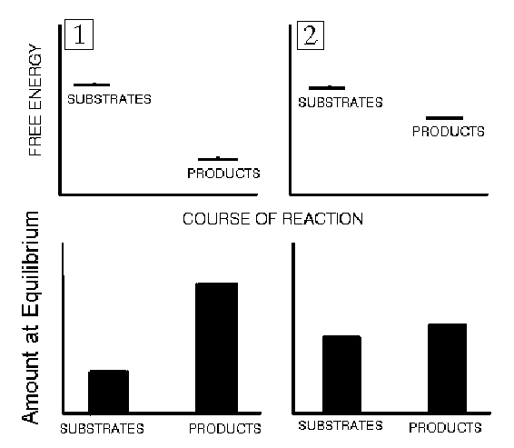
How much product will be produced from a reaction when it is allowed to go to equilibrium?

The ΔG determines the amount of product that will be produced at chemical equilibrium.

11

In some chemical reactions the products have more energy than the substrates. Such reactions require the input of energy from another source and are called endergonic reactions. In endergonic reactions the change in free energy is positive.
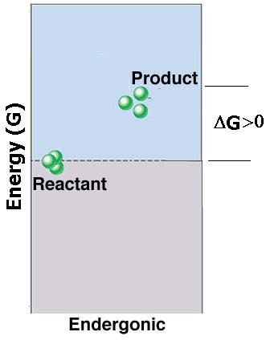An endergonic reaction
6 CO2 + 6 H2O → C6H12O6 + 6 O2
Plants perform this reaction in the synthesis of glucose, and supply the energy needed from energy captured from sunlight.
All chemical reactions are reversible. 6 CO2 + 6 H2O ↔ C6H12O6 + 6 O2
One direction is endergonic and the
other is exergonic.
12

If the tendency of the universe is to convert potential energy into kinetic energy, why don’t all energy containing molecules release their energy right now?

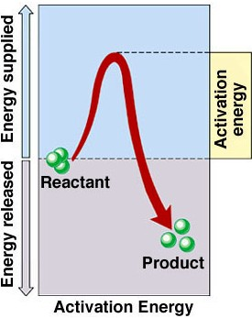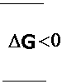Some molecules do degrade readily but others don’t. Those that don’t are considered more stable.
For stable substrates to be converted into products, they must be “activated” through the input of energy. The amount of energy that must be supplied to cause a reaction to occur is the activation energy.
13

For most chemical reactions the activation energy comes from the surrounding environment.
Molecular collisions provide the energy necessary to elevate a substrate to its activated state.
Chemical reactions happen more quickly at higher temperatures because at higher temperatures there are more molecular collisions and more of the collisions have sufficient force to elevate the substrate to its activated state.

14

The activation energy determines the rate of conversion of substrate to product. The higher the activation energy the slower the rate of production of product.

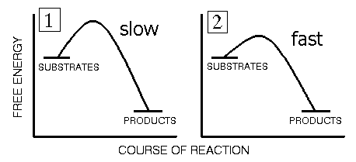

15

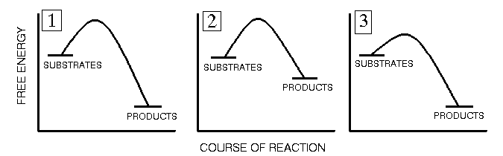

Given the same amount of substrate, temperature, etc.: Which reaction will produce the least product at equilibrium? Which reaction will produce product at the highest rate?

16

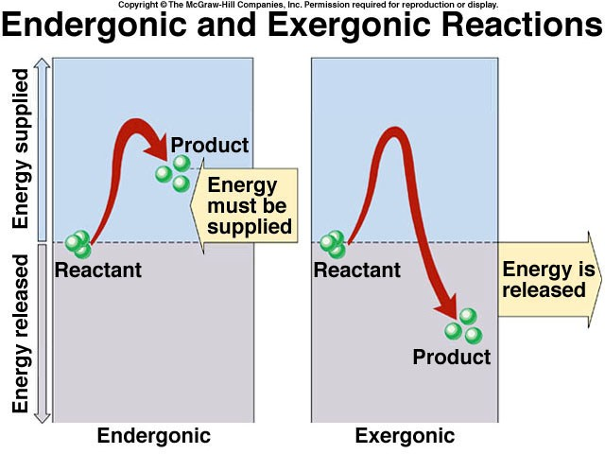
17

Enzymes - biological catalysts
A catalyst increases the rate of a chemical reaction but is unchanged by the reaction. Catalysts can promote the formation of products from substrates repeatedly.
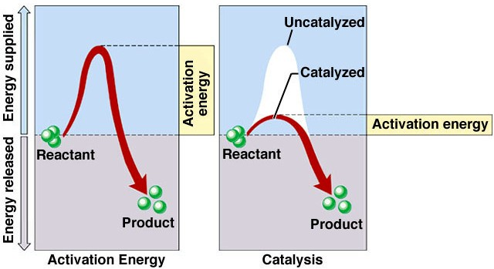
Enzymes are proteins (or sometimes RNA) that associate with substrates in a way that makes the formation of product more
favorable. They lower the activation energy needed to
convert substrate to product so reactions proceed
quickly at normal biological temperatures. 18

Enzymes don’t change the ΔG of the reaction. So they don’t change the amount of product that can be produced at equilibrium.
Enzymes make life possible by allowing reactions to proceed quickly enough for the organism to resist physical degradation.
Enzymes are usually named for the reaction they catalyze and the suffix ASE is added to the name.
DNAse - breaks down DNA
DNA polymerase - synthesizes new DNA from nucleotides ATP synthase - synthesizes ATP from ADP and inorganic phosphate
Pyruvate dehydrogenase - removes a hydrogen from pyruvate Phosphofructokinase - adds a phosphate group to fructose
Ribulose Biphosphate Carboxylase - adds a CO2 to Ribulose biphosphate
19

Enzymes are large proteins which associate with a specific or very limited number of substrates. They are specific because they have an active site that matches the shape of the substrate.
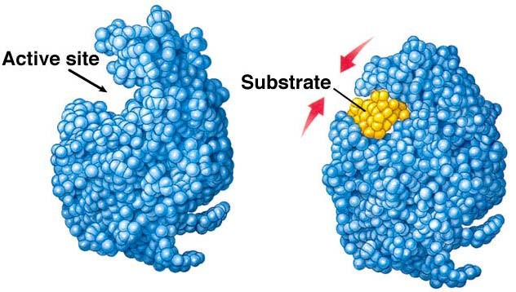
The substrate and enzyme have a lock and key like relationship.
The enzyme may change conformation (shape) after
the substrate

enters the active site.
After the substrate enters the active site, the
binding of the enzyme helps to promote the breakage or formation of covalent bonds.
20

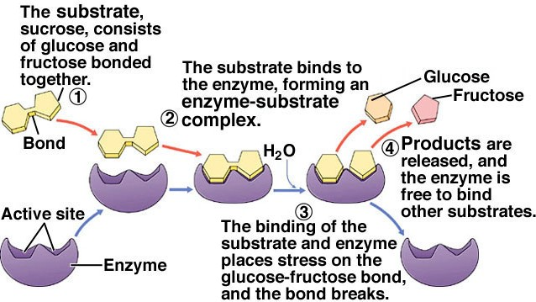
Many of the properties of enzymes are explained by the Enzyme-Substrate Complex Model (a hypothesis about how enzymes work).
Enzymes don’t get used up - they can catalyze the same reaction through an indefinite number of cycles.

21

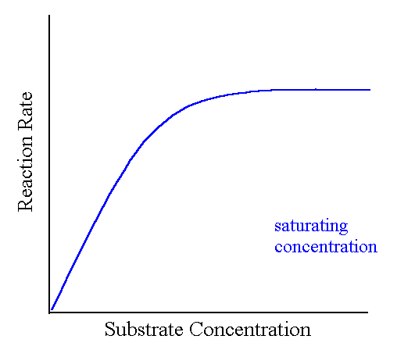Because there is usually a limited number of enzymes in solution relative to the number of substrate molecules, enzymes exhibit saturation. As substrate concentration increases the rate of product formation increases up to the point at which all the enzymes in solution at any given time have their active sites occupied.
Increasing substrate concentration further will result in no further increase in the rate of product formation.

22

Enzymes are sensitive to environmental conditions
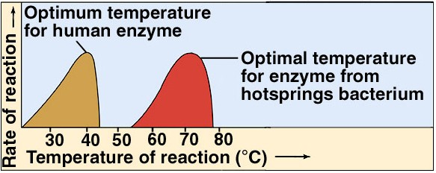Temperature influences the strength of hydrogen bonds. If the temperature is too low the enzyme may be too rigid to bind the substrate readily.
At very high temperatures the enzyme may denature and catalysis stops.

There is an optimum temperature for the activity of an enzyme. The optimum temperature is usually matched to the environment in which the enzyme normally functions.

23

Enzyme activity is influenced by the concentration of ions. Positively or negatively charged molecules in the environment of the enzyme can change the conformation of the enzyme and influence its ability to bind the substrate.

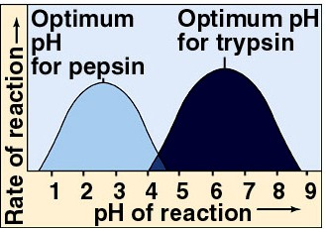
A change in pH is a change in the concentration of H+ in the environment.
Changing the concentration of H+ (or any other ion) can change the shape of the enzyme.

Enzymes are usually well suited for the environment in which they normally work. Pepsin is a protease in the stomach.
Trypsin is a protease in the small intestine.
24

Enzyme activity is also influenced by other chemicals in the environment. Enzyme inhibitors reduce enzyme activity.
Enzyme activators increase enzyme activity.

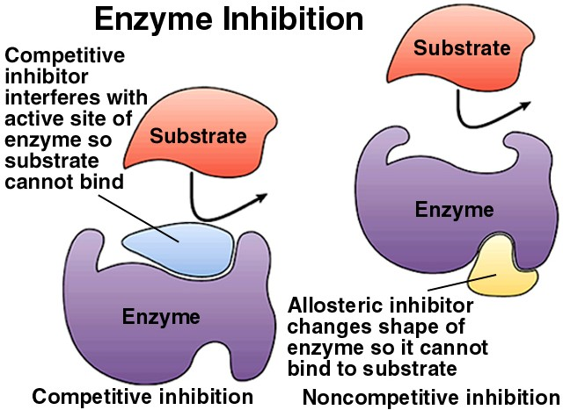
Inhibitors are of two types - competitive and noncompetitive
Noncompetitive inhibitors interact with the enzyme away from the active site - at the allosteric site
25

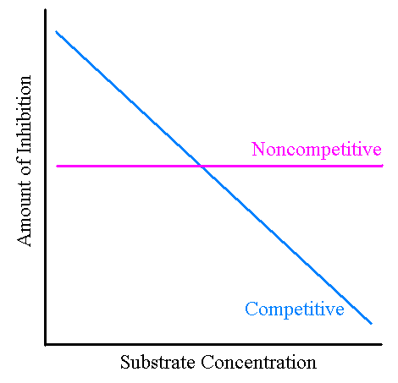
The effect of a competitive inhibitor can be reduced through an increase in substrate concentration. The effect of a noncompetitive inhibitor is insensitive to change in substrate concentration.
At higher substrate concentrations a competitive inhibitor has less access to the active site.
At all substrate concentrations, a noncompetitive inhibitor remains bound to the
allosteric site. 26

Activators increase an enzyme’s ability to catalyze a reaction. Activators bind to an allosteric site and change the shape of the enzyme so that it is a more effective catalyst.
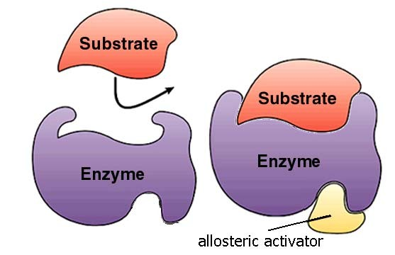

27

Enzymes often depend on the presence of other molecules to catalyze a reaction.
Cofactors are inorganic ions (Zn+, Mg++, Ca++) that associate with the enzyme and increase the enzyme’s catalytic ability.
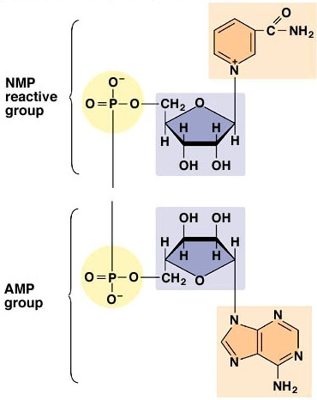
Coenzymes are non-protein organic molecules that carry substrates to the enzyme or carry products away from the enzyme. Many vitamins or derivatives of vitamins function as coenzymes.
NAD is an important coenzyme. It carries high energy electrons to and from oxidation-reduction
reactions. 28

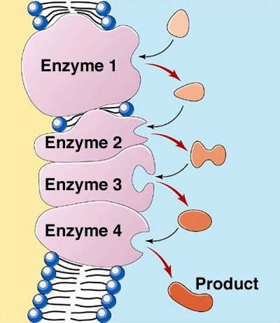Many important compounds are built or broken down in a series of reactions - a biochemical pathway.
Substrate
The product of one enzyme is the substrate for the next enzyme in the pathway.

29

The entire of sequence of reactions in a biochemical pathway is commonly regulated through the regulation of a single enzyme early in the pathway. The end-product of the pathway is often an allosteric inhibitor (regulator) of an early enzyme. This type of regulation is called feedback inhibition or end-product inhibition.
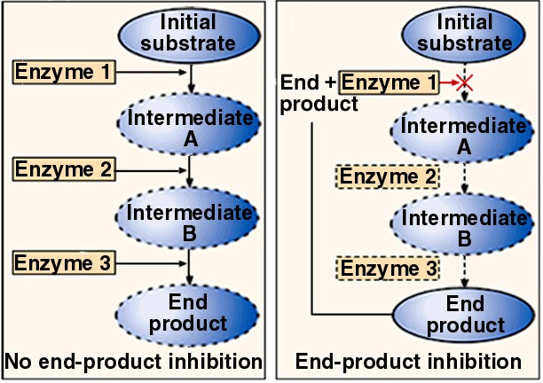 30
Reference: https://www.nicholls.edu/biol-ds/biol155/Lectures/Energy%20&%20Enzymes.pdf

