John Berryman Briefly
(1914-1972)

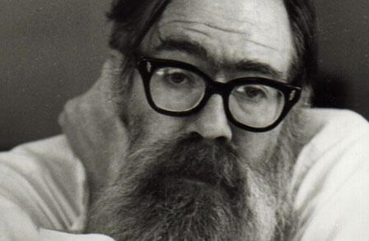

….
A scholar and professor as well as a poet, John Berryman is best-known for The Dream Songs (1969), an intensely personal sequence of 385 poems which brought him the Pulitzer Prize and National Book Award. In these he invented a style and form able to accommodate a vast range of material while expressing his turbulent emotions…

…Berryman suffered a great loss at 12 when his father shot himself outside the boy’s window. This event haunted him throughout his life, and recurred as a subject in his poetry…

…Made up of three six-line stanzas that teem with allusions to past and present events and to literary figures, The Dream Songs display an astonishing variety of poetic resources that include slangy diction and a nervous, fractured syntax. Influenced by the Irish poet W.B. Yeats, psychoanalysis and Berryman’s beloved Shakespeare, they also stirred controversy by drawing on nineteenth century minstrel shows in which white performers in blackface enacted racist stereotypes….
…The poet’s lifelong struggles with alcoholism and depression ended in 1972, when he jumped off a Minneapolis bridge in the dead of winter…

Read the complete article at https://www.poetryfoundation.org/poets/john-berryman

