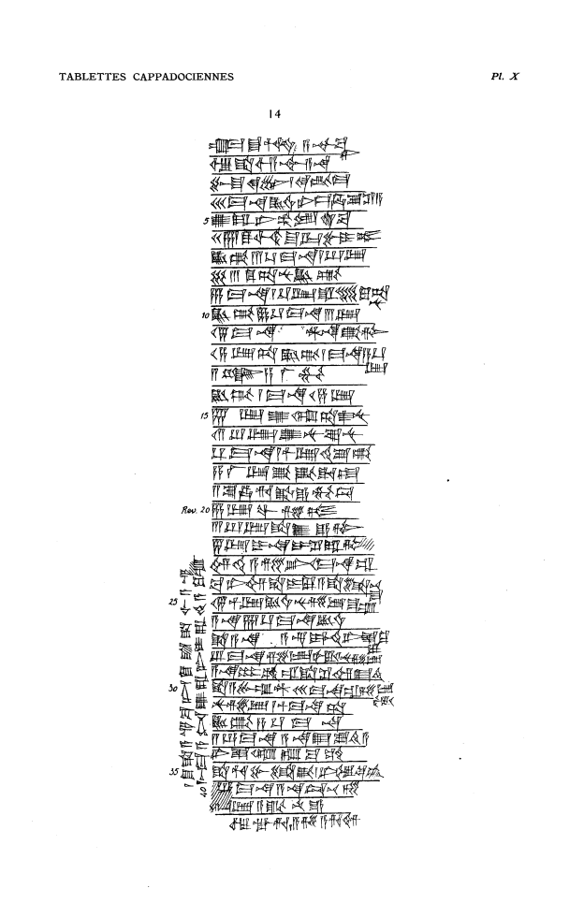

um-ma S^u-Hu-bur A-s^ur3-ba=ni
u3 S^a-lim-A-s^ur3 a-na
Pu-s^u-ke-en6 / qi2-bi-ma
30 ma-na KU3.BABBAR ni-is-ha-su2 DIRI
5 u2-ra-ni ub2-lam S^A3.BA
27 TUG2 SIG5 S^u-ur-bu-i-tum
KU3.BI 3 1/3 ma-na 1 2/3 GIN2
63 TUG2.ta-nu KU3.BI
6 ma-na 1 1/3 GIN2 is^tenis^ 90 ku-ta=nu
10 KU3.BI 9 1/3 ma-na 3 GIN2
15 ma-na AN.NA qa2=tim
14 GIN2.TA KU3.BI 1 ma-na 4 1/3 =GIN2
2 ANS^E s,a-la2-mu
KU3.BI 1 ma-na 14 GIN2
15 15 GIN2 u2-kul-ta-as^2-nu
12 2/3 GIN2 u2-nu-su2-nu
1/3 ma-na 1 1/2 GIN2 te2-su2-pi2
4 <<LA2>> GIN2 qa2-qa2-da-at
2 s,u2-ha-ri-ka3 / e-mu-du
20 6 GIN2 wa-s,i2-tum
3 2/3 s^a sa-e-tim
45 GIN2 i-na i-s^i2-ra-tim
im-t,i2 a-s,e2-er 10 ma-na URUDU
pa2-ni-im s^a I-lu-a s^a li-bi4=s^u
25 15 1/2 GIN2 KU3.BABBAR nu-s,i2-ib-s^um
a-na 7 1/3 ma-na KU3.BABBAR
s^a a-na A-s^ur3-i-mi3-ti2 ni-is^-qu2=lu
2/3 ma-na s,i2-ib-tam2 / nu-s,i2-ib
a-na 6 GU2 URUDU s^a s^i2-im E2.ti2
30 s^a A-bu-um-DINGIR 30 ma-na s,i2-ib=tam2
nu-s,i2-ib 1 1/2 ma-na-TA
KU3.BI 4 1/3 ma-na
2 5/6 ma-na a-na E2 Su2-ti2-a
ni-is^-qul2 t,up-pa2-am
35 s^a hu-bu-li-ka3 / ni-il5-qe2-am
5/6 ma-na a-na Tu3-pe3-zi
x GIN2 a-qa2-nu-e
u3 ag-ri / a-Zi-a-ri-im
1 TUG2 s^a A-s^ur-ba-ni 1 TUG2 s^a S^a-lim-A-s^ur
40 mi3-ma a-nim U2-ra-ni i-ra-de8-a-ku-um

