Molecular Transport and Convective Transport

The total flux of any quantity “ϴ” is the sum of the molecular flux and convective flux. The flux resulting from potential gradients or driving forces are called molecular flux.
In addition, momentum, energy, and mass can be transferred by bulk fluid motion or bulk flow and the resulting flux can be called as convective flux.

1. MOLECULAR TRANSPORT
Objects might behave differently when subjected to the same gradients. Constitutive equations identify the characteristics of a particular object.
For example;
- If the driving force is momentum, then the viscosity is defined by the constitutive equation, which is called as Newton’s law of viscosity.
- If the driving force is energy, then the thermal conductivity is defined by the constitutive equation, which is called as Fourier’s law of heat conduction.
- If the diriving force is concentration, then the diffusion coefficient is defined by the constitutive equation, which is called as Fick’s first law of diffusion.
At these constitutive equations, viscosity, thermal conductivity and diffusion coefficient are called as transport properties.

1.1. Newton’s Law of Viscosity
When we placed a fluid between two large parallel plates of area A, which is separated with a distance of L. The system is initially at rest at the time of t = 0, which means that the lower and the upper plates have a linear velcity of zero. Suddenly, the lower plate is set in motion in the x-direction at a constant velocity of V by applying a force F in the same direction. At the same time, the upper plate is kept stationary. The resulting velocity profile is illustarted in Figure 1 for various time intervals. At steady-state condition, a linear velocity profile is obtained as shown below.
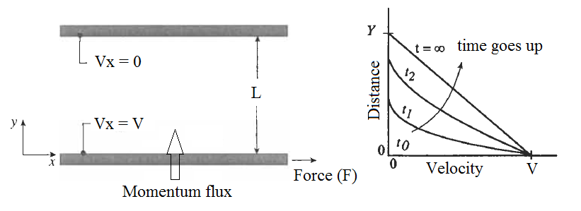
Figure 1. Velocity profile between parallel plates containing stagnant fluid.

Experimental results exhibit that the force “F” required to maintain the motion of the lower plate per unit area, which is the momentum flux, is proportional to the velocity gradient.
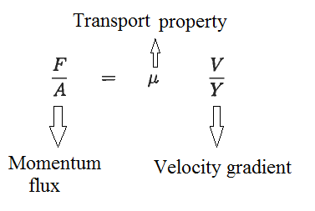
The transport property “µ”, which is also the proportionality constant, is the viscosity. The relation given above can be written in microscopic form as shown below.
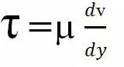
Where λ is shear stress and dv/dy is the rate of shear deformation. The given equation is known as Newton's law of viscosity and any fluid obeying this type of equation is called a Newtonian fluid.
Viscosity depends on the temperature. While liquid viscosity reduces with increasing the temperature, gas viscosity increases with increasing the temperature.

Example: A Newtonian fluid with a viscosity of 1x10⁻³ kg/m.s is placed between two large parallel plates. The distance between the plates is 1 mm. The lower plate is pulled in the positive x-direction with a force of 2 N, while the upper plate is pulled in the negative x-direction with a force of 1 N. Each plate has an area of 1 m². If the velocity of the lower plate is 1 m/s, calculate the steady-state momentum flux and the velocity of the upper plate. Calculate the steady-state momentum flux and the velocity of the upper plate when the fluid between the parallel palte has a viscosity of 10x10⁻³.
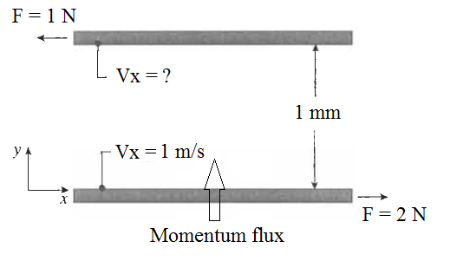
Solution: The momentum flux is equal to
λ = F / A = (2 + 1) / 1 = 3 Pa
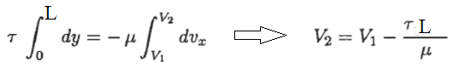
The velocity of the upper plate when the fluid between the parallel plate has a viscosity of 1x10⁻³
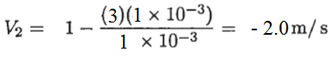
The velocity of the upper plate when the fluid between the parallel plate has a viscosity of 10x10⁻³
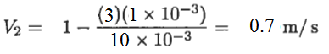
References:
İ. Tosun, “MODELLING IN TRANSPORT PHENOMENA A Conceptual Approach”, Elsevier, 2002.

