Other applications for the reduction of emissions (NOx emissions)

Exhaust gas recirculation

In internal combustion engines, exhaust gas recirculation (EGR) methos employed in gasoline and diesel engines. It works through recirculation of a ppart of an engine's exhaust gas back to the engine cylinders.

This decreased the O₂ in the air stream and provides gases inert to combustion to act as absorbents of combustion heat to reduce peak in-cylinder temperatures. By this way, NOx is produced in a narrow band of high cylinder temperatures and pressures.

Water injection system

In this method,H2= dissocitae to form OH and H₂ at high temperature, which absorbs the heat during combustion. The water not only absorbs the heat of intake gas for decreasing the temperature, but also to provides oxygen for burning the fuel. The injected water also reduces the local temperature of the combustion flame and leads to lower NOx emissions.

Below figure is taken from http://www.bosch-presse.de/pressportal/de/media/dam_images/pi9352/infographic-water_injection_img_w1280-2.jpg

Catalytic converters

Catalytic treatment of unconverted HCs, CO and NOx just before they are emitted to the atmosphere.

Two types: Two way oxidation type and three way oxidation and reduction type.
Two way oxidation type ------ treats only CO and unconverted HCs.
Three way oxidation type ----- oxidizes CO and unconverted HCs and reduced NOx.

Inside the converter, there is a monolith section on which required catalysts are adsorbed.

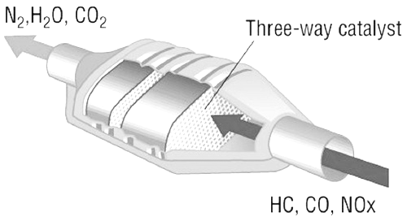

A dismantled catalytic converter

Figure taken from https://i.ytimg.com/vi/aS-XsmXLMLo/maxresdefault.jpg.

CO₂ splitting

CO₂-splitting process converts more than 98 percent of the CO₂ into CO. In addition, the process also uses the resulting oxygen to convert methane into syngas, which is itself a feedstock used to make fuels and other products.

Syngas can be produced from many sources, including natural gas, coal, biomass, or virtually any hydrocarbon feedstock, by reaction with steam (steam reforming), carbon dioxide (dry reforming) or oxygen (partial oxidation). Syngas is a crucial intermediate resource for production of hydrogen, ammonia, methanol, and synthetic hydrocarbon fuels.

Reference: Ghazi A. Karim, Fuels, Energy and the Environment, 1st Edition, CRC Press.

