HIGH-PERFORMANCE LIQUID CHROMATOGRAPHY
High-performance liquid chromatography (HPLC) is the name of the method and the instrument, which is used to separate, identify and quantify the components of a mixture. HPLC performs as an automated column chromatography and quantification system.
HPLC is the most important instrument of a quality control laboratory for many industries. For example, HPLC is used for the analysis of active pharmaceutical ingredients, their degradation products and impurities in a drug preparation; drug molecules and their metabolites in blood; chemical compounds in plants; chemical compounds in foods and food supplements; enzymes, amino acids, proteins, polysaccharides etc. in the organism.
In HPLC, a stainless steel column is filled with small particles. These particles are coated with a liquid film. That is why, in HPLC, the stationary phase is liquid, hence HPLC is called a liquid-liquid chromatography system and works with the principal of partition. A pump is used to provide the flow of mobile phase through the system. As the components of the sample pass through the stationary phase along with the moving phase, they are partitioned (distributed) at different rates between the stationary phase and the moving phase. The components with a low partition rate in stationary phase (with a low interest in stationary phase) leave the column quickly, whereas the components with a high partition rate in stationary phase are retained more and leave the column later. In analytical HPLC, a detector is placed at the end of the column. The detector monitors the components that are leaving the column. In preparative HPLC, the different components which leave the column at different times, are collected in different containers, hence the physical separation is performed.
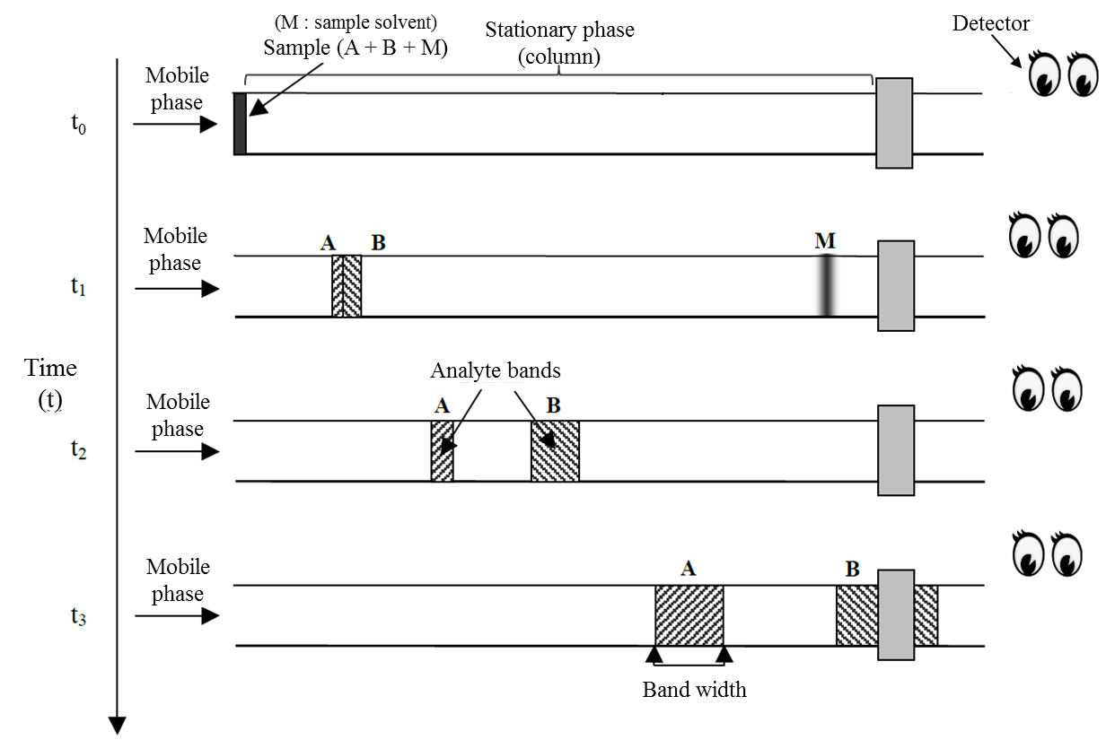
Fig 1. Separation of the substances A and B in the column
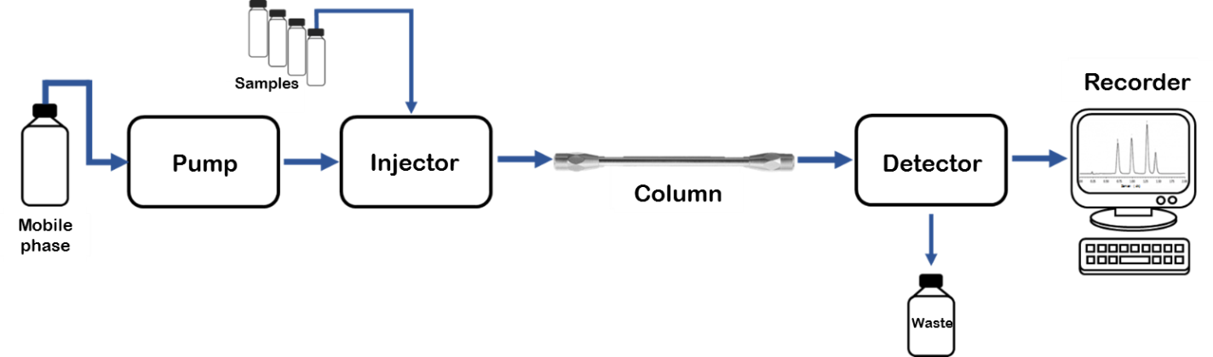
For example, in Figure 1, a sample which contains substances A and B in solvent M is injected to HPLC system at the time of t₀. At the time of t₁, it is seen that the solvent M has been moved through the column with the same speed as the mobile phase. It means that solvent M has not been retained in the column at all, because it doesn’t get partitioned in the stationary phase. At the time of t₂, it is seen that substances A and B have been separated because substance B moves faster than substance A in the column. The substances form groups inside the column while migrating, because each substance has different migration rate. The group of molecules is called a band. The period of time that the substances spend on the stationary phase, which is, the difference between the time they left the column and injection time, is called retention time and is abbreviated as t_{R}. In this example, the first substance that comes out of the column and reaches the detector is substance B, which has a high migration rate and short retention time. The migration rate of substance A is low, and its retention time is longer.
Fig 2. Schematic representation of HPLC instrument
HPLC consists of five parts:
- Pump: Provides the flow of mobile phase. It draws the solvents from their container, pushes them into the column so that the mobile phase moves through the column with high pressure and reaches the detector and the waste tank. Different solvents (water, buffer, methanol, etc) can be used as a mixture in desired ratios by using double or quaternary pump systems.
- Injector : Enables the sample to be introduced into the column after mixing with mobile phase. When automatic injectors are used, injection of various samples can be performed under computer control at the desired time. In HPLC, 1-10 μL of sample is sufficient for the analysis.
- Column : It is the part where the separation occurs. It is produced by filling a stainless steel column with small particles. The dimensions of the column vary, but generally they have a length of 10-30 cm and a diameter of 4-10 mm. The particles are coated with a liquid film. Usually a temperature controlled compartment is used to hold the column.
- Detector: It is the part that detects the signals of the substances leaving the column.
- Recorder: It converts the analytical signal measured by the detector into a digital (numerical) data and plots the signals against time which is called as chromatogram.
One of the most commonly used detectors for HPLC is ultraviolet / visible (UV / VIS) detector. Fluorescence, infrared, refractive index, electrochemical and mass spectroscopy detectors are also used.
In an HPLC with a UV/VIS detector, the light source and the detector are placed at the end of the column, opposing each other. The intensity of light that reaches the detector is measured continuously, during the analysis, so all the liquid leaving the column (eluent) is being measured. Decrease in the measured light intensity means that, molecules which absorb the light are leaving the column. The decrease in light intensity produces a response in the detector and it is recorded as a peak. For example, if only the mobile phase is leaving the column, all the light reaches the detector and the signal is saved as zero. But when an analyte comes out of the column, the intensity of the light decreases, because this analyte absorbs the light, so the signal increases. The absorption of light increases with the increasing concentration of the substance. For example, if we double the concentration of the substance, the substance will absorb twice as much light and the measured signal will double, as well.
The concentration profile of each substance is called as peak. The graph formed by the peaks is called a chromatogram. Chromatogram is obtained by plotting the detector response against the time. When the concentration of a substance increases, the peak height and peak area of this substance increase as well. In HPLC, the quantitative determination is made by establishing a mathematical relationship between peak areas and known concentrations. Then, the unknown concentration is calculated by using the peak area of the unknown sample and the mathematical relationship.
The time that the components leave the column is called retention time and it gives qualitative information about the substances. In a chromatogram, the retention time corresponds to the time of peak apex, which means the highest level the signal reaches. A particular substance has the same retention time in the case of using the same mobile and stationary phases. By comparing the retention times of different substances, we can compare their polarity, as well.
In Figure 1, the migration and separation of the substances A and B has been given. The HPLC chromatogram of substances A and B is given in Figure 2. In this figure, X axis shows the time, and Y axis shows the detector signal. The zero point of the X axis is the time of injection.
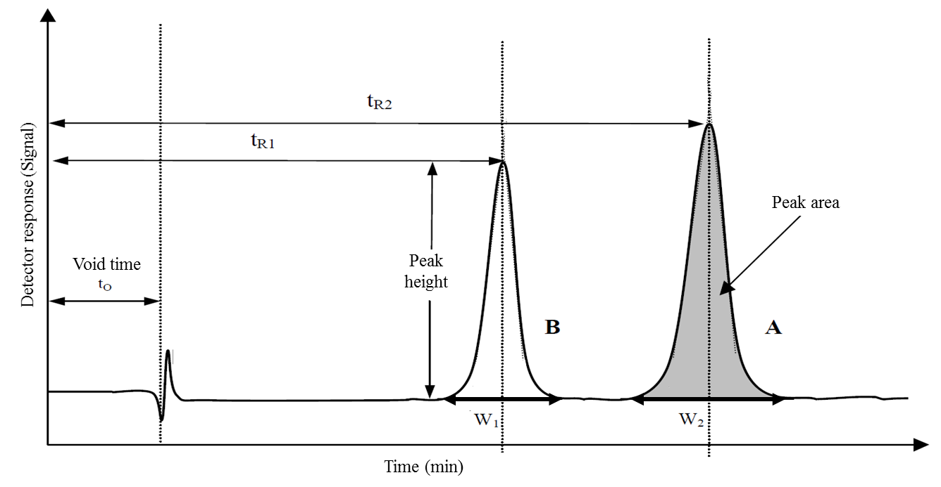
Fig 3. Representative chromatogram of HPLC analysis of a sample which contains substances A and B
t_{R1} : Retention time of the first substance (B)
t_{R2} : Retention time of the second substance (A)
t₀ : Void time (The time which the solvent of the sample leaves the column)
w₁, w₂ : Baseline width of peaks
Peak height : The distance between the peak apex and baseline. Peak height increases with increasing concentration.
Peak area : The area between the baseline and the curve of peak. Peak area is proportional to the concentration of the substance.

In HPLC applications, there are two techniques according to the polarity of the phases.
Normal phase Stationary phase : Polar
Mobile phase : Nonpolar (hexane, octanol, etc.)

Reversed phase Stationary phase : Nonpolar (particles bonded with alkyl chains)
Mobile phase : Polar (water, buffer, methanol, acetonitrile, etc.)

In normal phase technique, stationary phase is polar and mobile phase is nonpolar. Initial applications of the chromatography were performed using the normal phase (see Tswett). In the normal phase HPLC technique, the most polar analyte is retained the most, because it interacts more with the polar stationary phase and leaves the column lastly. Analytes with less polarity (closer to nonpolar) get partitioned in the mobile phase more, so they move faster along with the mobile phase, so their retention times are shorter and they leave the column earlier. The most nonpolar analyte leaves the column first, so it has the shortest retention time.
The reversed phase technique was later developed as an alternative to the normal phase. In reversed phase, a nonpolar material is used as stationary phase and mobile phase is polar. A polar analyte does not interact with the stationary phase, so it moves rapidly with the mobile phase, its retention time is short. A nonpolar analyte gets partitioned in the stationary phase more, it has a strong interaction with the stationary phase, so it moves slowly and its retention time is higher. Reversed phase technique is preferred in most of the HPLC applications. Because there are a variety of polar solvents such as water, methanol, acetonitrile and buffers. They are cheaper than nonpolar solvents and they can be mixed together to achieve a wide range of polarity and pH.

References
- Principles of Instrumental Analysis, D.A. Skoog, Hollar, F.J. Crouch S.R., II. Ed. 1981
- Analitik Kimya II, F. Onur, A.Ü. Eczacılık Fakültesi Yayınları No. 101, 2011
- Analitik Kimya Pratikleri Kantitatif Analiz, F. Onur (Ed.), A.Ü. Eczacılık Fakültesi Yayınları No. 111, 2014

