SUM

anisotropic mineral: A mineral with more than one principal refractive index.
birefringence: The mathematical difference between the largest and smallest refractive index for an anisotropic mineral.
biaxial mineral: A mineral with three principal refractive indices and two optic axes. Its indicatrix is a triaxial ellipsoid.
dispersion: Change of any optical property with wavelength. indicatrix: The three-dimensional surface describing the
variation in refractive index with relationship to vibration direction of incident light.
isotropic mineral: A mineral with the same refractive index regardless of vibration direction. Its indicatrix is a sphere.

optical class: One of five possible classes (different indicatrices)
to which a mineral can belong: isotropic, uniaxial
+/-, or biaxial +/-.
optical orientation: The relationship between a mineral's crystallographic axes and optical indicatrix.
pleochroism: The property of exhibiting different colors as a
function of the vibration direction.
principal refractive
index: For isotropic minerals -n, for uniaxial minerals - and , for biaxial minerals - , , and .
uniaxial mineral: A mineral with two principal refractive indices and one optic axis. Its indicatrix is a prolate or oblate ellipsoid.

INTRODUCTION

Optical mineralogy is formed one of the most basic lecture of geology earth science and the most important of mineralogy-petrography division. Microscope is one of the fundamental parts of this lecture, for this reason definition, parts and light source of the microscope should be known clearly before starting to the identification and determination of the minerals. In order to understand the duty of the microscope one should be answer the question of Why we have to know the parts of the microscope?

Type of the microscope can be classify in the studding of the type of the minerals in geological materials. Transmitted and reflected light were formed because of the transmitted and opaque minerals. Opaque minerals mostly formed the ore minerals which are not the function of the course. Opaque minerals can be determined under reflected light microscope in ore petrography courses. Transmitted minerals mainly formed the rock formed mineral which can be determined under the polarizing transmitted light microscope and formed the main object of the GEO 202 optical Mineralogy courses. The interaction of light with minerals, most commonly limited to visible light and usually further limited to the non-opaque minerals. Opaque minerals are more commonly studied under reflected light and is generally named as ore microscopy and most of the opaque minerals are formed the ore minerals. The most general application of optical mineralogy is to aid in the identification of minerals, either in rock thin sections or individual mineral grains. Another application occurs because the optical properties of minerals are related to the crystal chemistry of the mineral for example, the mineral's chemical composition, crystal structure, order/disorder. Thus, relationships exist, and correlations are possible between them and some optical property. This often allows a simple optical measurement with the polarizing petrographic microscope that may yield important information about some crystal chemical aspect of the mineral under study. Optical mineralogy yield an important background for the Electron Microprobe (Mineral chemistry) and confocal Raman spectroscopy (mineral identification) determination and researches.

I. LIGHT

A. Theory of light

Light can be thought of both as a wave phenomenon (electromagnetic theory) or a particle phenomenon (quantum theory), depending upon the physical process under study. In optical mineralogy both forms of light are employed to fully explain the interaction of light with minerals. The range and colors of visible light are defined in terms of wavelength: violet (390-446 nm), indigo (446-464 nm), blue (464-500 nm), green (500-578 nm), yellow (578-592 nm), orange (592-620 nm), red (620-770 nm). Visible light commonly is referred to as 400-700 nm. This range is somewhat arbitrary based upon the variation in an individual's eye sensitivity.

The wave theory of light describes light as a longitudinal wave, with the direction of propagation and the direction of energy transfer
being perpendicular. In optical mineralogy the direction of propagation is referred to as the ray path and the energy transfer direction as the vibration direction. The geometrical relationships between ray path, vibration direction, and a mineral constitute one major portion of the optical study of minerals, basically a geometrical optical phenomenon. Results from wave theory are used to explain how light is refracted by a mineral. Several techniques for the measurement of optical properties of minerals use observation of light refraction.

The particle theory describes light as composed of photons of different energies with these energies related to the wavelength in the electromagnetic theory. A description of the interaction of photons with the bonding electrons in minerals can be used to explain such phenomena as refractive index, color, and pleochroism, and to interpret most spectroscopic studies.

B. Polarized light

The electromagnetic theory of light is used to explain polarization phenomena. There are four types of polarized light: random, plane,
Circular, and elliptical. Plane polarized is the most important form for the study of minerals. However, circular and elliptical forms become important in more advanced studies.
Recall that the direction of energy transfer is perpendicular to the propagation for a light ray. In plane polarized light the energy transfer directions (vibration directions) are restricted to a plane parallel to and coincident with the ray path (Figure 1). Plane polarized light is used to study anisotropic crystals because the vibration direction of the light can be made parallel to specific directions within the crystal.
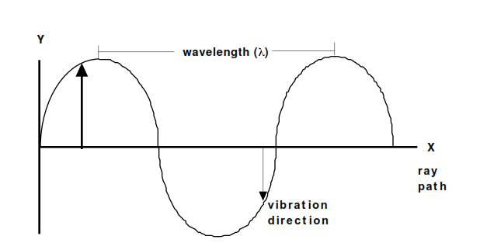

Figure 1. Plane polarized light, showing wavelength, ray path, moving in
the x direction, and vibration direction perpendicular to X in the Y
direction. The light is plane polarized in the XY plane. The vibration
direction is perpendicular to the ray path in isotropic and certain
directions in anisotropic crystals.

