MATERIAL INFORMATION

4.MATERIAL FEATURES

Most of the material properties depend on the internal structure. Therefore, the features will often be explained by the internal structure. Material properties can be collected under 4 groups; mechanical, electrical, physical and technological properties.

4.1.Mechanical Properties

The reaction of a solid object to external forces applied to it is called mechanical behavior. The mechanical behavior of materials is three groups: elastic, plastic and visco-elastic. The mechanical properties of the materials are determined experimentally under different loadings. Stress is defined as the ratio of force to the impact-directional cross-section of force that acts on a solid object.

Elastic deformation is a reversible event. If the stress is increased, the strength limits of the object are enforced and plastic form change begins. The tensile boundary that creates a plastic form change in the material internal structure is called strength.

If constant stress is applied to an object, sudden elastic elongation followed by ever-increasing elongation, this is called viscoelastic behavior. Viscoelastic behavior also has an effect on loading speed, loading time and temperature. Many agricultural products also exhibit viscoelastic behavior.

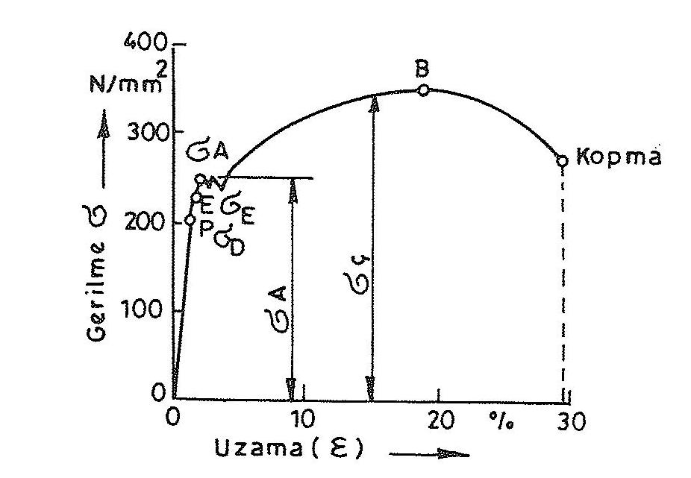

Figure 4.1. Drawing diagram of low carbon steel

4.1.1.Pull properties

It is one of the most used mechanical features obtained by tensile experiment. By preparing the standard test bar, the pull test is connected to the device from both ends and the tensile force is applied. The force (P) and the amount of elongation applied during the experiment (dl = l_{o} – l) (Figure4.1).

Figure 4.2. Determination of the flow limit on the diagram

For some materials that are not clearly visible in the pull diagram, the flow limit is determined by marking the amount of 0.2% elongation from the starting point (Figure 4.2).

The tensile stretch applied at the end of the tensile experiment is determined by the ratio of the force applied to the test bar to the first section of the bar;

σ = P / f₀ (N /mm²)

In the same experiment, the change of format – the elongation interval; it is obtained by dividing the amount of elongation by the first length of the test bar.

ε = l – l₀ / l₀ ( % )

Elasticity module:

E = σ / ε

equality.

Tensile strength: is the ratio of the largest force applied to the test bar to the first section.

σ ç = Pç / f₀ ( N / mm² )

The plastic shape-shifting feature of a material is called perch. The measure for ductity is the values of rupture elongation or rupture shrinkage, which can be obtained by pulling experiments. Materials that are large to break or shrinkage are perched, while small ones are crunchy material.

Rupture elongation; is the ratio of the length of the test bar to the first length of the bar at the breakpoint.

δ = l_{1 –} l₀ / l_{0.} 100 (% )

Rupture shrinkage; is the ratio of the amount of reduction in the section of the test bar to the first section at the breaking point.

φ = f₀ – f / f₀ .100 ( % )

4.1.2. Printing features

If the force that influences the surface of an object is perpendicular to the surface and from the outside to the inside, pressure stress occurs in the object.

Press strength; The ratio of the maximum force applied to the experiment sample in the compression experiment to the first section:

σ B = P_{B} / f₀ ( N /mm² )

4.1.3. Hardness

Hardness is its resistance to a hard object soaked on the surface of a material. Based on the scratches that materials open on each other, mohs hardness measurement method has been replaced by advanced and responsive methods today. Today, the most commonly used hardness measurement methods are divided into two groups: static and dynamic. Static hardness measurement methods brinel, rockwell, vickers and knoop tour. The dynamic hardness measurement method is called the Shore hardness method.

Brinel hardness measurement method: In this method, a standard steel ball is pressed on the material with a specific load. The resulting permission diameter is measured.

H_{B} = 0.102. 2. F / π D (D – ( D² – d² ) ^{1/2}

In this equation, F is the pressing force (N), the D ball diameter (mm) and the d track diameter (mm).

Vickers hardness measurement method: In this method, a quadrilateral pyramid-shaped diamond tip is pressed to the material surface. The resulting permission field is calculated.

H_{v} = 0.189 F / d²

In this equation, the F compression force (N), d diagonal length (mm) is.

Rockwell hardness measurement method: A standard tip in the form of a cone is immersed in the material surface with a specific load. The resulting permission depth is measured and evaluated.

H_{R} = 100 – h_{b} / 0.002

In this equation, h_{b} is permanent trace depth ( mm ).

Knoop hardness measurement method: Similar to Vickers hardness measurement method. It is used to measure the hardness of crunchy materials such as ceramics. The dimensions of the diamond pyramid are different.

Shore hardness measurement method: A hammer with cylindrical diamond tip or a hard steel ball is dropped from a certain height to the material surface. The height of bounce back is considered a measure of elastic hardness.

4.1.4. Other mechanical properties

Mechanical features that are more of a concern to the machinery industry are satiety, notch impact experimentation, fatigue and crept.

Satiety is defined as a measure of the energy required to break a material Figure 4.3).

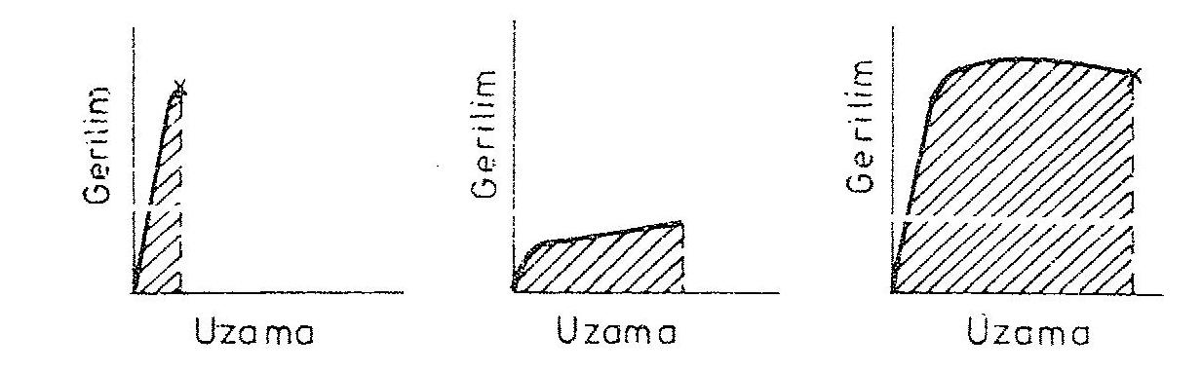

Figure 4.3. Relationship between stretching form-change and satiety values

Notch impact satness is a measure of the energy required for crunchy breakage of the material (Figure 4.4).
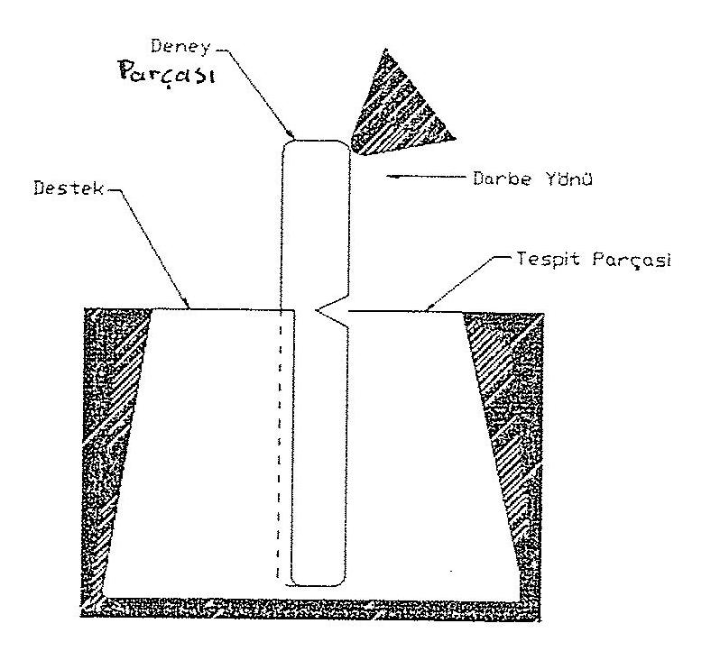

Figure 4.4. Notch impact satness test

Fatigue resistance is the greatest stretching of the material in which it can withstand a certain number of repeated variable loads (Figure 4.5).

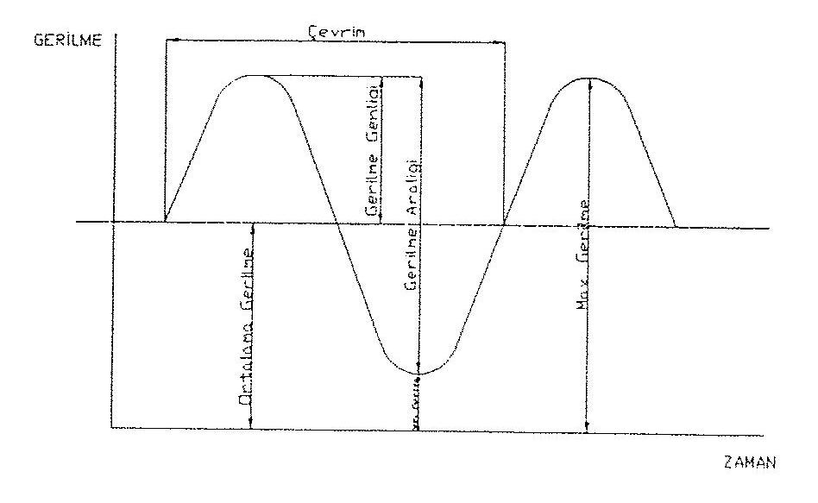
Figure 4.5. Fatigue experiment

Cremation strength is the permanent extension that a material shows over time under constant load.

Wear is the rupture and separation of very small parts by rubbing another material from the surface of a material.

4.2. Electrical Properties

The conductivity, insulation, magneticity, optical and thermal properties associated with the electron structure of the material.

4.2.1. Electrical conductivity

Table 4.1. Conductivity values of some materials

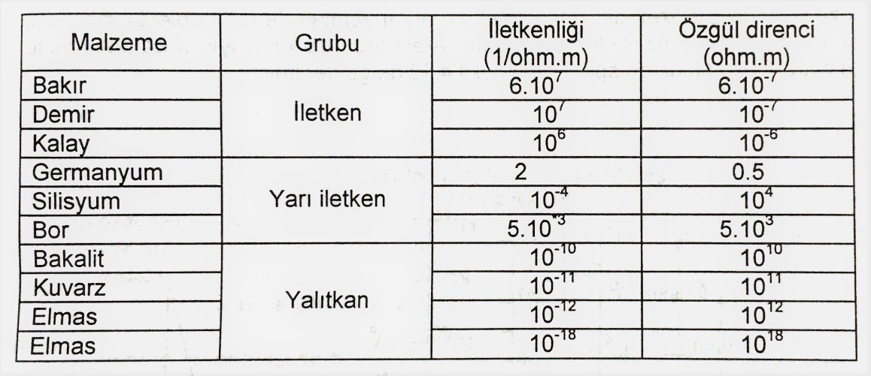

Metals are materials that transmit electricity well. They owe it to the ability to move the valans electrons freely. However, these electrons must be able to enter the domain of one atom from the domain of another atom, that is, to change it to energy levels.

In materials with ion and valence bonds, electrons are tightly attached to the atom. These materials are not conductive as there are no free electrons. If electrical field and temperature are applied at sufficient height, a sufficient number of electrons may become free. Materials that become conductive in this case are called semiconductor materials.

With the cooling of some superconducting metal material to critical temperature, their self-resistance is zero. Such materials are called superconducting materials (Table 4.1).

4.2.2. Magnetic properties

Electrons give rise to some rotating currents, rotating around the atomic nucleus and around their axis called spin. This causes magnetic fields to form in currents.

However, in the case of an external magnetic field, electron currents are affected, causing the internal areas to be partially directed and two different magnetic behaviors to occur. In the first case, the inner area affects the outer area, weakening it slightly. So these materials are poorly transmitted by the magnet. It's called diamagneticism. In the second case, the outer area is slightly strengthened and pulls to a minimum. It's called paramagneticism. A special form of paramagneticism is ferromagneticity, these materials are very strongly strengthened and strongly drawn by the external field.

4.2.3. Optical properties

The optical properties of materials are light-related permeability, reflection, suction, refraction. In metals, the light wave is reflected back by the free electron cloud, preventing it from passing through the material. Therefore, metals are not transparent, but opaque materials. Since ceramic and polymer materials containing ion and valence bonds do not contain free electrons, the material does not reflect light.

4.2.4. Heat properties

In solid materials, the type of heat conduction is called conduction. In gas and liquid fluids, heat transmission occurs by the movement of atoms and molecules. This heat transmission is called convection. The third type of heat conduction is called radiation. In this type of transmission, they release some of their energy onto the surface of the object hit by photons that form electromagnetic waves.

