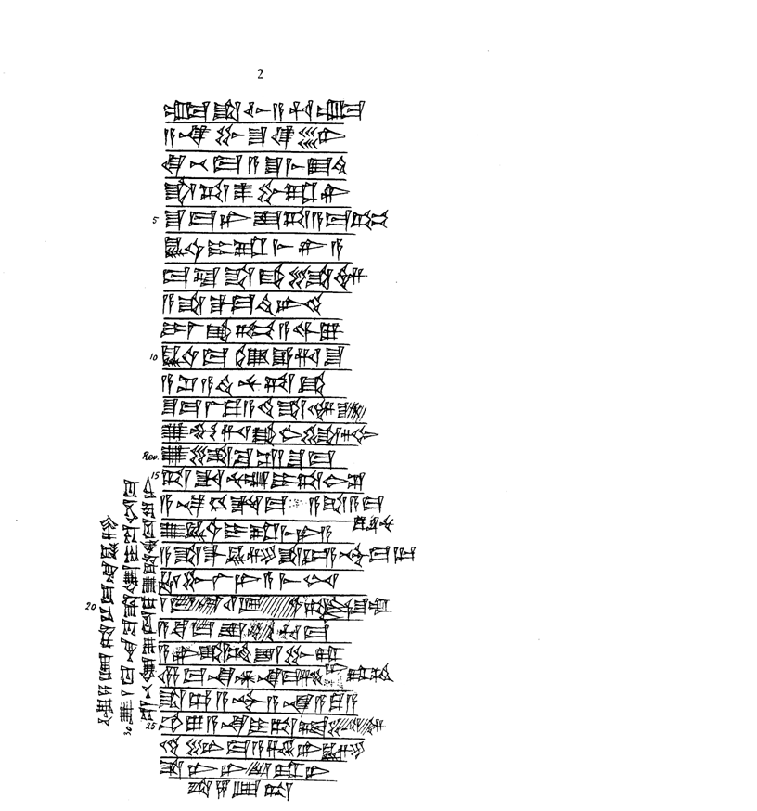
TC II, 2
{Vs.} 1 um-ma S^a-lim-a-hu-um-ma
a-na Pu-s^u-ke-en6
qi2-bi4-ma a-s^u-mi3 E2.ti2
s^a ta-as^2-pu-ra-ni
5 s^u-ma ni-is^-ta-a-ma-kum
KU3.BABBAR i-ra-mi3-ni-a
ma-la s^a-qa2-li-im
a-s^a-qal-ma te2-er-ti2
i-la2-ka3-kum a-wi-lu
10 KU3.BABBAR ma-dam e-ri-s^u
a-s^i2-a-ti2 nu-ta-qa2
s^u-ma la ku-a-ti2 s^a-im-s^[u-nu]
u2 mu-ri qa2-ab2-li-tim
{Rs.} u2-li-ba-s^i2 / s^u-ma
15 ta-da-nu-um i-ta-ab2-s^i2
a-na-hi-id-ma a-s^a-a-ma=ku-s^u-nu
u3 KU3.BABBAR i-ra-mi3-ni-a
a-s^a-qal KU3.GI s^a DUMU A-s^ur3-ma-lik
ha-bu-la2-ni a-mi3-nim
20 1 ma-na 11 GIN2 [KU3].BABBAR ta!-tur4!-s^u-um
a-ki-ma is^-mu-hu-ma
a-ni-s^a-am is^-pu-ra-ni
14 ma-na AN.NA ma-si2-a-am
s^a Dan-A-s^ur3 a-na A-gu5-a
25 ub-lu a-na i-ta-at,-li-im
di2-in-ma a-s,e2-er KU3.GI
s^a I3-li2-[as^2]~-ra-ni
s^a 5 GIN2.TA
{l.S.} u3 4 GIN2.TA 1/3 ma-na KU3.GI
30 u2 1 ma-na pa2-s^a-lam i-pa2-nim-ma
s^e2-bi-lam u2-tu3-ku u2-s^a-ah-du-ru-ni

