13.Hafta 39-41
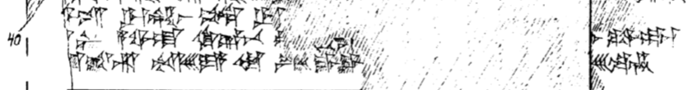
39 [DINGIR-^{LI}]^{M}-is UR.MAH-as pe-di UR.[MAH-an-pat ti-it-ta-nu-zi ku-e-da-ni-ma]
40 [me-h]u-ni A-WA-AT KI.KAL.BAD pa-[iz-z]i n[a-as-ma wa-ag-ga-ri-ya-u-as ut-ta]r ku-wa-at-ka₄
41 [DUGUD-es-k]at-ta-ri ARADMES-YA Ù ^{LÚ.MES}GAL.GAL[-YA DUMU-mi wa-ar-ri-es e-]es-te-en

