  - COMMON ORGANIC LABORATORY APPARATUS

Nowadays, in the organic chemistry laboratory, the apparatus using for reactions, separation and purification as standard laboratory materials are consist of joint glass tubes and glass materials made of them. It will be useful at the very outset to introduce the student to the apparatus that is commonly employed in the organic laboratory. Whether he will personally handle all the types of apparatus to be described will, of course, depend (i) upon the duration of the course in practical organic chemistry and (ii) upon the facilities provided by the laboratory. Nevertheless, it is deemed advantageous that the student should, at least, know of their existence. The use of less commonly used cork and rubber stoppers for the bonding of glass materials is given first. The joint ground glass material is then described in detail.

    - Glass Materials and The Others

Beaker, erlen, mesure etc. In addition to standard glass materials, different shapes and types of flasks, coolers and funnels are used in organic chemistry laboratory.

- Flasks. Various types of flasks are shown in Fig. 1.3.1, a-e.
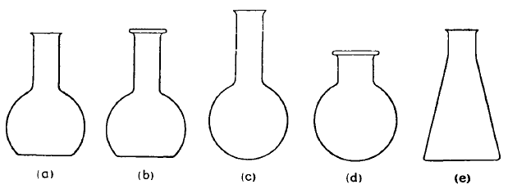

Fig. 1.3.1a-e.

(a) Flat-bottomed flask (the so-called Florence flask) with vial mouth. The sizes vary between 50 ml and 40 litres.
(b) This is similar to (a) except that it is provided with a ring neck, which increases the mechanical strength, prevents breakage when a stopper is inserted, and provides a means for wiring a stopper in place. The upper rim is ground flat.
(c) Round-bottomed flask. The common sizes range between 25 ml and 50 litres.
(d) Round-bottomed flask with short ring neck (the so-called bolthead flask). This is widely used, particularly in advanced work, and possesses the advantages given under (b). The common sizes range
between 50 ml and 20 litres.
(e) This is the familiar Erlenmeyer or conical flask. The common sizes range between 25 ml and 6 litres.
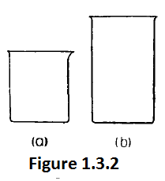
- Beakers. The usual Griffin form with spout, (Fig. 1.3.2,a) are widely used. Sizes between 30 ml and 6 litres are available. The tall form without spout (Fig. 1.3.2, b) occasionally finds application in organic laboratories.

- Distilling flasks. (Fig. 1.3.3),

(a) is the ordinary distilling flask. The sizes vary between 25 and 5,000 ml
(b) is the so-called Claisen flask, a distilling flask with two necks; the thermometer is placed in the neck carrying the side arm. Sizes vary between 25 ml and 2,000 ml. It is of particular value in distillations
where foaming or bumping occurs, and is widely employed in distillations under diminished pressure.
(c) is identical with (b) except that it is provided with a second long and indented neck (which is essentially a Vigreux column). It is sometimes termed a Claisen flask with fractionating side arm.
In (d) the side arm outlet extends a short distance into the long neck of the flask, thus preventing any vapour which has been in contact with cork or rubber stoppers from condensing and flowing down the side arm.
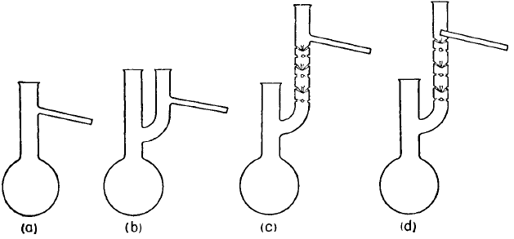

Fig. 1.3.3

It is usually employed for those liquids which attack cork or rubber stoppers.

- Condensers. The various types in common use are shown in (Fig. 1.3.4, a-h.)

(a) is a typical Liebig condenser, which consists of an inner glass tube surrounded by a glass jacket through which water is circulated. The inner jacket is fitted into the outer jacket by means of rubber stoppers; rubber tubing, formerly used, is less durable and is not recommended.
(b) is an all-glass Liebig condenser of similar design to (a); the jacket is sealed to the condenser tube. Two convenient sizes of condensers, suitable for general use, have jackets of 20 and 40 cm length. In the Pyrex glass West condenser greater efficiency of cooling is obtained by having a light-walled inner tube and a heavy-walled outer tube with a minimum space between them.
(c) is the inner tube of a Liebig condenser. It is used as an air-condenser when the boiling point of the liquid is above 140-150°C.
(d) is an all-glass Allihn condenser. The condensing tube is made with a series of bulbs; this increases the condensing surface and lessens the resistance to the passage of vapours when the condenser is employed for refluxing, i.e., for condensing the vapours issuing from the flask so that the liquid continuously flows back again.
(e) is a typical double surface condenser (Davies type). It is far more efficient than any of the preceding types and the jacket is usually shorter.
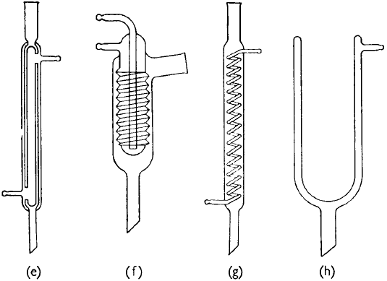
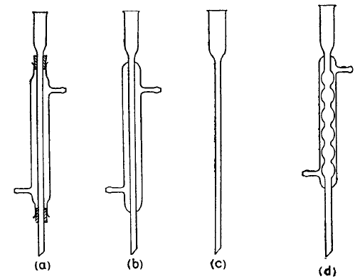

(Fig. 1.3.4, a-h.)

(f) is an efficient spiral condenser of the Friedrich type. The hot vapours can be introduced either at the side or the bottom, thus permitting the use of the condenser either for condensing vapours from another reaction vessel or for ordinary reflux purposes.
(g) is a coil condenser provided with an internal glass coil or spiral. In a modification there is both an internal spiral as well as an outer cooling jacket.
(h) is a Dewar type of reflux condenser. It is usually charged with a freezing mixture, e.g., Dry Ice mixed with alcohol or acetone.

- Funnels. Various kinds of funnels are depicted in Fig. 1.3.5, a-f.

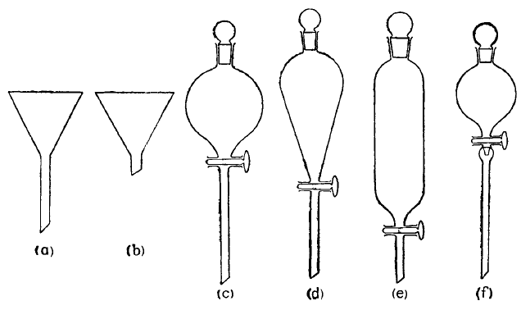

Fig. 1.3.5, a-f.

(a) is the ordinary 60° filtration funnel. It is convenient in many operations to employ funnels with a short stem (0,5-1 cm long) as in (b).
(c), (d) and (e) are examples of separatory funnels. Type (c) is the globular form and is the most widely used; (d) and (e) are the Squibb (pear-shaped) and cylindrical separatory funnels respectively. The funnel (f) is similar to (c) except that it is provided with a device immediately below the tap which enables the liquid to be added dropwise, the rate of addition being visible even when the stem of the funnel is immersed in a liquid: it is termed a dropping funnel.

- Hot water funnels. Three varieties of hot water funnel are illustrated in Fig. 1.3.6. Type (a) consists of a double-walled copper jacket to

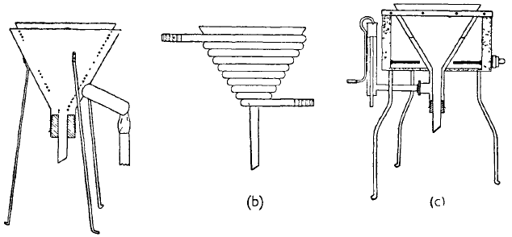
Fig. 1.3.6

house the funnel; it is mounted on a tripod. The space between the walls is almost completely filled with water, and the water may be heated to any desired temperature below 100°C by directing the flame of a Bunsen burner on to the side tube. Type (b) consists of a coil made of copper or lead tubing of about 10 mm diameter forming a 60° cone; this will therefore accommodate any funnel. Hot water or steam is passed through the coil, hence it is very suitable for the filtration of inflammable liquids. The funnel may also be used for " cold filtrations " by circulating cold water through the coil. Type (c) is an electrically heated funnel and is provided with a constant level device. Electric heating mantles for both 60° glass funnels and Buchner funnels are commercial products.

- Funnels for filtration by suction. These are illustrated in Fig. 1.3.7 a-g

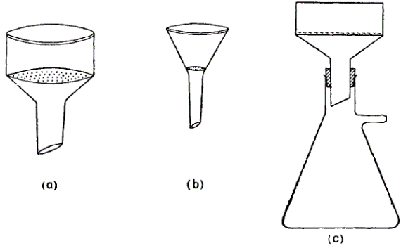
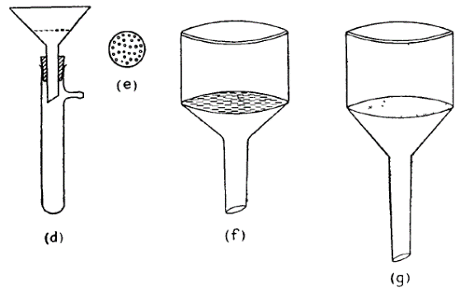

Fig. 1.3.7 a-g

(a) is a Buchner funnel; it is made of porcelain and has a perforated porcelain plate to support a filter paper. A Buchner funnel (and other funnels described below) is used in conjunction with a filter or suction flask, into which it is fitted by means of a rubber stopper as in (c); the flask is attached by means of thick-walled rubber tubing (" pressure tubing ") to a water suction pump.
(b) is a modification known as a Hirsch funnel. This has sloping sides and is designed to deal with a smaller amount of precipitate than the Buchner funnel. The smallest size will accommodate filter papers 3-4 mm in diameter.
(d) is a substitute for the Hirsch funnel. It consists of an ordinary glass funnel fitted with a Witt plate (e), which is a perforated porcelain plate 1-4 cm. in diameter, upon which a filter paper can rest. The great advantage of (d) is that it is possible to see whether the apparatus is clean; with porcelain funnels it is impossible to inspect the lower side of the perforated plate.
(f) is a " slit sieve " funnel. It is constructed entirely of glass (Jena or Pyrex) and therefore possesses obvious advantages over the opaque (porcelain) Buchner or Hirsch funnel.
(g) is a sintered glass funnel, and is available in a number of porosities (coarse, medium and fine).

- Multi-necked flasks. Fig. 1.3.8, a, illustrates a typical threenecked flask. This has numerous applications in organic chemistry; for many operations, the central aperture carries a mechanical stirrer, and the two side apertures a dropping funnel and a reflux condenser respectively.

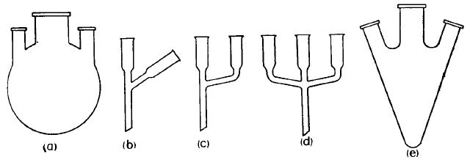

Fig. 1.3.8

(b) and (c) are alternative forms of two-way addition tubes. These normally have an overall length of 16-20 cm, and the openings have an internal diameter of 24-25 mm
(d) is a three-way addition tube. The addition tubes are usually inserted into wide-necked flasks (e.g., bolt-head flasks).
(e) is a special form of three-necked flask (sometimes termed a Grignard flask), which is particularly suitable for any reaction (e.g., the Grignard reaction) where components of widely different densities are to be mixed.

Miscellaneous apparatus. Two forms of adapters (or adapter tubes) are illustrated in Fig. 1.3.9, a and b; these are generally used to facilitate the delivery of a distillate from a condenser to a receiver.

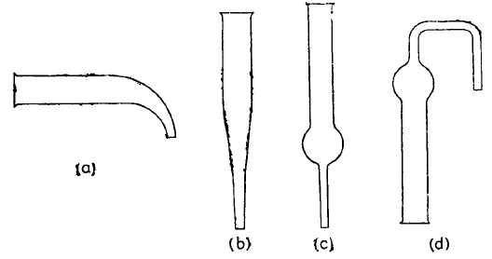

Fig. 1.3.9

Two forms of the so-called calcium chloride tubes (also termed drying tubes, straight form) are shown in (c) and (d); these are filled with anhydrous calcium chloride or with cotton wool (previously dried at
100°C), and are attached by means of a stopper to a flask or apparatus containing substances from which moisture is to be excluded.

    - Use of Cork and Rubber Stoppers
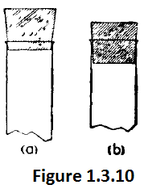
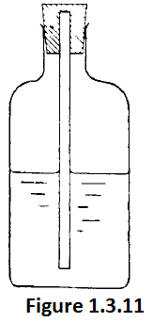
Two points must be borne in mind when selecting a cork stopper. In the first place, the cork should be examined for freedom from flaws; unless corks of the highest quality are employed, they are liable to have deep holes, which render them useless. In the second place, the cork should originally fit as shown in Fig. 1.3.10, a and not as in b. It should then be softened by rolling in a cork press or by wrapping it in paper and rolling under the foot. To bore a cork, a borer should be selected which gives a hole only very slightly smaller than that desired. The cork borer is moistened with water or alcohol or best with glycerine; it is convenient to keep a small bottle (ca. 25 ml capacity) containing glycerine, Fig. 1.3.11, for this purpose. The borer is held in the right hand and the cork in the left hand. The hole is started at the narrow end with a continuous rotary motion. Beginners should bear in mind that the borer is a cutting instrument and not a punch, and on no account should it be allowed to burst its way through the cork because the borer, upon emerging, will almost invariably tear the surface of the cork. It is a good plan to examine the borer from time to time as it advances through the cork to see that it is cutting a straight hole. Boring should be stopped when it is half through the cork and the tool removed from the hole. The cork plug is pushed out with the aid of the solid metal rod supplied with the set of borers, and the remainder of the hole is bored from the other end. If the holes are carefully aligned, a clean cut hole is obtained. Experienced laboratory workers frequently complete the whole boring operation from one side, but beginners usually tear the edges of the cork by this method, which is therefore not recommended.

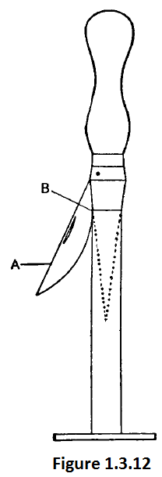
A well-fitting cork should slide over the tube (side arm of distilling flask, thermometer, lower end of condenser, etc.) which is to pass through it with only very moderate pressure. The bored cork should be tested for size; if it is too small, the hole should be enlarged to the desired diameter with a small round file. When the correct size is obtained, the tube is held near the end and inserted into the cork. The tube is then grasped near the cork and cautiously worked in by gentle twisting. Under no circumstances should the tube be held too far from the cork nor should one attempt to force a tube through too small an opening in a cork; neglect of these apparently obvious precautions may result in a severe cut in the hand from the breaking of the glass tube. For consistently successful results in cork boring, a sharp cork borer must be used. The sharpening operation will be obvious from Fig 1.3.12. The borer is pressed gently against the metal cone, whilst slight pressure is applied with the " cutter " A at B; upon slowly rotating the borer a good cutting edge will be obtained. If too great pressure is applied either to the borer or to the " cutter," the result will be unsatisfactory and the cutting circle of the borer may be damaged. To maintain a cork borer in good condition, it should be sharpened every second or third time it is used. Rubber stoppers are frequently employed in the laboratory in " vacuum distillation " assemblies; for distillations under atmospheric pressure bark corks are generally used. Many organic liquids and vapours dissolve new rubber stoppers slightly and cause them to swell. In practice, it is found that rubber stoppers which have been previously used on one or two occasions are not appreciably attacked by most organic solvents, owing presumably to the formation of a resistant surface coating. To bore a rubber stopper, it is essential to employ a very sharp cork borer of the same size as the tube to be inserted into the hole. The borer is lubricated with a little glycerine (Fig. 2.3.2) and steadily rotated under only very slight pressure. The operation requires a good deal of patience and time and frequent lubrication may be necessary; if too much pressure be exerted equent lubrication may be necessary; if too much pressure be exerted. borer, a hole of irregular shape and diminishing size will result.

The insertion of a glass tube into a rubber stopper or into rubber tubing is greatly facilitated by moistening the rubber with a little glycerine. After some use rubber may stick to glass and great care must be taken not to break the glass tube when removing it. Frequently the exertion of gentle pressure on the rubber stopper by means of the two thumbs whilst the end of the tube (or thermometer) rests vertically on the bench will loosen the stopper; this operation must, however, be conducted with great care. Another method is to slip the smallest possible cork borer, lubricated with a little glycerine, over the tube, and to gradually rotate the borer so that it passes between the stopper and the glass tube without starting a new cut.

    - CUTTING AND BENDING OF GLASS TUBING

Many students tend to forget the practical details learnt in elementary courses of chemistry; they are therefore repeated here. To cut a piece of glass tubing, a deep scratch is first made with a triangular file or " glass knife;" The tubing is held in both hands with the thumbs on either side of the scratch, but on the side opposite to it. The tubing is then " pulled " gently as though one wanted to stretch the tube and also open the scratch. A break with a clean edge will result. The cut edge must then be rounded or smoothed by fire polishing. The end of the tube is heated in the Bunsen flame until the edges melt and become quite smooth; the tube is steadily rotated all the time so as to ensure even heating. Overheating should be avoided as the tube will then partially collapse.

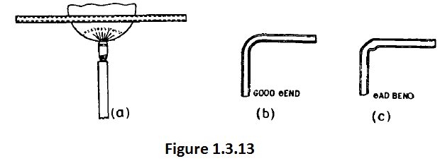

A " batswing " or " fish-tail" burner is generally used for the bending of glass tubing. The tube is held with both hands in the length of the flame (Fig.1.3.13 a) so that 5-8 cm are heated: the tube must be slowly rotated about its axis so as to heat all sides equally. As soon as the glass is felt to be soft, it is bent to the required shape. This is best done by removing it from the flame and allowing one end to fall gradually under its own weight, whilst being guided so that it is in the same plane as the rest of the tube. The glass must never be forced, otherwise a bad bend with a kink will be obtained as in Fig. 1.3.13.c

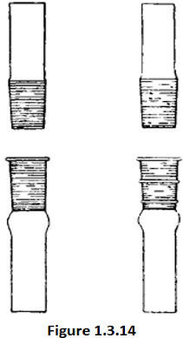
    - Types of Ground Glass Joints

All ground glass joints should be constructed of a high resistance glass, such as Pyrex. The most common form is shown in Fig. 1.3.14 and this is the type largely encountered in practice. Ground glass joints are used in laboratories to quickly and easily fit leak-tight apparatus together from commonly available parts. This is a large improvement compared with older methods of custom-made glassware, which was time-consuming and expensive, or the use of less chemical resistant and heat resistant corks or rubber bungs and glass tubes as joints, which took time to prepare as well.

Two general types of ground glass joints are fairly commonly used: joints which are slightly conically tapered and ball and socket joints (sometimes called spherical joints) (Figure 1.3.15)
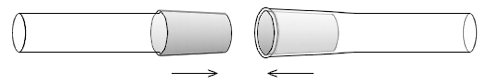
Figure 1.3.15

Conically tapered ground glass joints. Inner (male) joint (cone) shown on the left and outer (female) joint (socket) shown on the right. Ground glass surfaces are shown with gray shading. By assembling them in the direction of the arrows, they can be joined.

For ball-and-socket joints (also known as spherical joints), the inner joint is a ball and the outer joint is a socket, both having holes leading to the interior of their respective tube ends, to which they are fused. The ball tip is a hemisphere with a ground-glass surface on the outside, which fits inside of the socket, where the ground glass surface is on the inside. Ball-and-socket joints are labeled with a size code consisting of a number, a slash, and another number. The first number represents the outer diameter in millimeters of the ball at its base or the inner diameter in millimeters at the tip of the socket, in both cases where the diameters are their maximum in the joints.

The second number represents the inner diameter of the hole in the middle of the ball or socket, which leads to the inner diameter of the tube fused to the joint.

Figure 1.3.16

Ground-glass ball (left) and socket (right) joints. The ground-glass surfaces are shown with gray shading. By putting them together in the direction of the arrows, they can be joined, with some grease applied to the ground-glass surfaces (Figure 1.3.16)

The spherical joint or semi-ball joint or ball and socket joint is illustrated in Fig. 1.3.17 which includes one type of special clamp for holding the two halves of the joint together. To prevent a joint from separating during a reaction process, various types of plastic or metal clips or springs can be used to secure the two sides together. They are available in a variety of materials for different temperature and chemical environments.

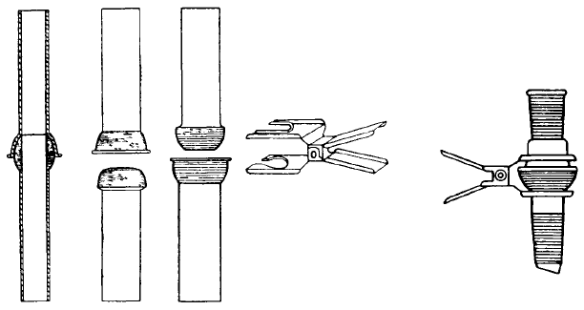
Figure 1.3.17

This connexion cannot freze or stick (as conical ground joints sometimes do) and it introduces a degree of flexibility into the apparatus in which it is used. The area of contact between the ground surfaces is relatively small so that the joints are not intended to provide for considerable angular deflection. The main application is in conjunction with conical joints rather than as a substitute for them. The conical-spherical adapters shown in Fig. 1.3.17 provide a means of inserting a spherical joint whilst retaining the standard conical joint principle.

The conically tapered ground glass joints typically have a 1:10 taper and are often labeled with a symbol ST, consisting of a capital T overlaid on a capital S, meaning "Standard Taper". This symbol is followed by a number, a slash, and another number. The first number represents the outer diameter (OD) in millimeters at the widest point of the inner (male) joint. The second number represents the ground glass length of the joint in millimeters. Internationally the ISO sizes are used with 14/23, 19/26 and 24/29 very common in research laboratories, with 24/29 the most common. In the US the ASTM sizes (equal to the now obsolete Commercial Standard 21) are used with common sizes being 14/20, 19/22, 24/40 and somewhat 29/42. In the US 24/40 is most common.

      - Apparatus wıth interchangeable ground glass joints suitable for general use in preparative organic chemistry

- Adapters and stopcocks

Stoppers; with flat heads are to be preferred, since they may be stood on end when not in use, thus avoiding contamination of the ground surface. An additional refinement is the provision of a finger grip as in Fig. 2.5.8, a.
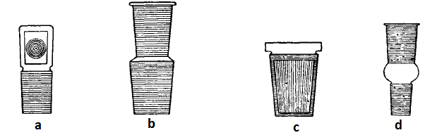

Figure 1.3.18, a-d

Reduction adapters; These may be employed to connect condensers, still-heads, etc. to flasks, extraction apparatus and the like. Used to switch from a large size threaded connection to a small size of threaded connection. Numerous combinations (Fig. 1.3.18b) are, of course, possible, but the commonest sizes are of joints and sockets available in the U.S.A. will be found in 14/23, 19/26 and 24/29.

Figure 1.3.18 c represents the Bushing type of adapter, which is much shorter than the above and permits of more compact assemblies. It must be emphasised, however, that in a well-designed assembly of apparatus, the number of adapters should be reduced a minimum and, best of all, completely eliminated.

Expansion adapters; (Fig. 1.3.18d) used to connect equipment having ground glass joints of different sizes. Used to switch from a small size threaded connection to a large size of threaded connection. Numerous combinations are, of course, possible, but the commonest sizes are of joints and sockets available in the U.S.A. will be found in 14/23, 19/26 and 24/29.

Stopcocks; (Figure 1.3.19) For laboratory glassware, items sometimes have plug valves with conically-tapered inserts called stopcocks (sometimes referred to as "plugs" by laypeople) with different bores. The valve bodies are usually made of glass, while the plugs are made of glass or Teflon. One can also find valves with Teflon spindle (for example one way valves or angled valves) When the plug is made of glass, the handle and plug are fused together in one piece out of glass. When both valve body and plug are made of glass, a suitable grease (e.g. silicone grease or Ramsay grease) is usually used to give a good seal, as well as to prevent the valve from seizing and subsequently cracking.
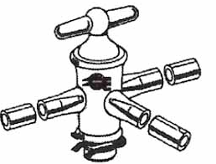
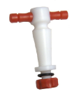

Figure 1.3.19

Multiple adapters; The double neck adapter (Fig. 1.3.20 a) provides as its name implies, two entries into a flask. Two forms of triple neck adapters are shown in Fig. 2.5.10, b. The sizes of cones and sockets are similar to those for the double neck adapter. These adapters convert an ordinary flask into what is virtually a three-necked flask.
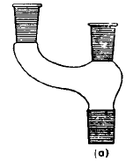
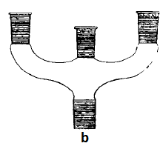

Fig. 1.3.20 a-b

Multi-necked flasks. Various types of multi-necked flasks are illustrated in Figs. 1.3.21a-e. The centre socket is usually the largest and the side sockets are generally smaller. (e) is a jacket-flask, it provides fluids recirculation in the constant temperature.
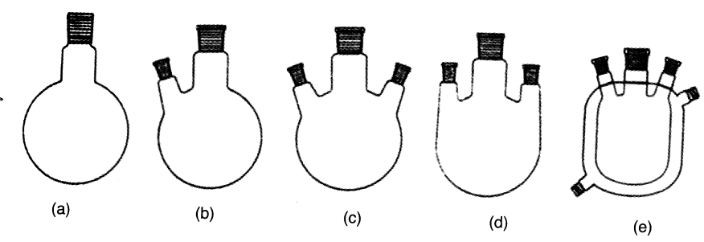

Figs. 1.3.21a-e

Condensers; Several types of condensers are widely used. Fig. 1.3.22 (a) is an improved form of Liebig's condenser, sometimes termed a West condenser: it has an inner tube with very thin walls and the space between it and the heavy-walled outer tube is small, consequently there is a rapid heat transfer to the fast-flowing cooling water leading to greater efficiency. (b) is Allihn type condenser, (c) is Graham types (double coil type) are examples of efficient double surface condensers; (d) is type of Dimroth cendenser; (e) is an examples of efficient double surface condensers (Davies types); (f) is double surface and double coil type condenser; (g) is dry ice condenser.
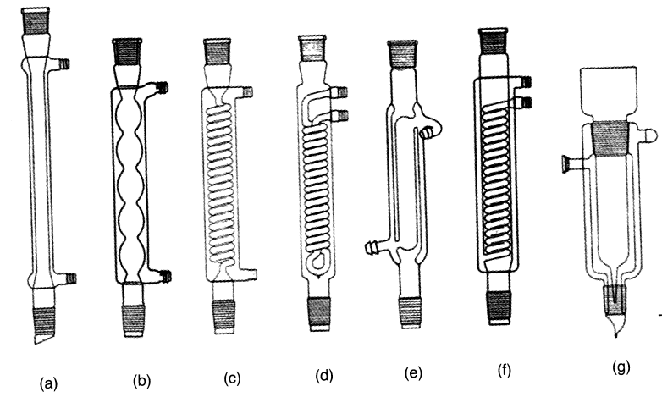
Figure 1.3.22 a-g

Dropping Funel; it is provided with a device immediately below the tap which enables the liquid to be added dropwise. This is similarly provided with a cone on the stem and a ground socket Fig. 1.3.23, a. The insertion of a dripping tip immediately below the stopcock is a valuable refinement. Fig. 1.3.23,b represents a cylindrical funnel with pressure equalising tube; this is useful for reactions which are conducted in an atmosphere of inert gas. An open dropping funnel with side tube is shown in Fig. 1.3.23, b. A Buchner funnel shown in Fig. 1.3.24 is fitted by ground joint. used in conjunction with a filter or suction flask.
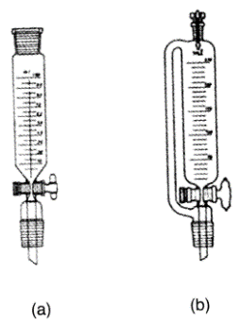
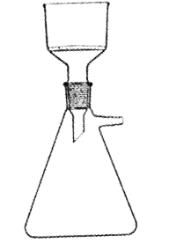

Figure 1.3.23, a-b Figure 1.3.24

1.3.5 Cleaning and Drying Of Glassware

All glassware should be scrupulously clean and, for most purposes, dry before being employed in preparative work in the laboratory. It is well to develop the habit of cleaning all glass apparatus immediately after use; the nature of the " dirt " will, in general, be known at the time, and, furthermore, the cleaning process becomes more difficult if the dirty apparatus is allowed to stand for any considerable period, particularly if volatile solvents have evaporated in the meantime.

The most widely used cleansing agent is the " chromic acid " cleaning mixture. It is essentially a mixture of chromic acid (CrO₃) and concentrated sulphuric acid, and possesses powerful oxidising and solvent properties. One method of preparation are available :—

Five grams of sodium dichromate are dissolved in 5 ml of water in a 250 ml. beaker; 100 ml of concentrated sulphuric acid are then added slowly with constant stirring. The temperature will rise to
70-80°C. The mixture is allowed to cool to about 40°C and then transferred to a dry, glass-stoppered bottle. Before using the chromic acid mixture for cleaning, the vessel should be rinsed with water to remove organic matter and particularly reducing agents as far as possible. After draining away as much of the water as practicable, a quantity of the cleaning mixture is introduced into the vessel, the soiled surface thoroughly wetted with the mixture, and the main quantity of the cleaning mixture returned to the stock bottle. “After standing for a short time with occasional rotation of the vessel to spread the liquid over the surface, the vessel is thoroughly rinsed successively with tap and distilled water. If a black solid, probably consisting largely of carbon produced by overheating the contents of the apparatus, remains after the above treatment, it is recommended that a small volume of the reagent be introduced into the flask and the latter gently and evenly heated with a free flame until the acid commences to fume. Under these conditions, most carbonaceous matter is oxidised.

1.4 STIRRING

In organic chemistry, well stirring is necessary to ensure mixing of the starting materials and/or to facilitate the interaction between the phases.

stirring is also necessary in work with homogeneous solutions especially when it is desired to add a substance portion-wise or dropwise so as to bring it as rapidly as possible into intimate contact with the main bulk of the solution. This applies particularly in those cases where a precipitate is formed and adsorption may occur, or where heat is generated locally which may decompose a sensitive preparation. In such cases the solution must be continuously agitated by manual shaking, by mechanical stirring or, preferably, magnetic stirring. When large quantities of material are to be dealt with, it is much easier and very much more efficient to employ mechanical stirring.

1.4.1 Magnetic Stirring

A rotating field of magnetic force is employed to induce variable speed stirring action within either closed or open vessels. The stirring is accomplished with the aid of small permanent magnets sealed in Pyrex glass, teflon or in Polythene (PVC). The principle of magnetic stirring will be evident from Fig. 1.4.1. A permanent bar magnet, mounted horizontally, is attached to the shaft of an electric motor: the whole is mounted in a cylindrical housing with flat metal top and heavy cast metal base. A resistance (which is frequently incorporated in the housing) is provided to control the rate of stirring. To use the apparatus, the rheostat, which is initially in the off-position, is slowly rotated (this increases the motor speed) until the required rate of stirring is attained. When the experiment is complete, the rheostat is returned to the zero position, the " stirrer " allowed to come to rest and removed with the aid of a pair of forceps.

Magnetic stirring has many obvious applications, but the most important are probably to stirring in closed systems, e.g., (a) where gas volume changes must be observed as in catalytic hydrogenations, (b) where exclusion of air is desirable to prevent oxidation, (c) where reactions are to be carried out in an anhydrous environment, and (d) where small containers are used and the introduction of a propeller shaft is inconvenient.
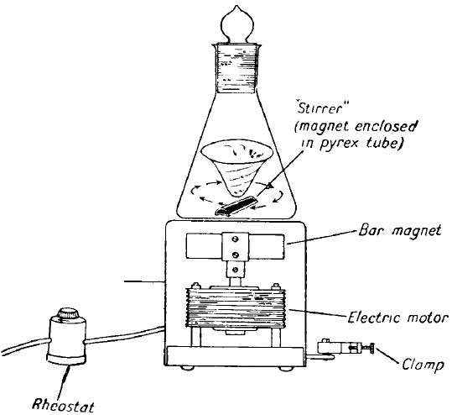
Figure 1.4.1

Many forms and sizes of magnetic stirrer (7-10 mm length; 2-10 mm diameter) are available commercially. These include those fitted with an electric hot plate provides both heating and stirring at the same time. If necessary some heating baths (water, oil or sand baths) can be used with this magnetic stirrer.

1.4.2 Mechanical Stirring
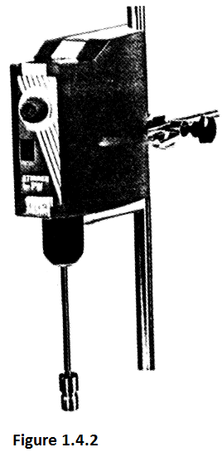
A mechanical stirrer comprises a stir bar connected directly to the shaft of an electric motor (Figure 1.4.2). The stirrer bars are usually made of glass, sometimes of steel or teflon and of various lengths. Those made of glass and teflon are connected to the shaft of the motor by means of a short length of heavy-wall rubber tubing whilst stainless steel stirrer fitted into the position by means of a screw. The speed of mixing can be controlled in mechanical stirrer by analog or digital.

Stirrers are usually made of glass, but those of monel metal, stainless steel or Teflon (a polyfluoroethylene) also find application in the laboratory. Illustrated in Figure 21.4.3a-e. An important advantage of a stirrer with a Teflon blade is that it is comparatively soft and merely bends if it hits the glass even at high speed; furthermore, it can be shaped to fit the bottom of the vessel, thus rendering the stirring of small volumes of liquid in a large flask possible.

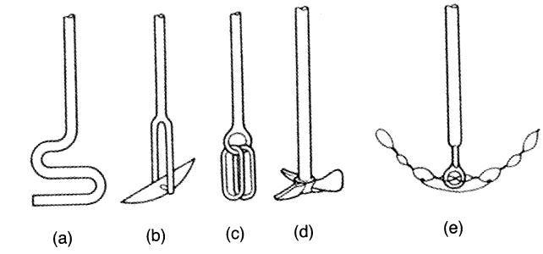
Figure 1.4.3

A useful stirrer—sometimes termed a Hershberg stirrer—efficient agitation in round-bottomed vessels, even of pasty mixtures, is presented in Fig. 1.4.3e. It consists of a hollow glass tube to which a glass ring is sealed. The glass ring is threaded with sealing another glass ring at right angles to the first and threading this with wire, better results will be obtained; this is usually unnecessary. The stirrer is easily introduced through a narrow opening, and in operation follows the contour of the flask; it is therefore particularly valuable when it is desired to stir a solid which clings obstinately to the bottom of a round-bottomed flask.

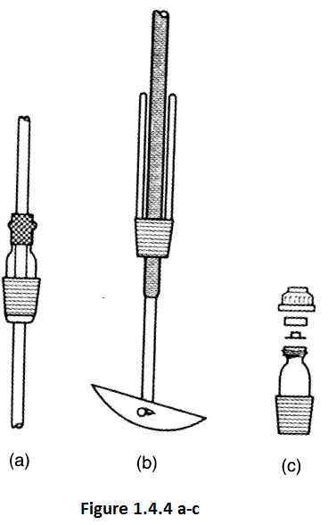
Mechanical stirrers are used in the following operations: (1) simultaneous stirring and refluxing of a reaction mixture ; (2) stirring the contents of a closed vessel; (3) agitation with prevention of the escape of a gas or vapour; and (4) stirring in an inert atmosphere, such as nitrogen or hydrogen. A simple substitute for a mercury-sealed stirrer is illustrated in Fig. 1.4.4a-c. The upper, fire-polished end of a 8-10 cm length of 10 mm glass tubing, projecting through a stopper which fits into the flask, is fitted with a 2 cm length of 6 mm heavy-wall rubber tubing so that it projects 5-8 mm beyond the end of the glass tube; this projecting portion fits tightly to form a seal round an 8 mm stirrer shaft running through the glass tubing. Glycerine (or Silicone grease) is applied to the point of contact of the glass and rubber to act as a lubricant and sealing medium. The seal, sometimes known as the Kyrides seal, can be used with reduced pressure down to 10-12 mm. of mercury.

A common operation in practical organic chemistry is for stirring, refluxing, and addition of a liquid from a dropping funnel to be carried on simultaneously. The most convenient apparatus for this purpose is a three-necked flask, fitted as in Fig. 1.4.5.

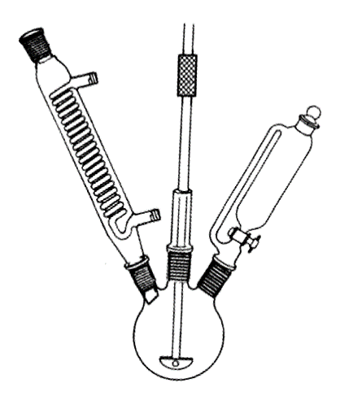
Figure 1.4.5.

1.4.3 Mechanical shaking

The mechanical shaking machine is employed for automatic mixing of heterogeneous systems and finds many applications in the organic chemistry laboratory. One type of them, illustrated in Fig. 1.4.6.a, has a case and some erlens, flasks, bottles or tubes, etc., placed in that case and are mixed with right-to-left movement or rotational movement of the case. Additionally the case can be placed into some of heating or cooling baths. The speed of shaking may be simply controlled. Or as shown in Fig. 1.4.6.b flasks fitted with a thick metal rod attached to the axis of the rod rotate around the rod and by this way flasks are shakened.
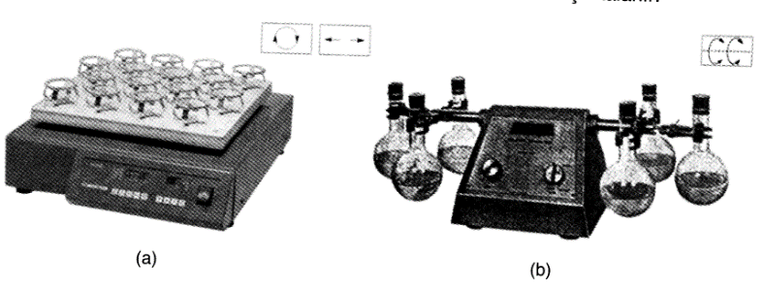
Figure 1.4.6.a-b

1.5 HEATING and COOLING

Each chemical reaction occurs when the heat is taken or supplied. The success of the reaction is therefore closely related to temperature control. The inability of controlling the temperature in organic reactions results of forming by-products or cleavage products. In the end, it becomes difficult to separate and purify the desired product and the yield is reduced. For this reason, a heating or cooling bath is selected according to the desired temperature for the organic reactions and also the sensitivity of the temperature control.

1.5.1 Heating Tecniques

In the organic chemistry laboratory, heating baths are used instead of heating directly in the flame when a sensitive temperature control is desired or the same temperature needs to be maintained for a long time. Direct heating causes placing the heat in a small area; hot spots are formed at the bottom of the flask. The heat is emitted by convectionally in liquid or by boiling. However, hot spots cause the heated liquid to not boil properly.

For temperatures up to 100°C, a water bath or steam bath is generally employed. The simplest form is a beaker or an enamelled iron vessel mounted on a suitable stand; water is placed in the vessel, which is heated by means of a flame. This arrangement may be used for noninflammable liquids or for refluxing liquids of low boiling point. Since numerous liquids of low boiling point are highly inflammable, the presence of a naked flame will introduce considerable risk of fire. For such liquids a steam bath or an electrically-heated water bath, provided with a constant-level device, must be used. Using aqueous solutions of NaCl, KCl, NaNO3, K2CO3 and CaCl2 in heating baths’ instead of water; it provides the temperature rises up to 105°, 108°, 120°, 135° and 180°C respectively.

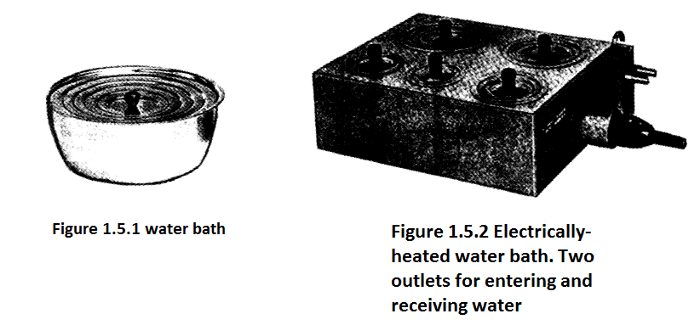

For temperatures above 100°C, oil baths are generally used. The use of oil baths provides two important advantages. First, the temperature of the bath can be adjusted with sensitivity to provide the desired temperature for the reaction or distillation. Second one, since the heat will spread slowly and smoothly, no hot spots occur.
Medicinal paraffin may be employed for temperatures up to about 220°C. Glycerol is satisfactory up to 140-150°C; above these temperatures fuming is usually excessive and the odour of the vapours is unpleasant. For temperatures up to about 250°C " hard hydrogenated " mineral oil or silicone oil is recommended: it is clear, not sticky and solidifies on cooling; its advantages are therefore obvious. Slight discoloration of the " hard " oil at high temperatures does not aflfect its value for use as a bath liquid. The Silicone fluids, are probably the best liquids for oil baths, but are at present too expensive for general use. Oil baths should be set up in the fume cupboard wherever possible. A thermometer should always be placed in the bath to avoid excessive heating. Flasks, when removed from an oil bath, should be allowed to drain for several minutes and then wiped with a rag. Oil baths are generally heated by a gas burner. Some form of internal electrical heating may be employed. A commercial heater embedded in ceramic material and sealed in metal may be supported near the bottom of the bath: the heat input is conveniently controlled by a variable transformer.

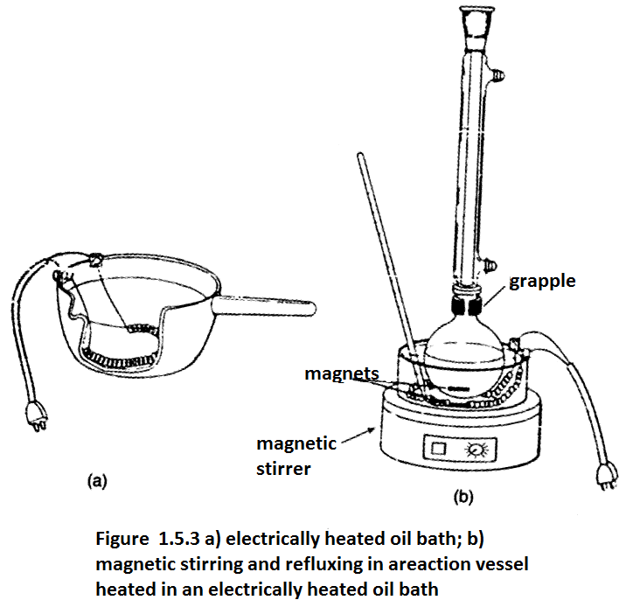

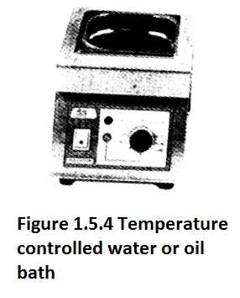
An air bath may be readily constructed by the student from a commercial circular tin can (that from tinned fruit or food is quite suitable), and is very satisfactory for most work involving the heating of liquids of boiling point above 80°C (or below this temperature if the liquid is non-inflammable).

A shallow metal vessel containing sand, the so-called sand bath, heated by means of a flame, was formerly employed for heating flasks and other glass apparatus. Owing to the low heat conductivity of sand, the temperature control is poor; the use of sand baths is therefore not recommended for routine work in the laboratory. It may occasionally be employed where high temperatures are required, e.g., in thermal decomposition; as a rule, graphite or nickel shot is preferable for this purpose.

The properties of the materials used in heating baths are summarized in the table 1.5.1.

Table 1.5.1 Materials used in heating baths

Material | Flash point, °C | Temperature range, °C | Properties
Water | - | 0-70 | Nonflammable, easy to clean if splashed and spilled, nontoxic and cheap.
Mineral oil | ~110 | 25-100 | Low flash point, easy to clean, dangerous if water and organic matter splashes, heat polymerizes, easy to supply.
Paraffin | Changeable | 50-180 | Solidified when it cooled, dangerous if water and organic matter splashes, nonpolymeric and cheap
Silicone oil | 150-350 | 25-230 | Wide range of use, not so expensive.
Vegetable oil (sunflower seed, olive oil and corn oil) | - | 25-150 | Dangerous if water splashes and nonpolymeric.
Wood metal (%50 Bi, %25 Pb, %12,5 Sn, %12.5 Cd) | - | 70-350 | steel heating bath required, can be used at high temperatures, nonpolymeric, difficult to clean, toxic and a little expensive
Sand | - | 25-500 | Hard to heat and to cool, nonpolymeric, easy to clean, nontoxic, unaffected by organic substances and cheap.

Electrically heating systems have variety of types and mostly preferred nowadays. This type of heating has many advantages such as easily controllable, safer and clean. This kind of heating provided by resistant heaters. The most commonly used resistant heaters are grouped in six groups; hot plate, oven, drying-oven, immersion heater, heating mantle and others. Hot plates' metal surface is heated with the resistance wires. The baths are placed directly on this surface, reached temperature maximum 400-500°C (Fig. 1.5.5a). Hot plates are used for nonflammable liquids heating such as aqueous solutions, chloroform and carbon tetrachloride. It should never used for heating and/or vaporising the flammable organic solvents. Since the vapor of these solvents may ignite if they get in to contact with hot surface.

When hot plates have magnetic stirrer, it called magnetic stirrer. It provides heating and stirring at the same time with temperature and rotating control (Fig. 1.5.5b).

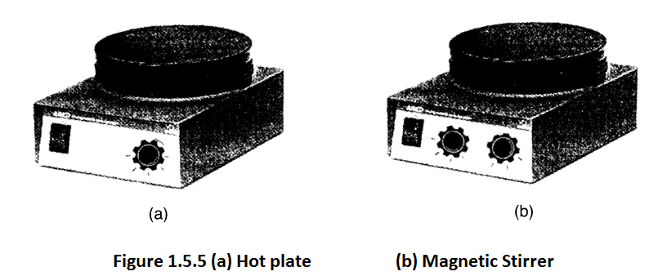

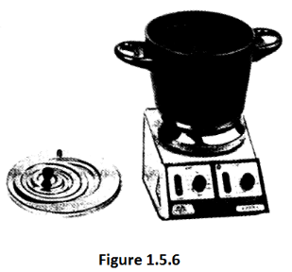
Figure 1.5.6 illustrates Teflon baths (coated with aluminium) placed on magnetic stirrer, can be used with water or oil baths and temperature rises up to 200°. Figure 1.5.7a illustrates a kind of heating setup on which a glass container is used as a water, oil or sand bath. In Figure 1.5.7b, a reflux process is shown.

Immersion heaters are resistance wires controlled by a rheostat. By this way, they are used for very high temperatures because of the high heat convection to the fluids. Mostly copper or steel wires are bent according to the shape of the container in which the liquid to be heated (Fig. 1.5.8).

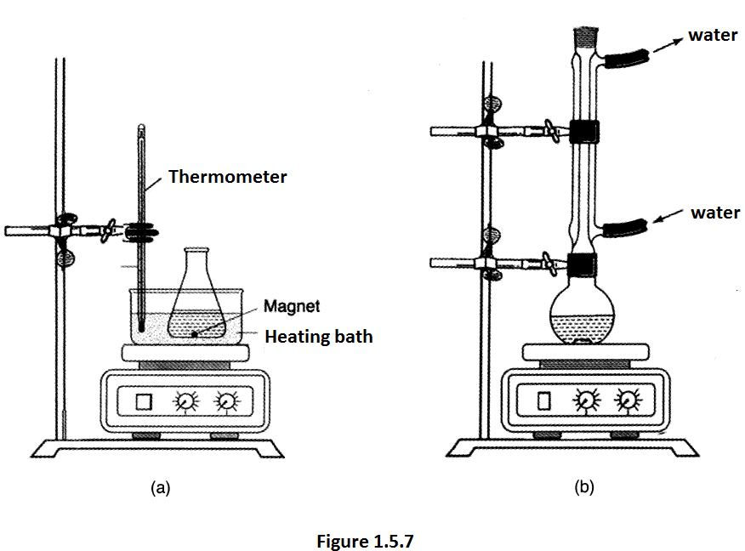

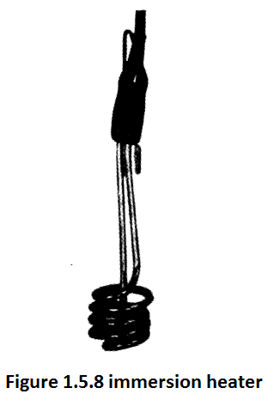
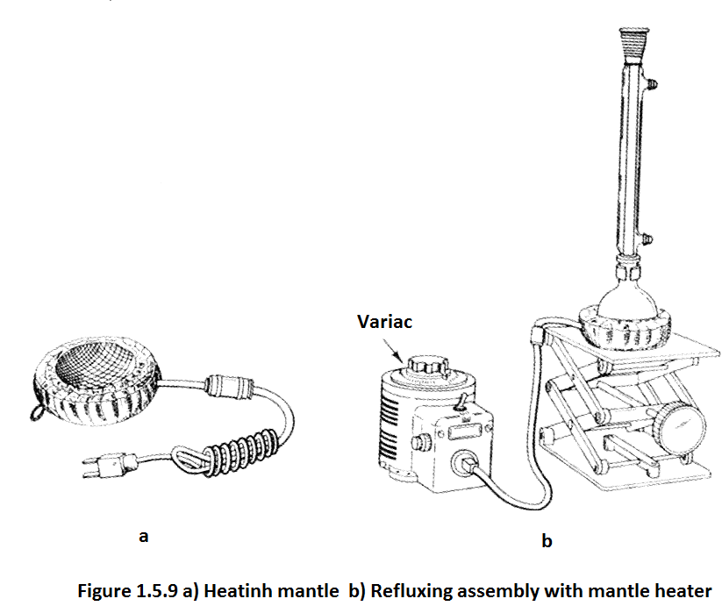
Heating mantles are preferred to use heating of the reaction and distillation flasks in the case where the hot plates or water or oil baths is difficult and dangerous. It is made of a nichrome resistance wires coated with a layer of glass is placed into a thick cloth container (Fig. 1.5.9a). Temperature controlled by a variac. Using mantle heaters is the easiest and most secure way of heating the laboratory. However, there is some undesirable side, such as the need for a little slow heating at the beginning, the higher the temperature of the container and the higher the temperature of the heat. To do so, for example, if a reaction temperature begins to out of control, it is not enough to reduce the voltage or unplug; the heater must be removed from the flask immediately and taken into a cooling bath if necessary. Therefore, the mantle heater must not be on the bench; it is possible to remove it from the flask if it is fastened to a metal bar or above a laboratory jack (Figure 1.5.9b). Another point to note is that the temperature of the mantle is changeable during the refluxing of the liquid. Because the vapor decreases the heat of mantle while cooling down and so the temperature changes. If the flask heats up to dryness, the mantle resistance wires may melt and burn. For this reason, the highest voltage to be applied to a dry flask is usually stated. One benefit of the mantle heater is that it can be used with a magnetic stirrer. This ensures stirring during heating. Nowadays, mantle heaters which are enclosed in an aluminum container are also used and the temperature control is provided by a rheostat and light signal set by a button on the front of the instrument. Adjustable heating and magnetic stirring are provided in mantle heater-stirrer. (Figure 1.5.10).

In modern laboratories central heating and steam are provided, and thus heating to 100°C can be achieved easily. The steam outlet is connected to a steam bath (a water bath with two holes for the entry of steam and condensate of water) (fig. 1.5.11).

Heat guns (figure 1.5.12) are similar to electric hair dryers and heat up the rapid airflow to 600°C. It is particularly useful in drying glass articles (mostly in an inert gas stream).

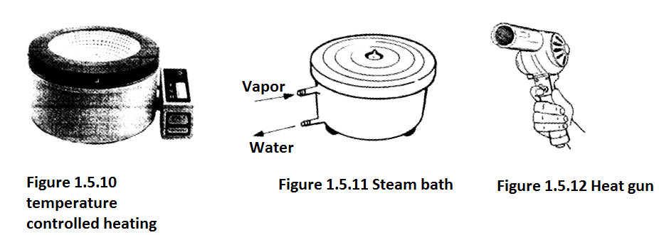

1.5.2 Cooling Techniques

It is often necessary to obtain temperatures below that of the laboratory. Finely-crushed ice is used for maintaining the temperature at 0-5°C. It is usually best to use a slush of crushed ice with sufficient water to provide contact with the vessel to be cooled and to stir frequently. For temperatures below 0°C, the commonest freezing mixture is an intimate mixture of common salt and crushed ice: a mixture of one part of common salt and three parts of ice will theoretically produce a temperature of about -20°C but, in practice, the ice salt mixtures give temperatures of -5° to -18°C. Greater cooling may be obtained by the use of crystalline calcium chloride; temperatures of -40° to -50° may be reached with five parts of CaCl₂.6H₂0 and 3.5-4 parts of crushed ice. If ice is temporarily not available, advantage may be taken of the cooling effect attending the solution of certain salts or salt mixtures in water (Table 1.5.2 i).
Solid carbon dioxide (Dry Ice, Drikold) is employed when very low temperatures are required. If it is suspended in solvents, such as alcohol or a mixture of equal volumes of chloroform and carbon tetrachloride, temperatures down to -50°C can be easily attained. Lower temperatures still are reached if intimate mixtures of solid carbon dioxide and organic solvents are employed: with ethyl alcohol, -72°; with diethyl ether, -77°C; and with chloroform or acetone, -77°C (Figure 1.5.2 ii).

Table 1.5.2 Freezing mixtures
- Lowest temperatures to be achieved with various salt-ice mixtures (instead of salt %66 H₂SO₄ solution can be used)

Salt | g/100g water | Lowest temperatue, °C
Na₂CO₃ | 20 | -2
NH₄NO₃ | 106 | -4
NH₄Cl | 30 | -5
CaCl₂.6H₂O | 41 | -9
KCl | 30 | -11
NH₄Cl | 25 | -15
NaCl | 33 | -21
H₂SO₄ (%66) | 23 | -25
NaNO₃/NH₄NO₃ | 55/52 | -26
H₂SO₄ (%66) | 40 | -30
KCl | 100 | -30
MgCl₂ | 85 | -34
H₂SO₄ | 91 | -37
CaCl₂.6H₂O | 123 | -40
CaCl₂.6H₂O | 150 | -49

- Lowest temperatures to be achieved with various solvent-dry ice mixture

Solvent | Lowest temperatue, °C
Dioxane | 12
Benzene | 5
Ethylene glycol | -10
Carbon tetrachloride | -23
o-Xylene | -29
Acetonitrile | -41
m-Xylene | -47
Ethylene glycol diethylether | -52
Chloroform | -61
Ethanol | -72
Acetone | -78
Diethyl ether | -100

- Lowest temperatures to be achieved with various solvent- liquit nitrogene mixture

Solvent | Lowest temperatue, °C
n-Buthanol | -89
Hexane | -94
Acetone | -95
Toluene | -95
Methanol | -98
Ethanol | -116
Diethyl ether | -116
n-Pentane | -131
Isopentane | -160

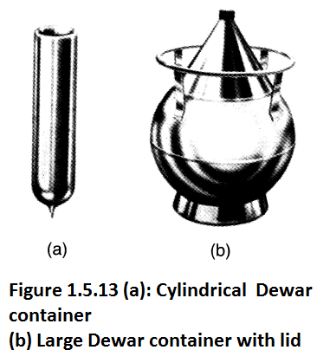
Table 1.5.2 (iii) provides the lowest temperatures that can be obtained by mixing certain solvents with liquid nitrogen. The temperature is -190° and -196°C, respectively, provided with liquefied air and nitrogen. Liquid air, liquid nitrogen and dry ice-solvent and liquid nitrogen-solvent mixtures are kept in the Dewar containers and the desired container is placed therein. Dewar containers are double-walled and the air is evacuated between the two walls and the inner surfaces are covered with silver. Thus the heat conduction is minimized. The thermos is also a kind of Dewar. Figure 1.5.13 shows different examples. Liquid air and nitrogen are purchased. Dry ice can sometimes be purchased ready. But it can be prepared in the laboratory when needed. To do this, a carbon dioxide tube is inverted and a thick cloth bag is attached to the mouth of the tube. Dry liquid is collected in the bag when the liquid phase is opened quickly when the liquid phase reaches the mouth of the tube.

1.5.3 Constant Temperature Baths (thermostat and cryostat)

A constant temperature bath (thermostat) is used in the organic chemistry laboratory when should be working at a constant temperature. They have various types and the fluid in a bath is kept at a constant temperature and as also a constant temperature liquid can be recirculated. A constant temperature bath contained with a liquid is usually heated with electric immersion heater in a metal tank. For regular heating, it is also stirred and the temperature is controlled by a temperature regulator. The liquid is selected according to the desired temperature range and is mostly water between 30-90°C. A contact thermometer is often used as a temperature controller. Figure 1.5.14 shows a constant temperature bath. The flask which is intended to be kept at a constant temperature is immersed in the liquid in the bath. The constant temperature bath shown in Figure 1.5.15 is used to circulate liquid (water) at a constant temperature by means of a pump in it. This type of bath, spectrophotometer, refractometer, polarimeter, etc. from the cell jackets or the studies of reaction kinetics by circulating water from the jacket around the reaction vessel provides the possibility of working at a constant temperature and also allow the reaction to be carried out at a constant temperature. Similarly, it is possible to transfer water at a constant temperature from the jacket of the separation column during the distillation.

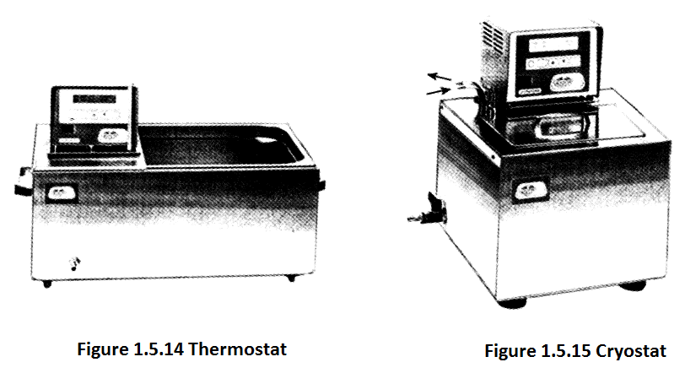

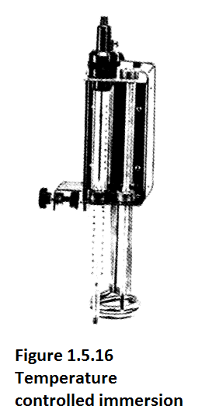

Figure 1.5.16 shows a constant temperature supplying apparatus for any bath consists of an immersion heater, a stirrer and a temperature regulator. It allows the temperature of the liquid in the container to the desired point. If it contains a liquid transfer pump also allows the liquid to recirculate.

There are also types of constant (low) temperature bath called (cryostat). This provides a lower temperature than the room temperature with the aid of a cooling device (Figure 1.5.15). Cooling down to -30 °C can be achieved. These baths can also be fitted with a heating device, allowing operation between -30-150°C. Suitable solvent mixtures as liquids for use in such a bath may be, for example, water with glycerin. In the bath, heating or cooling can be carried out by immersion and also liquid can be circulated.

1.6. DRYING METHODS

1.6.1 Theory of the action of drying agent

Drying agents may be divided broadly into (a) those which combine with water reversibly and (b) those which react chemically with water by a non-reversible process giving rise to a new water-free compound. To appreciate the action of a drying agent of class (a), let us imagine some anhydrous copper sulphate in an evacuated vessel provided with a pressure gauge, and water is allowed to enter slowly; the temperature is assumed constant at 25°C. The results may be best expressed by means of a vapour pressure - composition diagram (Scheme 1.6.1). The initial system is represented by the point A; the pressure will rise along AB until the monohydrate CuSO₄.H₂O commences to form at B.
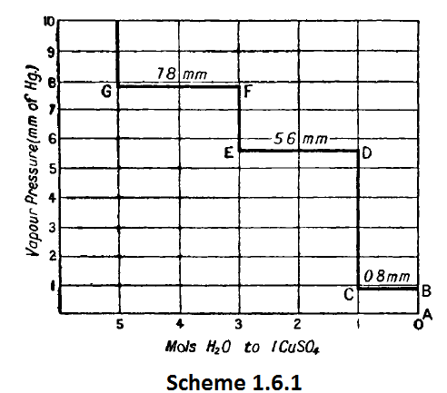
As more water vapour is absorbed by the system, the pressure remains constant along BC until the anhydrous salt is completely converted into the monohydrate. The conversion is complete at G: the pressure then rises along CD until the trihydrate is formed at D. Two solid phases

(CuSO₄.3H₂O;CuSO₄.H₂O) are now present and the pressure remains constant until all the monohydrate is transformed into the trihydrate at E. The pressure again rises to F, and when it attains the value denoted by F, the pentahydrate commences to form and the system has a constant pressure until all the trihydrate has passed into the pentahydrate at G. The same curves are obtained if copper sulphate pentahydrate is dehydrated at constant temperature (25°): here the powdered crystals of the pentahydrate are contained in a vessel and the water vapour is gradually removed by means of a pump. The pressure remains constant along GF whilst the pentahydrate is being converted into trihydrate; at F only the trihydrate is present. A sharp drop in pressure to E then occurs and along ED the trihydrate passes at constant pressure into the monohydrate. This change is complete at D, the pressure falls again to C, at which point dissociation of the monohydrate to the anhydrous salt occurs. This transformation is complete at B, and, with the complete removal of the water, the pressure drops to almost zero at A. It is evident from these results that three equilibria are to be considered,
viz.:—

Furthermore, it is the system, Hydrate I/Hydrate II (or Anhydrous Salt), that possesses a definite pressure at a particular temperature; this is independent of the relative amounts, but is dependent upon the natüre of the two components in equilibrium. It is incorrect, therefore, to speak of the " vapour pressure of a salt hydrate.''
We may now understand the nature of the change which occurs when an anhydrous salt, say copper sulphate, is shaken with a wet organic solvent, such as benzene, at about 25°. The water will first combine to form the monohydrate in accordance with equation (i), and, provided sufficient anhydrous copper sulphate is employed, the effective concentration of water in the solvent is reduced to a value equivalent to about 1 mmHg of ordinary water vapour. The complete removal of water is impossible; indeed, the equilibrium vapour pressures of the least hydrated system may be taken as a rough measure of the relative efl&ciencies of such drying agents. If the water present is more than sufficient to
convert the anhydrous copper sulphate into the monohydrate, then reaction (i) will be followed by reaction (ii), i.e., the trihydrate will be formed; the water vapour then remaining will be equivalent to about 6 mm. of ordinary water vapour. Thus the monohydrate is far less effective than the anhydrous compound for the removal of water.
A rough method for comparing the drying powers of the common desiccants consists in passing moist air over the drying agent maintained at a constant temperature and then determining the residual moisture with phosphorus pentoxide—the most efficient drying agent known. Some results, due largely to Bower (1934), are tabulated below.

1.6.2 Drying of solid organic compounds

The theory of the action of drying agents has been considered. We are now concerned with the practical methods for the removal of water from organic solids and liquids and from solutions of these in organic solvents. The present Section will be devoted to the drying of solids.

A solid, moist with water or a volatile organic solvent, may be dried in the open air by spreading it in thin layers on several layers of absorbent filter paper; the whole should be covered by a sheet of glass, clock glass or absorbent paper resting upon corks in order to protect it from dust. This method is rather time-consuming if water is to be completely removed. More effective drying may be secured by placing the substance in thin layers upon clock glasses in a steam oven or in a thermostatically-controlled, electrically-heated oven; the temperature of the drying oven must be 10-20°C below the melting or decomposition point of the compound, and it is recommended that a preliminary test be made with a small sample.

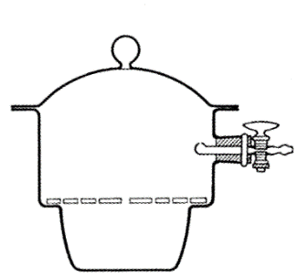
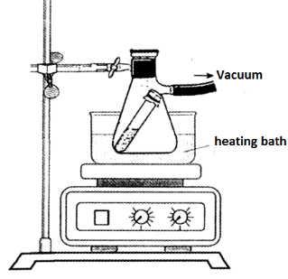

Figure 1.6.1 Vacuum desiccator Figure 1.6.2 Using filtering flask as a vacuum desiccator

The best method for removing water (and also solvents of relatively low boiling point) adhering to solids is drying under reduced pressure. A vacuum desiccator is used for this purpose.
These are fitted either with a ground-in stopcock or with a rubber stopper carrying the stopcock; the latter is more economical since the tap may be readily replaced if broken (Fig. 1.6.1) In order to render the desiccators air-tight, the ground surfaces of the cover and body are lightly smeared with pure vaseline or with a mixture of pure vaseline and resin stearate.

When exhausting desiccators, a filter flask trap should always be inserted between the desiccator and the pump. The " vacuum " should be applied gradually and should not exceed about 50 cm of mercury. These desiccators may withstand lower pressures, but it is generally considered unsafe to exhaust below this pressure unless the precaution be taken of surrounding the desiccator by a cage of fine-mesh steel wire; collapse of the desiccator will then do no harm.

The charge of the desiccator will naturally depend upon the exact nature of the substance to be absorbed. An effective " universal " filling is obtained by placing concentrated sulphuric acid in the lower half and flake sodium hydroxide in the inverted glass collar supported on the shoulders of the desiccator, the collar being then covered with a zinc gauze or a glazed porcelain perforated plate. If ether, chloroform, carbon tetrachloride, benzene, toluene and similar vapours are to be absorbed, some freshly cut shavings
of paraffin wax should be placed on the sodium hydroxide. Alternatively, granular calcium chloride may be placed in the bottom of the desiccator and silica gel in the shallow porcelain; if acid vapours are likely to be present, the latter may be charged with flake or pellet sodium hydroxide.

Frequently the water or other solvent is so firmly held that it cannot be completely removed in a vacuum desiccator at the ordinary temperature. These substances are dried in a vacuum oven at a higher temperature. A convenient laboratory form of vacuum oven is the so-called "drying pistol" (Abderhalden vacuum drying apparatus) (Fig. 1.6.3). The vapour from a boiling liquid in the flask A rises through the jacket surrounding the drying chamber B (holding the substance), and is returned by the condenser. The drying chamber B is connected by means of a ground glass joint to the vessel C containing the drying agent: C is attached to a suction pump. The liquid in A is selected according to the temperature desired, e.g., chloroform (62°), trichloroethylene (86°), water (100°), perchloroethylene (120°), s-tetrachloroethane (146°), etc. The charge in C consists of phosphorus pentoxide distributed on glass wool when water is to be removed, of potassium hydroxide flakes or pellets for removal of acid vapours, and of silica gel or thin layers of paraffin wax for removal of organic solvents, such as chloroform, carbon tetrachloride, benzene and toluene.

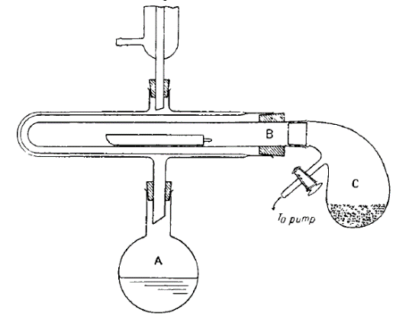
Figure 1.6.3

1.6.3 Drying of liquids or of solutions of organic compounds in organic solvents

Liquids or solutions of organic substances in organic solvents are usually dried by direct contact with a solid inorganic drying agent. The selection of the desiccant will be governed by the following considerations:—(i) it must not combine chemically with the organic compound; (ii) it should have a rapid and effective drying capacity; (iii) it should not dissolve appreciably in the liquid; (iv) it should be as economical as possible; and (v) it should have no catalytic effect in promoting chemical reactions of the organic compound, such as polymerisation, condensation reactions, and auto-oxidation. The various common drying agents are discussed in detail below; their relative efficiencies will depend upon the vapour pressure of the system, water:drying agent. It is generally best to shake the liquid with small amounts of the drying agent until no further action appears to take place:too large an excess is to be avoided in order to keep absorption losses down to a minimum. If sufficient water is present to cause the separation of a small aqueous phase (e.g., with calcium chloride), this must be removed and the liquid treated with a fresh portion of the desiccant. If time permits, the liquid, when apparently dry, should be filtered and left overnight in contact with fresh drying agent. The desiccant should, in general, be separated by filtration (best through a fluted filter paper) before the distillation of the liquid. This is particularly necessary with many reagents whose drying action depends upon the formation of hydrates (e.g., sodium sulphate, magnesium sulphate, and calcium chloride) : at higher temperatures the vapour pressures above the salts become appreciable and unless the salts are removed, much, if not all, of the water may be returned to the distillate. However, with some desiccating agents (sodium, quicklime, baryta, phosphorus pentoxide), the reaction products with water are quite stable and filtration is not essential.

A list of the common drying agents with their practical limitations and their important applications follows.

"Anhydrous" calcium chloride. This reagent is widely employed because of its high drying capacity and its cheapness. It has a large water-absorption capacity (since it forms CaCl₂.6H₂0 below 30°) but is not very rapid in its action; ample time must therefore be given fordesiccation. The slowness of the action is attributed to the blanketing of the particles of calcium chloride with a thin layer of the solution formed by the extraction of the water present; on standing, the water combines forming a solid lower hydrate, which is also a desiccating agent. The industrial process for preparing the reagent usually permits a little hydrolysis to occur, and the product may contain a little free calcium hydroxide or basic chloride. It cannot therefore be employed for drying acids or acidic liquids. Calcium chloride combines with alcohols, phenols, amines, amino-acids, amides, ketones, and some aldehydes and esters, and thus cannot be used with these classes of compounds.

Anhydrous magnesium sulphate. This is an excellent, neutral desiccating agent and is inexpensive. It is rapid in its action, chemically inert and fairly efficient, and can be employed for most compounds including those (esters, aldehydes, ketones, nitriles, amides, etc.) to which alcium chloride is not applicable. Granular magnesium sulphate is prepared by heating the heptahydrate gently (at 150-175°) in an oven until most of the water of hydration has been evolved, and then heating to redness. A product of less attractive appearance is obtained more rapidly by heating the crystallised salt in a thin layer in an evaporating dish or casserole over a wire gauze; the solid will melt partially and steam will be copiously evolved. The residue (granules and powder) is powdered in a glass mortar, and preserved in a tightly-corked, wide-mouthed bottle. If the crystallised salt is stirred with a glass rod during heating, a dry powder is ultimately obtained directly.

Anhydrous sodium sulphate. This is a neutral drying agent, is inexpensive, and has a high water-absorption capacity (forming Na₂SO.10H₂O below 32-4°). It can be used on almost all occasions, but the drying action is slow and not thorough. The desiccant is valuable for the preliminary removal of large quantities of water. Sodium sulphate is an inefficient drying agent for solvents, such as benzene and toluene, whose solubility in water is slight: anhydrous copper sulphate is preferable. Anhydrous sodium sulphate is useless as a desiccant above 32-4°C, the decomposition temperature of the decahydrate.

Anhydrous calcium sulphate. When the dihydrate CaSO₄.2H₂O or the hemihydrate 2CaSO₄.H₂O is heated in an oven at 230-240°C for about three hours, anhydrous calcium sulphate is obtained. The reagent is extremely rapid and efficient in its action, is chemically inert, and is insoluble in organic solvents; it may therefore be used with most organic compounds. The only disadvantage is its limited capacity for absorption of water since it passes into the hemihydrate 2CaSO₄.H₂O, and should theoretically absorb only 6-6 per cent, of its weight of water to retain its maximum efficiency.This desiccant is more expensive than magnesium and sodium sulphates, but it can easily be regenerated as indicated above.

Anhydrous potassium carbonate. This drying agent possesses a moderate efficiency and drying capacity (the dihydrate is formed). It is applied to the drying of nitriles, ketones, esters and some alcohols, but cannot be employed for acids, phenols and other acidic substances. It also sometimes replaces sodium or potassium hydroxide for amines, when a strongly alkaline reagent is to be avoided. Potassium carbonate frequently finds application in salting-out water-soluble alcohols, amines and ketones, and as a preliminary drying agent. In many cases it may be replaced by anhydrous magnesium sulphate.

Sodium and potassium hydroxides. The use of these efficient reagents is generally confined to the drying of amines (soda lime, barium oxide and quicklime may also be employed) : potassium hydroxide is somewhat superior to the sodium compound. Much of the water may be first removed by shaking with a concentrated solution of the alkali hydroxide. They react with many organic compounds (e.g., acids, phenols, esters and amides) in the presence of water, and are also soluble in certain organic liquids so that their use as desiccants is very limited

Aluminium oxide. The commercial material, " activated alumina," is made from aluminium hydroxide; it will absorb 16-20 per cent, of its weight of water, can be re-activated by heating at 175° for about seven hours, and does not appreciably deteriorate with repeated use. Its main pplication is as a drying agent for desiccators.

Boric anhydride. This is a powerful and efficient desiccant and will absorb up to about 25 per cent, of its weight of water. It is useful for drying formic acid.

Phosphorus pentoxide. This is an extremely efficient reagent and is rapid in its reaction. Phosphoric oxide is difficult to handle, channels badly, is expensive, and tends to form a syrupy coating on its surface after a little use. A preliminary drying with anhydrous magnesium sulphate, etc., should precede its use. Phosphorus pentoxide is only employed when extreme desiccation is required. It may be used for hydrocarbons, ethers, alkyl and aryl halides, and nitriles, but not for alcohols, acids, amines and ketones.

Metallic sodium. This metal is employed for the drying of ethers and of saturated and aromatic hydrocarbons. The bulk of the water should first be removed from the liquid or solution by a preliminary drying with anhydrous calcium chloride or magnesium sulphate. Sodium is most effective in the form of fine wire, which is forced directly into the liquid by means of a sodium a large surface is thus presented to the liquid. It cannot be used for anycompound with which it reacts or which is affected by alkalis or is easily subject to reduction (due to the hydrogen evolved during the dehydration), viz., alcohols, acids, esters, organic halides, ketones, aldehydes, and some amines.

CAUTION. Sodium must be handled with great care and under no circumstances may the metal be allowed to come into contact with water as a dangerous explosion may result. Sodium is stored under solvent naphtha or xylene ; it should not be handled with the fingers but with tongs or pincers. Waste or scrap pieces of sodium should be placed in a bottle provided for the purpose and containing solvent naphtha or xylene : hey should never be thrown into the sink or into the waste box. If it is desired to destroy the scrap sodium, it should be added in small portions to rather a large quantity of methylated spirit.
Concentrated sulphuric acid. The only well-known use for this reagent is for drying bromine, with which it is immiscible. The bromine is shaken in a separatory funnel with small quantities of concentrated sulphuric acid until no further action takes place. The reagent is, however, widely used for desiccators.

Absorbent cotton (cotton wool). This material is an excellent drying agent for use in the so-called " calcium chloride tubes," i.e., drying tubes, placed at the top of dropping funnels, reflux condensers, etc., to exclude moisture. It is more convenient than calcium chloride, and should preferably be dried in an oven at 100° before use.

Molecular sieves. a porous solid, usually a synthetic or a natural zeolite, that separates particles of molecular dimension. Zeolites are hydrated metal aluminosilicate compounds with well-defined crystalline structures. The silicate and aluminate groupings form three-dimensional crystal lattices surrounding cavities in which the metal ions and the water molecules are loosely held. Channels run through the entire crystal, interconnecting the cavities and terminating at the crystal surface. Upon heating, the zeolites lose their water content with little or no change in their crystal structure. The dehydrated zeolite can reversibly absorb water or other molecules that are small enough to pass through the channels or pores. The metal ions are also readily replaceable by other ionic units of similar charge and size.

Molecular sieves are used for drying gases and liquids and for separating molecules on the basis of their sizes and shapes. When two molecules are equally small and can enter the pores, separation is based on the polarity (charge separation) of the molecule, the more polar molecule being preferentially adsorbed.

Molecular Sieves are available in four primary generic forms, 3A, 4A, 5A and 13X. Each form has its own specific properties and applications, and all retain a polar preference for adsorption of water.
• 3A, cyristal potasium aluminosilicate; is the preferred Molecular Sieves adsorbent for the commercial dehydration of unsaturated hydrocarbon streams.
• 4A, sodium aluminosilicate; is the preferred Molecular Sieves adsorbent for the static dehydration in a closed gas or liquid drying system.
• 5A, calsium aluminosilicate; is the preferred Molecular Sieves adsorbent for the separation of normal paraffin's from hydrocarbons.

References

- Vogel’s Textbook of Practical Organic Chemistry, Brian S. Furniss, Antony J. Hannaford, Peter W. G. Smith, Austin R. Tatchell, Longman Scientific&Technical, 1989.
- Denel Organik Kimya, Metin Obalı, Ender Erdik, Gazi Kitabevi, Ekim 2013.

