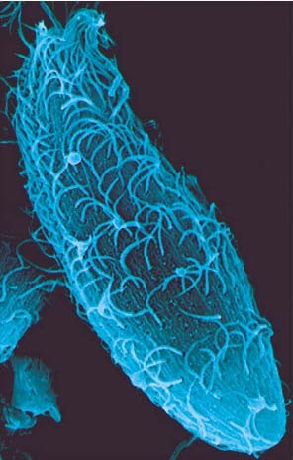
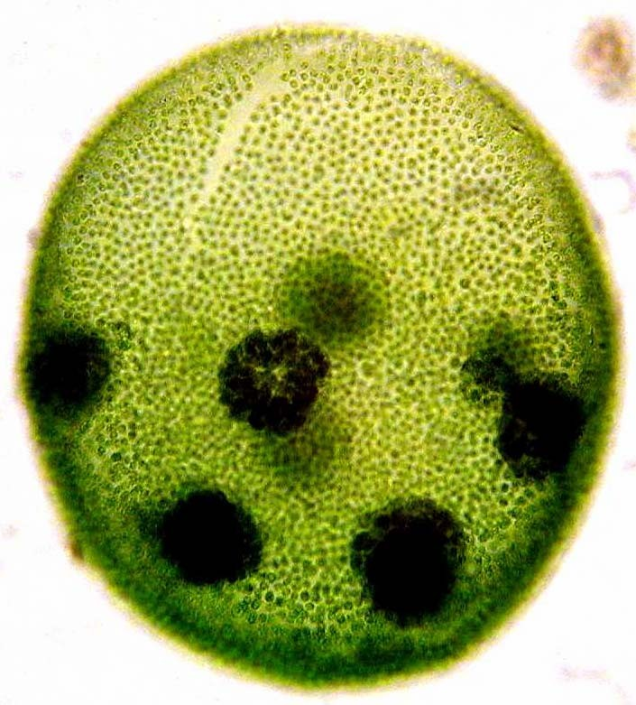
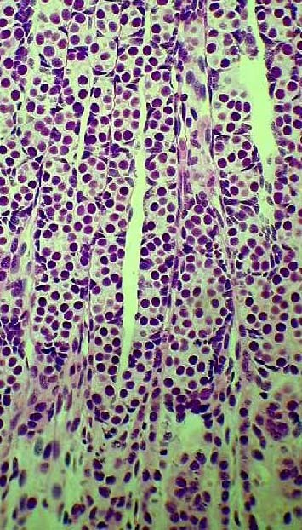
Cell Biology
A cell is chemical system that is able to maintain its structure and reproduce. Cells are the fundamental unit of life. All living things are cells or composed of cells.

1

The interior contents of cells is the cytoplasm. The cytoplasm is isolated from the surrounding environment by the . There are two fundamentally different forms of cells.
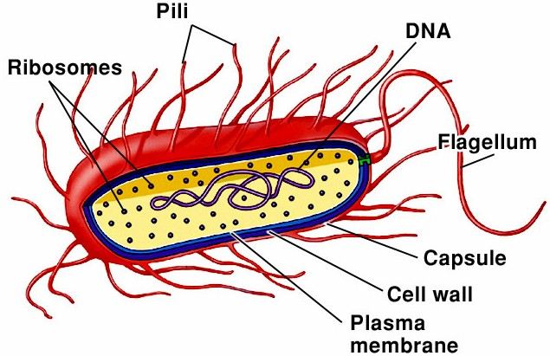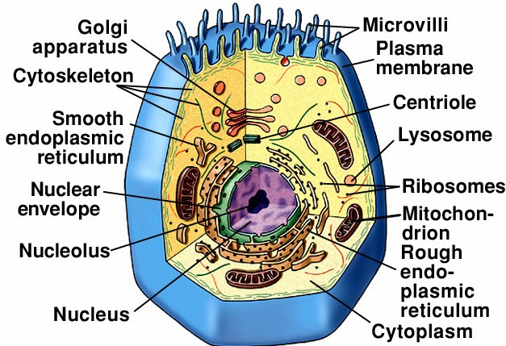 cells - relatively simple cells - lack nuclear membrane and many organelles - bacteria and their relatives are all prokaryotic

cells - more complex cells - have a nucleus and many organelles
- all cells of plants, animals, fungi, and protists

2

Cells and organelles
Most cells are small
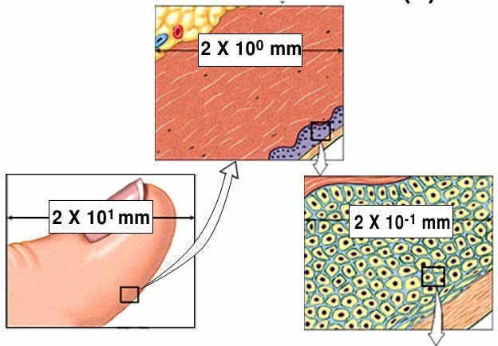
Prokaryotic: 1-10 μm
Eukaryotic: 10 - 100 μm
(1 μm = .001 mm)

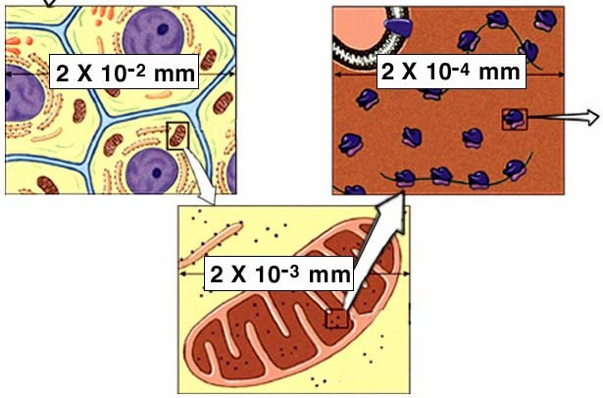
3

Organelles, Macromolecules, & Atoms

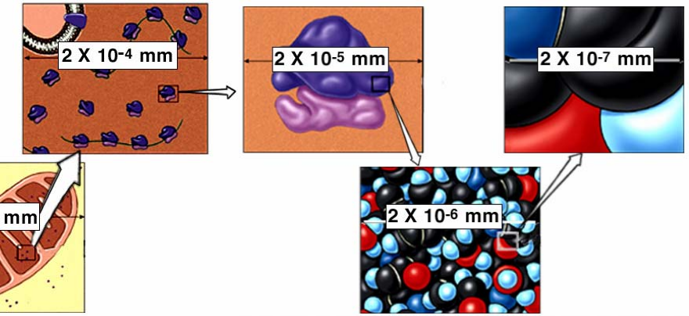

4

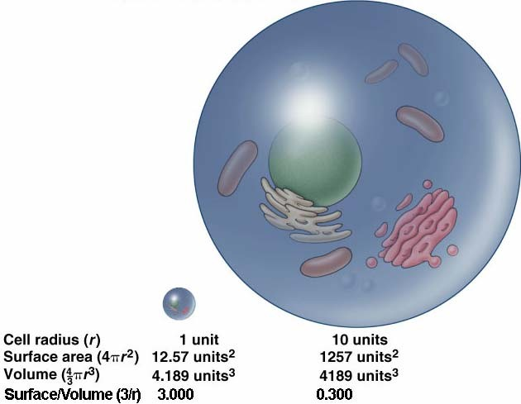
Why are cells small?
As cell size increases the volume increases much faster than the surface area.
Cells obtain nutrients, gain information and rid waste through their plasma membrane.

As cell size increases, a cell’s ability to exchange with its environment becomes limited by the amount of membrane area that
is available for exchange. 5

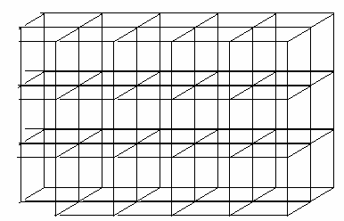
Robert Hooke - 1665 - using an early microscope viewed cork and saw many repeating box-like structures and called them “cells.”
What he saw were spaces surrounded by walls that
once contained living
cells. Since Hooke’s first observations
what is known about cells has
increased greatly.

6

Cell Theory
  - Cells are the fundamental unit of life - nothing less than a cell is alive.
  - All organisms are constructed of and by cells.
  - All cells arise from preexisting cells. Cells contain the information necessary for their own reproduction. No new cells are originating spontaneously on earth today.
  - Cells are the functional units of life. All biochemical processes are carried out by cells.
  - Groups of cells can be organized and function as multicellular organisms
  - Cells of multicellular organisms can become specialized in form and function to carry out subprocesses of the multicellular organism.

7

Prokaryotic cell structure
small, with a plasma membrane surrounded by a rigid cell wall -

in many the cell wall is made of cross-linked with polypeptides
- a carbohydrate

cell wall may be covered with a capsule made of polysaccharides
few or no membrane enclosed spaces within the cytoplasm
no nucleus - DNA is in a region called the nucleoid
DNA is circular and naked (has no protein associated with it)
8

Bacteria often have flagella with a single protein core (flagellin) that they can use to move in a rotary corkscrew like fashion
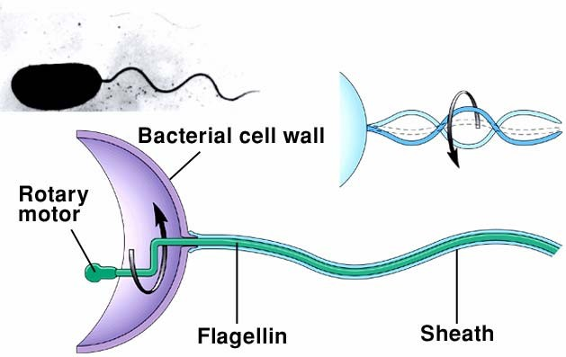
The rotary motor of prokaryotic flagella is powered by proton flow through the cell membrane.
Rotating structures are rare in nature.

9

Membrane enclosed spaces allow cell functions to be compartmentalized and isolated from other functions. Prokaryotes lack membrane enclosed spaces in their cytoplasm.

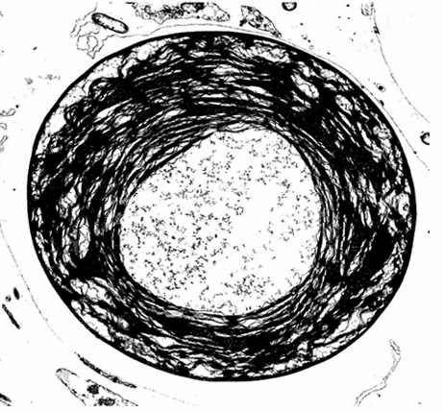
Some prokaryotes are photosynthetic. The biochemical machinery for trapping light energy is contained within a highly folded plasma membrane.

10

Eukaryotic cell structure
larger, with a typical plasma membrane - some with a cell wall

Many enclosed by membranes:
and other interior spaces

Nucleus, Endoplasmic reticulum, Golgi apparatus, Mitochondria, Chloroplasts, Lysosomes,Vacuoles, Vesicles
Cytoplasm with a cytoskeleton - protein tubules and fibers
cell wall found in plants (cellulose), fungi (chitin), some protists
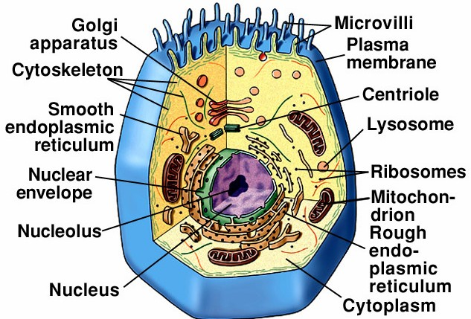 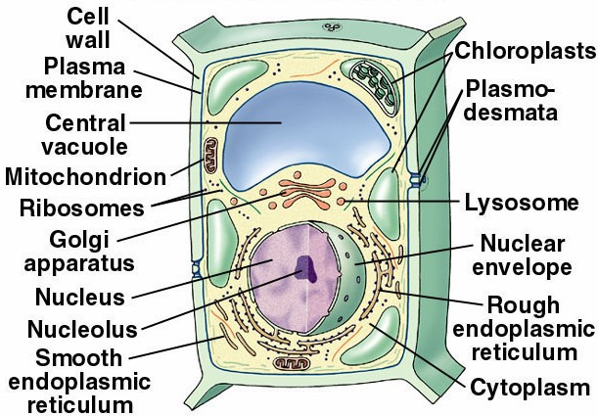11

Cellular Organelles
Nucleus - the largest and most obvious membrane bound compartment - controls cell activities
contains the nucleolus - a darkened region where ribosomal RNA is synthesized
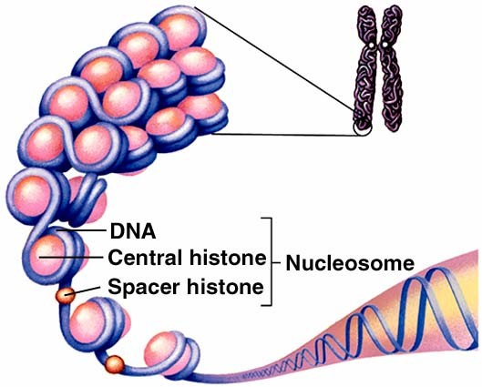
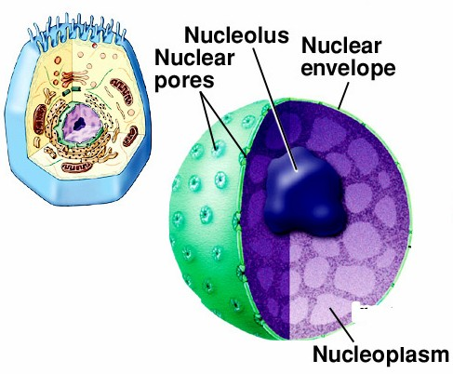
contains chromosomes - consist of DNA wrapped around proteins

12

Nucleus is surrounded by the nuclear envelope - a double membrane
Nuclear membrane has nuclear pores that control entry and exit of materials
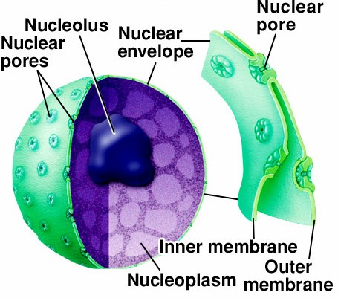
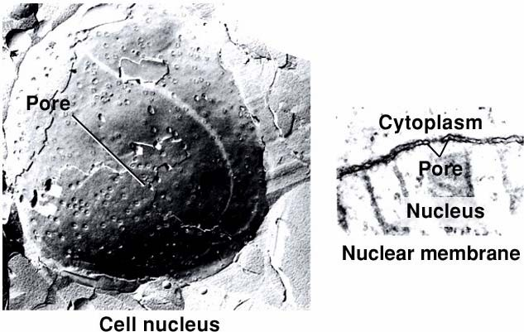

13

Chromosome - “colored body”
consists of both DNA and protein - seen as chromosomes when highly condensed in preparation for cell division

At other times the DNA and protein are threadlike and
called .

The most common proteins are histones. DNA is coiled around histones in a regular pattern that produces structures called nucleosomes.

14

Endoplasmic reticulum (ER) - a web-like series of membranes within the cytoplasm in the form of flattened sheets, sacs, tubes, creates many membrane enclosed spaces - spreads throughout the cytoplasm - has connections with the outer membrane of the nucleus and the plasma membrane
interior space is called the
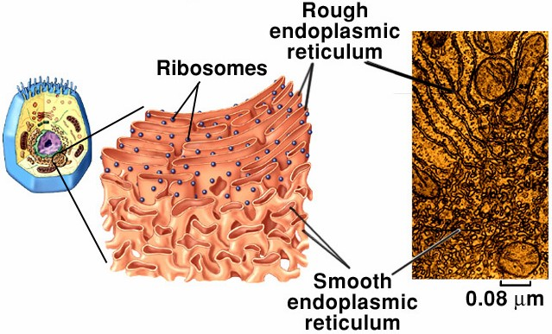
Functions:
-circulation and transport
-storage of proteins and minerals
-synthesis of lipids, carbohydrates, and proteins
-A large surface area for enzyme action.
15

Two types of ER - rough and smooth
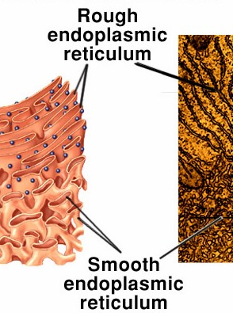
rough ER - studded with ribosomes site of synthesis of many proteins all ribosomes on rER are actively
involved in protein synthesis -
smooth ER - site for synthesis of steroids and other lipids
Ca++ storage in muscles detoxification of drugs, toxins,
alcohol (especially in liver)
The highly convoluted surface provides a large surface area for enzymatic activities. Many enzymes are imbedded in the membranes.

16

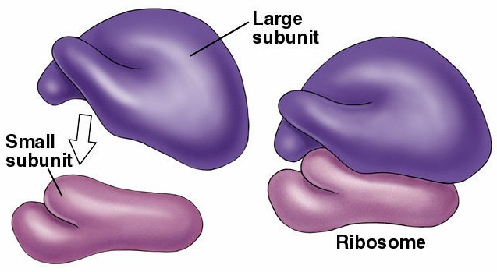
Ribosomes - protein synthetic machinery
  - two subunits - large and small - each made of protein and ribosomal RNA (rRNA)
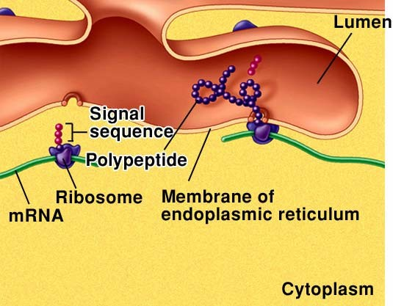
  - subunits associate when they are synthesizing proteins
  - protein synthesis occurs on ribosomes that are free-floating in the cytoplasm and on ribosomes attached to ER
  - rRNA is synthesized in the nucleolus
17

Golgi Apparatus -
a collection of membranes associated with the ER composed of flatten sacs called
concentrates and packages proteins synthesized on the ER
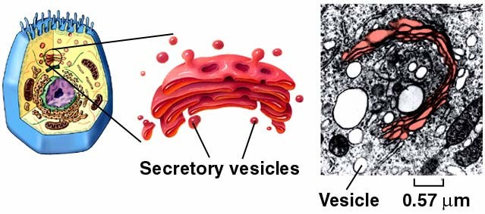

The Golgi is functionally associated with the ER.

18

Proteins synthesized on the ER are concentrated internally and transport vesicles are budded off
Transport vesicles fuse with the Golgi, dump their contents into the Golgi
Golgi packages proteins in vesicles so that they may be excreted from the cell, or used within the cell.
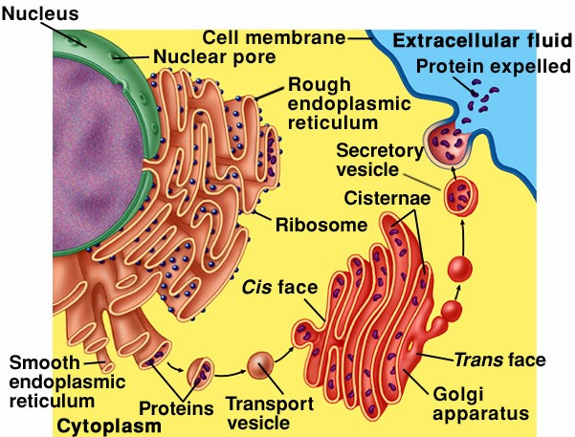
Secretory vesicles - used for excretion - leave the Golgi and move to plasma membrane where they fuse and dump their contents outside - seen in many

glands 19

The Golgi Apparatus also forms lysosomes
Lysosomes - vesicles filled with digestive enzymes - used for intracellular digestion
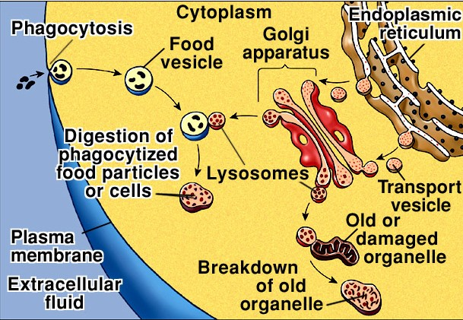
Particles can be taken into cell by phagocytosis and vesicle fused with lysosome
The components of organelles can be recycled after digestion by lysosomes

20

Microbodies: Peroxisomes and Glyoxisomes
vesicles that form through growth and division within the cytoplasm
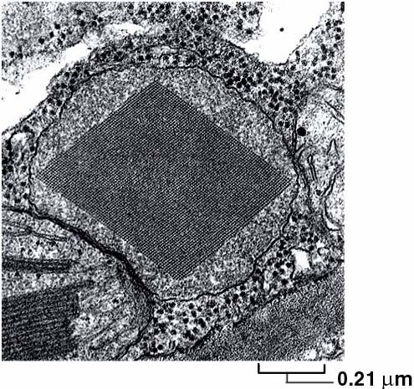
Glyoxisomes are found in plants - contain enzymes that convert fats into carbohydrates

Peroxisomes - used for removing reactive compounds from the cytoplasm - create H2O2 as a byproduct and degrade it with the enzyme catalase

21

Mitochondria - cellular powerhouses - the site of much of the energy harvest by cells
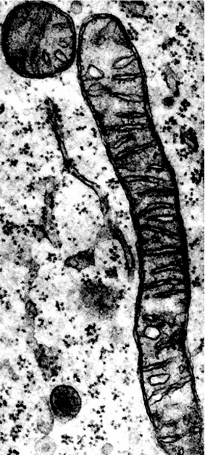
have double membrane structure
inner membrane folded into inward projections called cristae
two spaces within the mitochondrion -
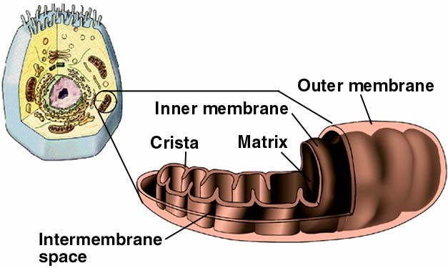
the matrix and the intermembrane space

22

Mitochondria -
- The site of oxygen consumption within cells
- Have their own DNA that is similar to prokaryotic DNA
- Have their own ribosomes that are similar in construction to prokaryotic ribosomes
- Synthesize many, but not all, of their own proteins
- Mitochondria replicate by binary fission - similar to prokaryotic cell division

23

Chloroplasts - sites of photosynthesis - in nearly all plants and some protists
trap light energy and convert it into chemical energy
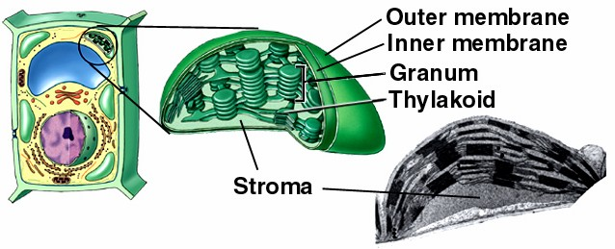
have double membrane structure - inner space is the stroma
Within the stroma have a series of stacks of flattened membrane structures called thylakoids - the stacks are called
grana The light energy trapping molecules of photosynthesis are found in the membranes of the thylakoids.

24

Chloroplasts
have their own DNA, similar to prokaryotic DNA
Can synthesize many of their own proteins using prokaryote-like ribosomes
Synthesize many, but not all, of their own proteins
Replicate through division similar to prokaryotic cell division

Chloroplasts can take on other functions
synthesize and store starch in roots and tubers have pigments and give fruits ripened color

25

Centrioles - are part of specialized region of the cell called the
centrosome (cell center)
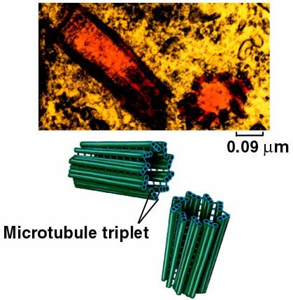
found in animals and most protists
the centrioles are involved in the production of microtubules
microtubules have many functions including moving chromosomes during cell division
centriole structure - 9 triplets of microtubules surrounding a hollow core -
similar to the basal body of flagella

26

Cytoskeleton - scaffolding of proteins that transport materials, position and move organelles, maintain and change cell shape, and organize enzymes into functional associations
3 components - actin filaments, microtubules, and
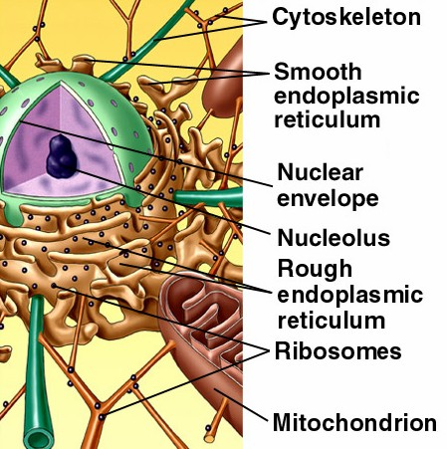
intermediate filaments

all are polymers of smaller protein subunits - lengthen through addition
of polymer subunits, shorten through

27

actin filaments - involved in cell movements and in membrane deformations - smallest components of the cytoskeleton
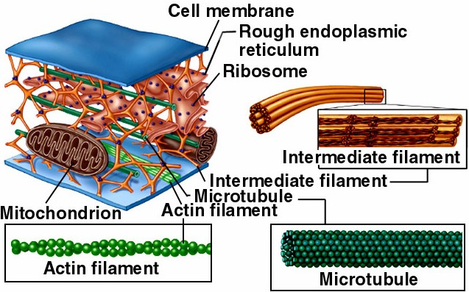
microtubules - hollow tubes made of proteins called tubulins responsible for cell movements and movements of organelles within the cytoplasm, movement of chromosomes during cell division - largest components of the cytoskeleton
intermediate filaments
- 8 stranded protein fibers - play a role in cell structure, anchoring organelles
and in transport of materials within the cytoplasm
anchor neighboring cells to each other in tissues
28

Flagella and Cilia - cellular appendages
can propel cells or propel materials over the cell surface cells that have flagella have few (usually 1 or 2)
cells that have cilia have many - covering the surface flagella move with whip-like movements to propel the cell cilia have a more regular stroke and groups of cilia appear to
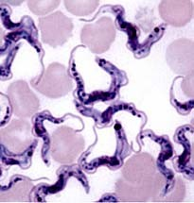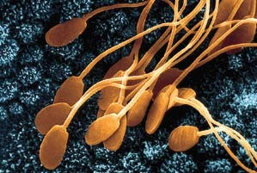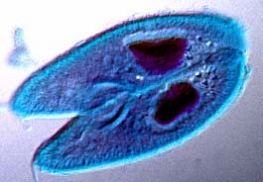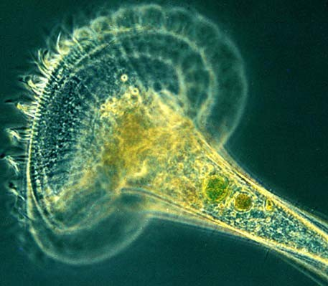move in unison, resulting in a wave-like motion flagella 5 to 20x longer than cilia

29

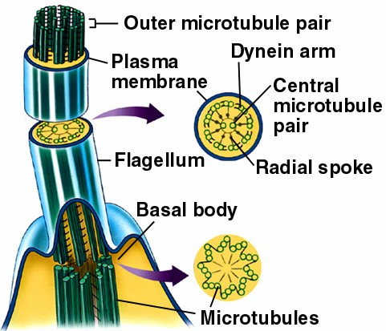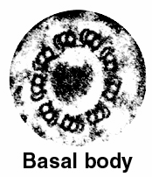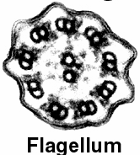Structure
has basal body with 9 + 0 structure of microtubules
flagellum is membrane bound with pairs of microtubules in a 9+2 pattern
each pair of tubules has short arms of another protein - dynein -
that extend to neighboring tubules
movement of the flagellum is produced by sliding of the microtubule pairs
30

Plant Cells have, in addition to the collection of organelles found in other groups, a central vacuole for storage and for producing
pressure inside the the cell.
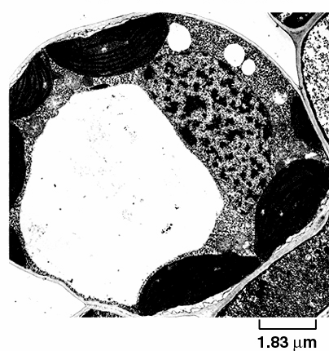
The central vacuole is usually filled with water and solutes. A high solute concentration draws water into the vacuole, expanding the vacuole and the cell.
Because plant cells are enclosed by a cell wall, the expansion of the vacuole can exert pressure on the cell without causing the cell to
burst. 31

Plants have cell walls made of cellulose.
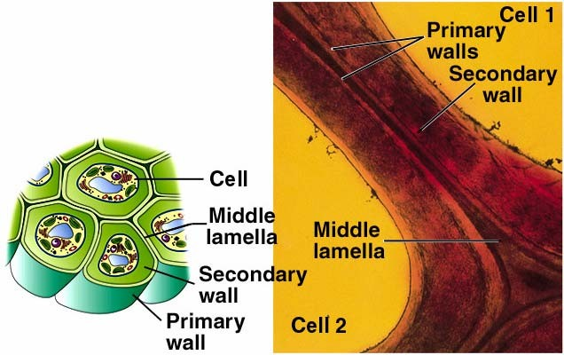
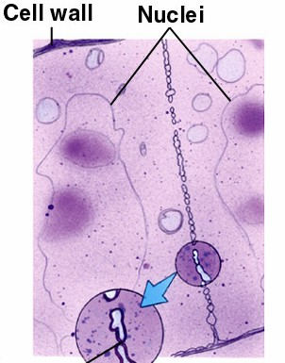
During cell division plant cells build dividing walls between the two new cells called the cell plate. An adhesive layer - the middle lamella - is laid down between the new cell walls
Cell walls can be thickened through the addition of materials to
the inside of the primary cell wall. 32

Where did Eukaryotic Cells come from?
The oldest rocks with evidence of fossil cells date to 3.5 billion years. The oldest rocks with cells large and complex enough to be eukaryotic date to 1.0 billion years.
For 2.5 billion years only prokaryotic cells existed on earth.
The best hypothesis for the origin of eukaryotic cells was proposed by Lynn Margulis in the early 1970s. This hypothesis is now called the .
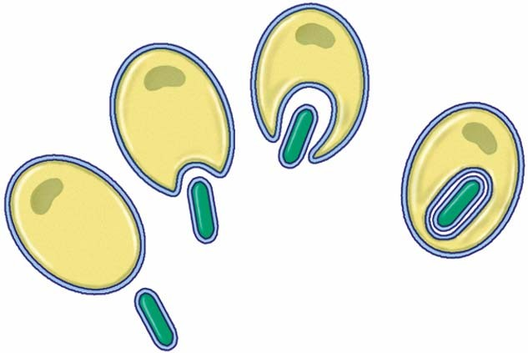
Eukaryotic cells appear to be the product of a collaboration among different types of prokaryotic cells. Some prokaryotic cells became the host for other prokaryotic cells that lived inside them. Some of the complex organelles of eukaryotes
provide evidence for this theory. 33

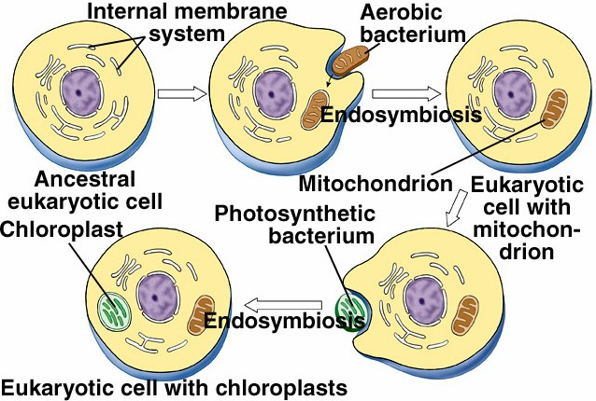
Mitochondria and chloroplasts appear to be the direct descendants of energy producing bacteria. Mitochondria are the descendants of bacteria that were capable of oxidative respiration. Chloroplasts are the descendants of photosynthetic bacteria.

34

Evidence:
Both have their own DNA and ribosomes that are similar to those found in prokaryotes. Both make many of their own proteins and both multiply in a fashion similar to prokaryotic cell division.
Both are double membrane organelles - the inner membrane descended from the ancestral guest cell, and the outer membrane descended from the vacuole membrane that was formed around the guest.
Other organelles may also be the product of endosymbiosis. Some centrioles and basal bodies have naked DNA as part of their structure.
There are many modern examples of endosymbiosis involving organisms that can live together or live independently. The same was probably true of the ancestors of endosymbiotic organelles in
the distant past. 35

Reference:
https://www.nicholls.edu/biol-ds/biol155/Lectures/Cell%20Biology.pdf

