Steady-State Nonisothermal Reactor Design
According to the first law of thermodynamics for a closed system, the change in total energy of the system, dE, is equal to the heat flow to the system, “Q”, minus the work done by the system on the surroundings, “W”.
Hence, the energy balance can be written for a closed system:
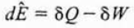
In the case of the continuous-flow reactors, we need to discuss about the open systems, in that mass crosses the system bundary. Some of the energy exchange is brought about by the flow of mass across the system for the open system case.
Hence, the energy balance can be written for an open system:
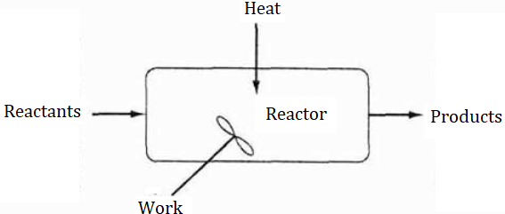
Figure 1. The energy balance diagram for an open system
The unsteady-state energy balance for an open well-mixed system that has n species, each entering and leaving the system at their respective molar flow rates “Fi” and with their respective energy “Ei” is:
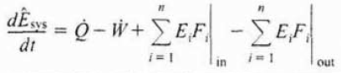
The work term “W” can divided into flow work and shaft work. Flow work means the work necessary to get the mass into and out of the system boundaries. The total work “W” can be illustrated as following:
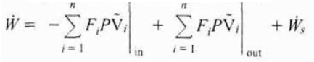
The flow work term can be combined with the terms in the energy balance representing the energy exchange by mass flow across the system boundaries.
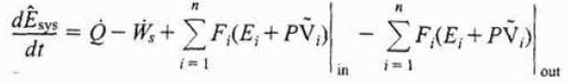
The energy “Ei” is the sum of the internal energy, the kinetic energy, the potential energy and any other energies like electric or magnetic energy or light. The total energy term can be represented as following:
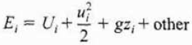
Generally, the kinetic energy, the potential energy and other energy terms can be neglected when compared to the entbalpy, heat transfer and work terms. The modified form of the energy balance equation can be shown as following:
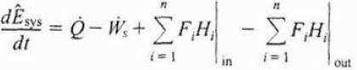
Where
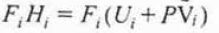
The open system can be considered as steady state. For the steady-state condition, the energy balance can be written as:
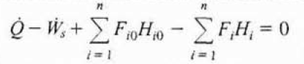
If we consider the energy balance equation for the following reaction
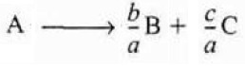
The inlet and outlet flow rate times enthalpy terms can be written as:
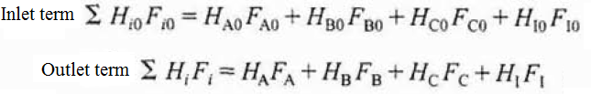
The molar flow rate of each species can be expressed as the folowing general flow rate term:
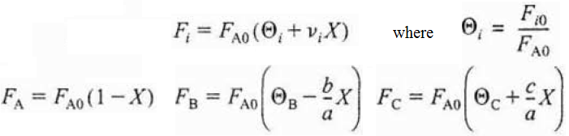
If we substitute the given flow rate expressions into the energy balance equation:
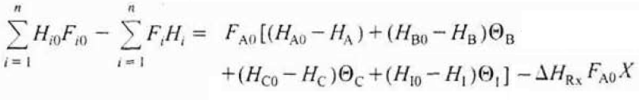
The general energy balance can be revised int the following expression using the given equation above:
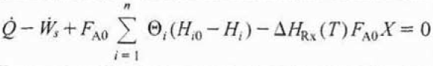
If the enthalpy of formation of the species is given at a reference temperature, then the enthalpy can be expressed at any temperature bu using the following expression:
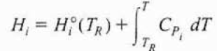
The heat capacity at any given temperature T can be expressed as a quadratic function of temperature as shown below:
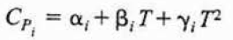
In order to calculate the change in enthalpy from the entrance condition to the outlet condition without a phase change can be expressed as:
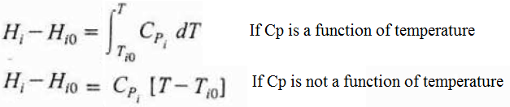
Hence, the final form form of the general energy balance equation after necessary manipulations can be written as following:
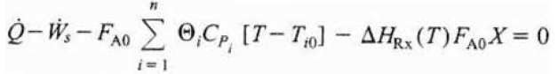

References:
- H. Scott Fogler, “Elements of Chemical Reaction Engineering”, Prentice Hall Professional Technical Reference, Fourth Edition.

