Robert Lowell Briefly
(1917-1977)

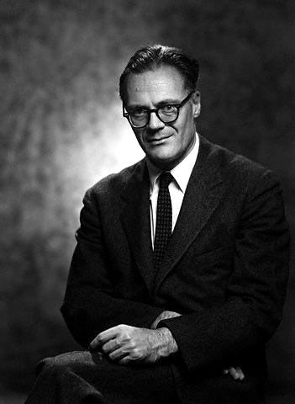

In the 1940s he wrote intricate and tightly patterned poems that incorporated traditional meter and rhyme; when he published Life Studies, he began to write startlingly original personal or confessional poetry in much looser forms and meters; in the 1960s he wrote increasingly public poetry; and finally, in the 1970s, he created poems that incorporated and extended elements of all the earlier poetry.

Lowell had a profound interest in history and politics; in his poetry he juxtaposed self and history in ways that illuminated both. His art and his life were inseparably intertwined, and he believed firmly in the identity of self and language.
In an essay appearing in Next-to-Last Things: New Poems and Essays, Stanley Kunitz has called Life Studies, which won the 1960 National Book Award, “perhaps the most influential book of modern verse since [T.S. Eliot’s] The Waste Land.”

In a note prefacing his Selected Poems, Lowell remarked that “my verse autobiography sometimes fictionalizes plot and particular”; by labeling his poems “verse autobiography,” he called attention to the inseparable relation between his life and his art.

Read the rest of the article at https://www.poetryfoundation.org/poets/robert-lowell

