CARBOHYDRATES

Carbohydrates are the most widely distributed and abundant organic compounds on earth. Basically, carbohydrates get their name from their chemical makeup—containing carbon, hydrogen, and oxygen. Carbohydrates, all coming from the process of photosynthesis, by the help of light green plants producing carbohydrates from oxygen and carbon dioxide.
Carbohydrates defined as aldehydic or ketonic compounds with some number of oxydrilic groups, so they are polyhydroxy aldehydes or polyhydroxy ketones, as well as their derives. They have a general formula (CH₂O)_{n}. In aldehydes, the carbonyl is bonded to one carbon and one hydrogen and located at the end of the carbon chain. In ketones, carbonyl group is bonded to two carbons with a carbon skeleton.
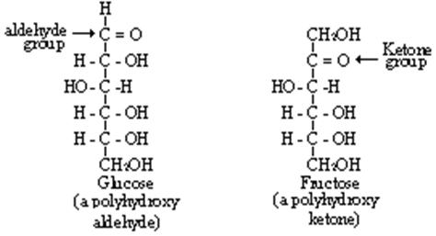
The main function of carbohydrates is to provide energy especially for the nervous system. Glucose is the main energy source of the brain. Eating carbohydrates is a quick way to increases blood sugar and stimulate insulin production. Healthy blood sugar and insulin levels are key to maintaining a healthy body. Carbohydrates increased the brain’s production of serotonin more than other food groups. Serotonin is known as the “feel good hormone”. Once activated in the brain, it works to stimulate sleep, regulate blood pressure, control your mood, appetite and your sensitivity to pain. Some of the carbohydrates known as the bulk material, that moves everything through our digestive tracks—because, unlike proteins and fats, they are indigestible and passes through our systems mostly intact—adding roughage to your bowels while keeping body full, regular, and satisfied after eating. Trigger appetite, hunger and fullness, high fiber diets have a slower digestion. Prebiotics are nondigestible carbohydrates that stimulate the growth or activity of bacteria in the colon. This ultimately improves digestive health. Their presence is necessary for the normal lipid metabolism. More than 100 years ago Pasteur said: “Fats burn in the fire of carbohydrates’.
Classification of Carbohydrates
On the basis of the number of forming units, three major classes of carbohydrates can be defined: monosaccharides, disaccharides and polysaccharides. Saccharon implies sugar in Greek.
Monosaccharides, are the simplest group of carbohydrates and serve as the building blocks of larger molecules. They contain a single polyhydroxy aldehyde or polyhydroxy ketone unit. Monosaccharides cannot be broken down into simpler units by hydrolysis reactions. Naturally occurring monosaccharides have from three to seven carbon atoms. Monosaccharides are water-soluble because of their hydroxyl groups and they are sweet.
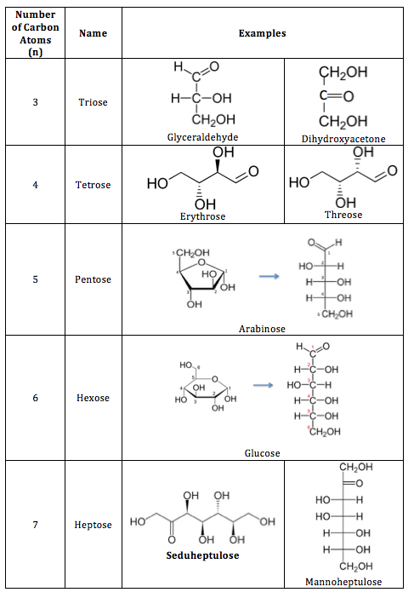
Five and six-carbon species are especially common. Glucose, fructose and galactose share the same molecular formula: C₆H₁₂O₆. Because of their six carbon atoms, each is a hexose. Although all three share the same molecular formula the arrangement of atoms differs in each case. Substances such as these three, which have identical molecular formulas but different structural formulas, are known as structural isomers.
Monosaccharides are divided into two families; D form and L form sugars. A monosaccharide is given D configuration if the hydroxyl group is on the right of the last stereocenter carbon, whereas L configuration is given if the OH is on the left. D or L is usually put in the beginning of the carbohydrate when naming the molecule eg; D-glucose.
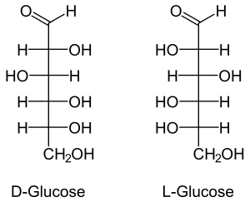
Common monosaccharides;
- Glucose, also called dextrose is the blood sugar. It is the immediate source of energy for cellular respiration, it is an aldose sugar.
- Galactose, is the sugar in milk products. It is an aldose sugar.
- Fructose, is known as fruit sugar, it is also found in honey. It is a ketose sugar.
Disaccharides, are carbohydrates composed of two monosaccharide units covalently bonded to each other. Like monosaccharides, disaccharides are water-soluble substances. Especially in the human diet the most important ones are sucrose (common table sugar), lactose and maltose. Although the process of linking the two monomers is rather complex, the end result in each case is one mole of water. The resulting linkage between the sugars is called a glycosidic bond. An aldehyde or a ketone group on the sugar can react with a hydroxyl group on another sugar, this called maltose type glycosidic bond. In a different type, an aldehyde or a ketone group of one sugar can react with the aldehyde or a ketone group of the other sugar. This bond is called trehalose type glycosid bond. The different types of this bonds effect the reduction property of the sugar. Reducing sugars have free aldehyde or ketone groups. Sucrose is the non-reducing sugar, while lactose and maltose are reducing.

