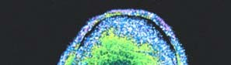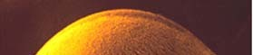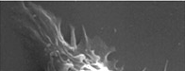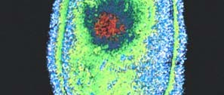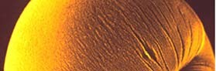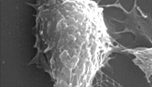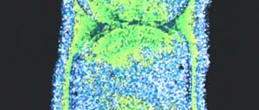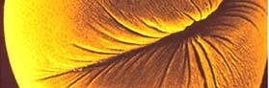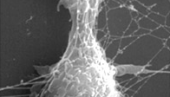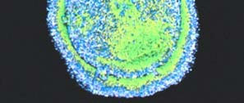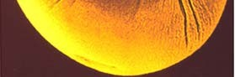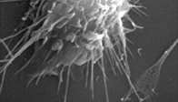

Cell Division

Reproduction is a fundamental property of life. Cells are the fundamental unit of life. Reproduction occurs at the cellular level with one mother cell giving rise to two daughter cells.
1

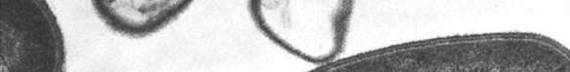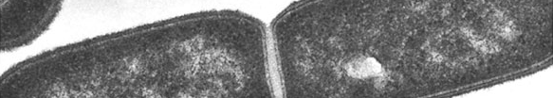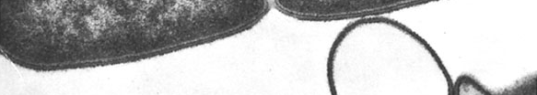

Cellular reproduction consists of making copies of all internal components of the cell, positioning those components, and then dividing the cell so that the new cells receive a copy of each of the important internal components.
Prokaryotic cells reproduce by binary fission.
They grow to a size sufficient to divide into two cells, replicate
their DNA (so that they have two DNA molecules) and then build a new cell membrane between the two DNA molecules.

2

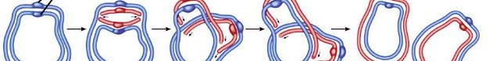

DNA replication in prokaryotes begins at a single point on the circular double stranded DNA molecule, the replication origin.
DNA is replicated in both directions from the replication origin, until there are two complete double stranded DNA molecules.
Each of the double stranded molecules consists of one of the original strands and one new strand.
Each strand is attached to neighboring attachment points on the cell membrane and then a new cell membrane is built to separate the molecules into different cells.
3

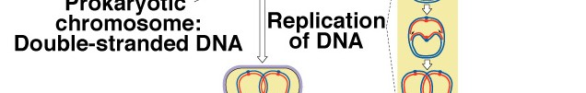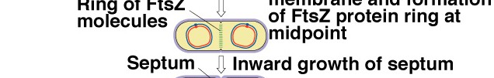

The FtsZ protein is required for proper cell division. The protein accumulates where the septum forms between the cells. The FtsZ protein is chemically similar to the microtubules that form the
spindle fibers in eukaryotes. 4

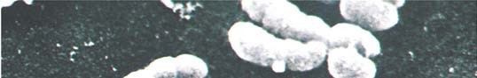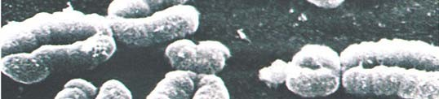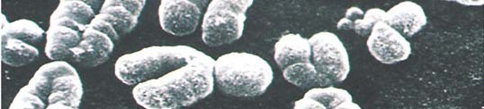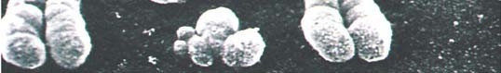Cell division in eukaryotic cells is more complex. The DNA of eukaryotes is distributed among many chromosomes and the chromosomes are contained within the nucleus. The chromosomes must be replicated and then organized in a way that ensures that each of the daughter cells receives one copy of each chromosome. The process of organizing and distributing chromosomes is called mitosis.
Humans have 46 chromosomes, that carry approximately 25,000 genes. If mitosis happens properly, each daughter cell gets one copy of each chromosome.
5

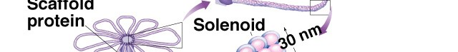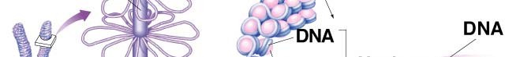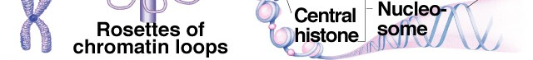

6

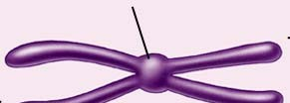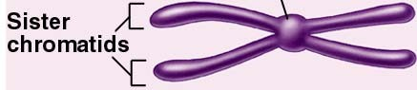

Before DNA replication, a chromosome consists of one continuous double stranded DNA molecule

After replication, each chromosome consists of two double stranded DNA molecules attached at a single point - the centromere.

Each of the double stranded DNA molecules is an exact copy of the other. Each of the copies is called a chromatid.

7

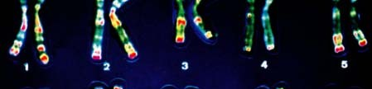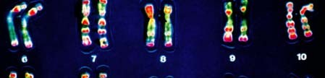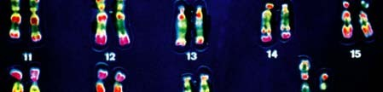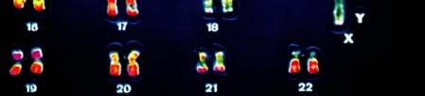
Each of the 46 chromosomes of humans has a centromere. The centromere can be located in a central position, a terminal position, or somewhere in between.

Metacentric

Submetacentric

Acrocentric

Telocentric

Chromosome size also varies greatly 8

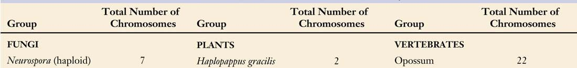

Most organisms have between 10 and 100 chromosomes in their cells. There is no relationship between chromosome number and evolutionary progress.

9

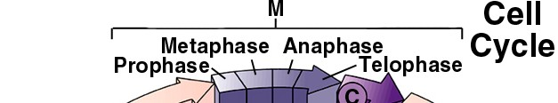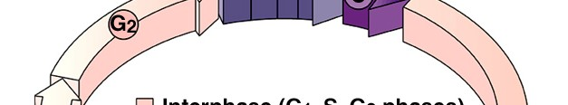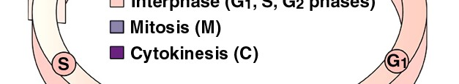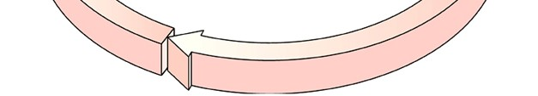

Cell division in eukaryotes can be viewed as part of a larger process in the life of a cell - the cell cycle. In the cell cycle, cells are either dividing or preparing to divide.

G1 - (first gap) - normal growth and metabolism
S - synthesis of DNA
G2 - (second gap) - normal growth and metabolism and replication of organelles - spindle fiber formation begins

G1, S, and G2 are collectively called interphase 10

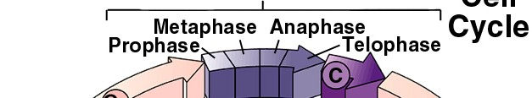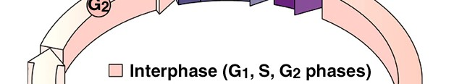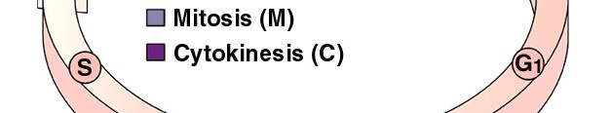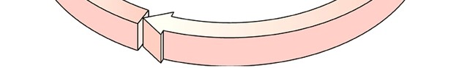M - mitosis - chromosomes are organized and chromatids are moved to opposite sides of the cell
mitosis has 4 named phases - prophase, metaphase, anaphase, and telophase
C - cytokinesis - the division of the cell into two cells

11

The entire cell cycle can be very short in some cells - especially in early embryos where cells are large and divide to produce smaller and smaller cells - or it may take years for a single cell to grow to a sufficient size to allow it to divide.
Some cells enter a resting stage - called G0 - where they don’t grow and aren’t preparing for another cell division. Most cells in the human body are in G0. Some can reenter G1 to prepare for cell division, but some, like nerve and muscle cells, never do.

12

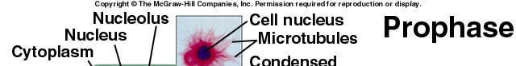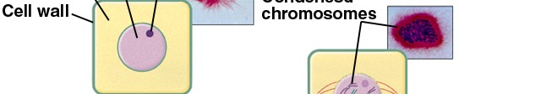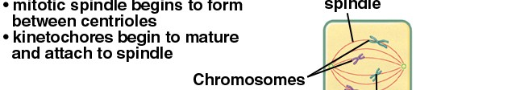

Mitosis
Cells leave G2 and enter mitosis with their chromosomes in a replicated state. During interphase the chromosomes are not tightly coiled - they exists as chromatin fibers.

During prophase - chromosomes condense, the spindle fibers form, nuclear membrane disintegrates, and the spindle fibers attach to either side of each centromere.

13

Spindle fibers (microtubules) attach to the kinetochore which is part of the centromere.
Each chromatid has a kinetochore.

After the spindle fibers attach the kinetochores begin shortening of

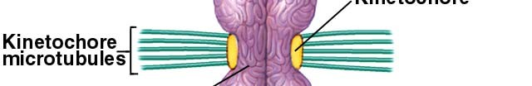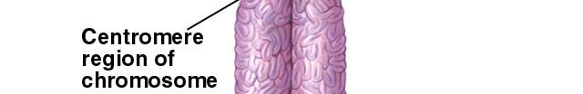the microtubules. the cell.
This positions the chromosomes in the center of
14

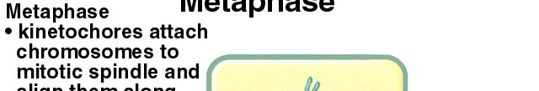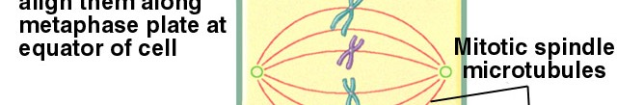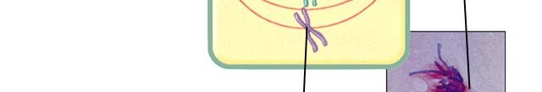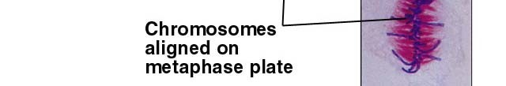

During metaphase, the chromosomes are aligned at the equator of the cell - at the “metaphase plate.”

15

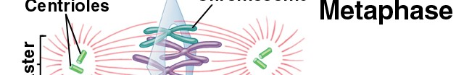

16

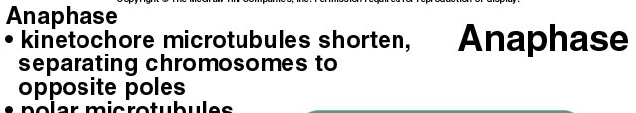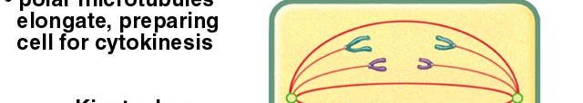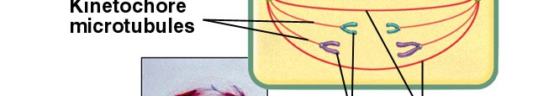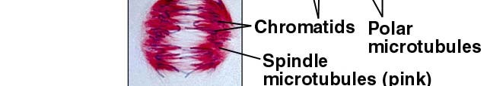

Anaphase begins with division of the centromeres. Sister chromatids are pulled to opposite poles of the cells.
Kinetochores depolymerize microtubules to shorten them. This moves the chromosomes

17

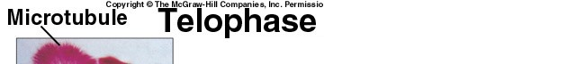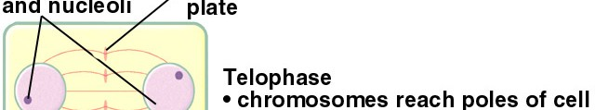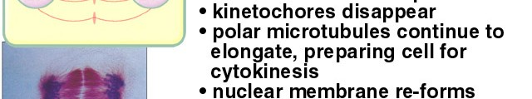

Telophase - chromosomes arrive at the poles of the cell, a nuclear membrane forms around them, chromosomes decondense

18

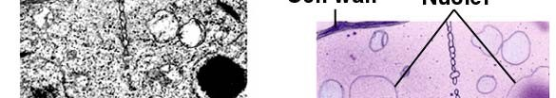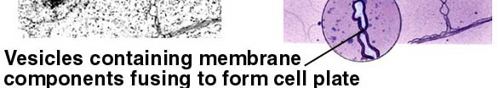

In plant cells, a cell plate forms between the two nuclei, creating two daughter cells.

19

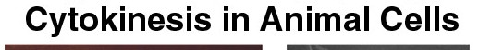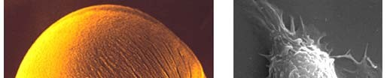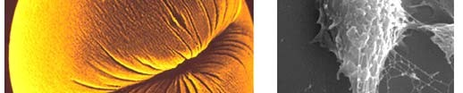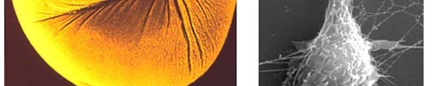

In animal cells, the cell membrane constricts between the poles, creating two daughter cells.

20

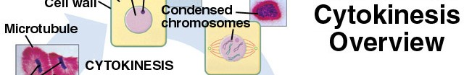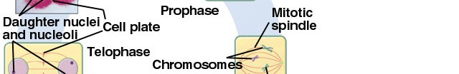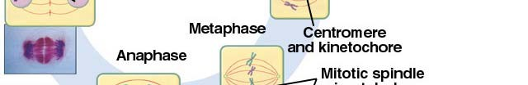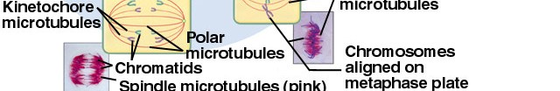

The end product of mitosis and cytokinesis is two daughter cells each with an exact copy of the DNA that was in the original parent cell. These cells can enter G1 and begin the process again.
21

With the exception of sperm and egg cells, all the cells in any multicellular eukaryote are produced by mitosis. All possess all the genetic information contained in the original cell from which they came.
Cells in some tissues (e.g. skin) go through the cell cycle twice each day. Others may cycle on a monthly basis. Other cells may be in an indefinite G0 stage and will never divide again.
How is cell division regulated?

22

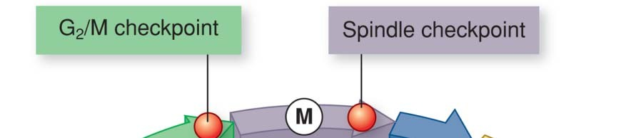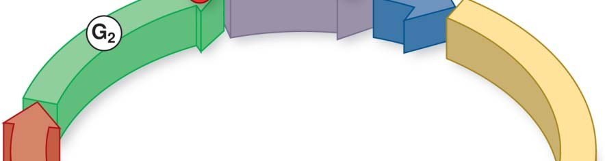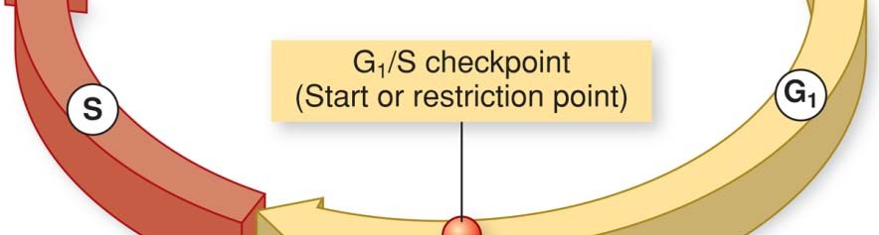Control of the Cell Cycle
Not all cells grow and divide at the same pace. Cells decide to proceed to the next stage in the cell cycle by assessing their state at three different checkpoints in the cell cycle.
G1/S checkpoint - a cell assesses its size and nutritional state. If it can support cell division it proceeds to S.
G2/M checkpoint - at the end the cell assesses the DNA synthesis. If OK, it proceeds to Mitosis.

M (Spindle) checkpoint - during metaphase the cell assesses the alignment of chromosomes. If OK, it proceeds to cytokinesis.
23

In single celled organisms the prime determiner of advance past

the G1
checkpoint is cell size and nutritional state.

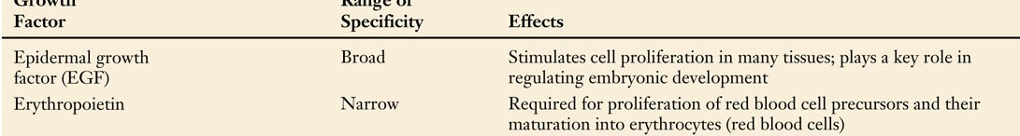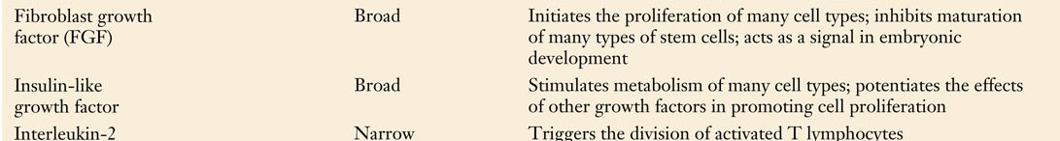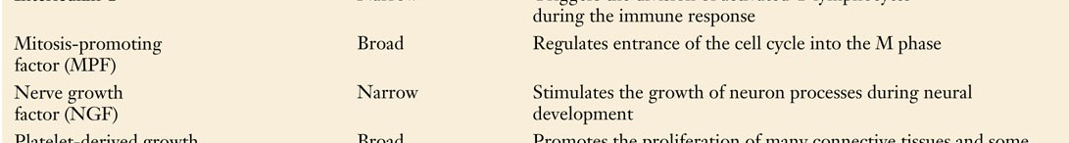In multicellular organisms, a growth factor or combination of growth factors present at the G1 checkpoint signals the cell to proceed to S if size and nutrition are sufficient.

24

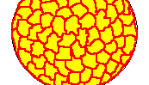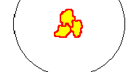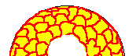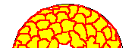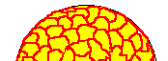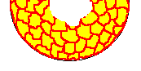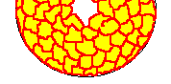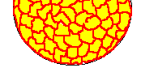

Mammalian cells grown in tissue culture will multiply to form a layer one cell thick and then stop dividing.

If a group of cells is removed from the culture, the surrounding cells begin dividing and fill in the gap created and then stop.
How do they know when and when not to grow?
25

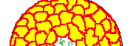
The cells in the tissue culture are constantly producing small amounts of growth factor. Each cell and its neighbors are also constantly taking up growth factor and breaking it down. Cells will only grow if the concentration of growth factor exceeds a threshold amount. It only does so when there is a gap in the cells, where the growth factor can accumulate.

After the cells fill the gap, all growth factor produced is degraded by neighboring cells and further growth stops.
26

Cancer is the uncontrolled growth of cells. Uncontrolled cell growth consumes resources needed by noncancerous cells.
When this occurs noncancerous cells die and are replaced by cancerous cells that continue to grow unchecked.
Cancerous cells in culture do not stop growing once they cover the surface of the growth medium.
Cancerous growth can be caused by
- growth in the absence of a normally required growth factor
- excessive production of the growth factor by cells
- lack of a growth inhibitor

All conditions that lead to cancer are ultimately the product of a gene that is not functioning normally. Genes can fail to function normally if they are damaged - if they mutate.

27

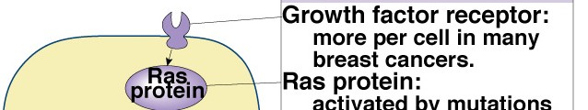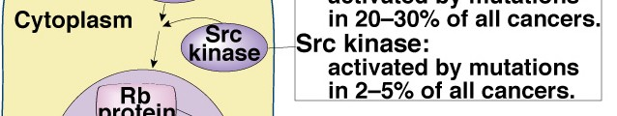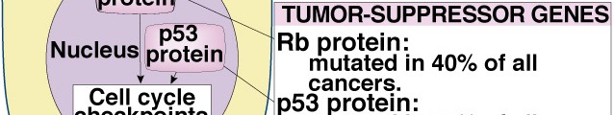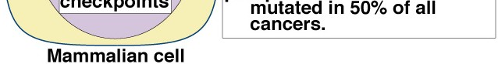
Genes that have mutated and as a result cause cancerous growth are called oncogenes.
Genes that have not mutated, but that can mutate to become oncogenes are called proto-oncogenes. Most proto-oncogenes have important functions in the development or maintenance of tissues.

Cancer is a genetic disease caused by mutations.
Mutations are caused by many things.
Some chemicals are powerful agents of mutation.

28

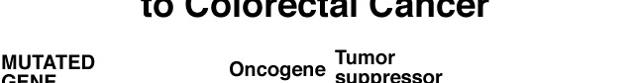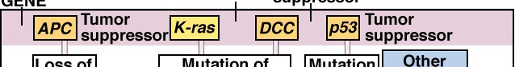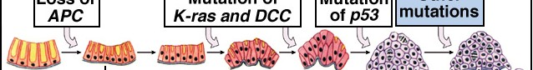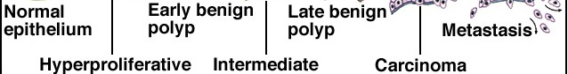

Cancer usually develops after many mutations have accumulated in cells.

29

Reference: https://www.nicholls.edu/biol-ds/biol155/Lectures/Cell%20Division.pdf

