Lawrence Ferlinghetti Briefly
(1919-)

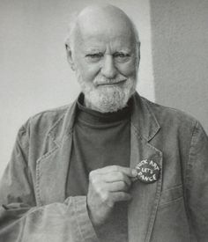

- In one aspect the most important figure of the Beat Generation as he was the owner of City Lights where he published the Beat classics. His bookstore bearing the same name was a meeting place for the Beats.
- After a hectic youth colored by living abroad and an orphanage for a while, time in the US Navy, he attended university and majored in journalism.
- “His poetry engages readers, defies popular political movements, and reflects the influence of American idiom and modern jazz.”
- He wrote for people to understand and enjoy poetry. And people responded well to his desire: His A Coney Island of the Mind sold more than one million copies.
- He wrote fiction and plays as well which we are well-received as well.
- For more https://www.poetryfoundation.org/poets/lawrence-ferlinghetti

