3.1.6. Blanching
Blanching is one of the basic processes applied in canning technology. Blanching is generally applied to vegetables and is done in 3 different ways^{[7]}:
- Blanching with hot water: Blanching equipments with adjustable temperature and time settings are used. Blanching time varies between 1-10 minutes and water temperature 80-100 °C.
- Blanching with steam: Individual quick blanch (IQB) application is used. The raw material spread on the belt is first passed through the steam section, then through the hot keeping section, and finally cooling is done.
- Microwave blanching: Since the water in the raw material absorbs microwaves, it heats up easily and has an internal drying effect.

The purposes and benefits of the blanching process^{[7]};
- Enzymes are inactivated. Thus, enzymatic reactions that may occur in the product during the period until the heat treatment are prevented.
- Microorganism load is reduced. In particular, most of the vegetative bacterial cells, yeast and molds are killed.
- An effective cleaning is also ensured when blanching in water.
- Leaf vegetables and hard raw materials (such as spinach) soften and decrease in volume. Thus, easy filling is provided.
- Respiratory gases in the tissues of vegetables are removed. Thus, sufficient vacuum is created in the can. In addition, since it causes the reduction of O₂ gas in the can, corrosion of the can is prevented.
- The raw flavor remains in the water and is not carried to the final product. The raw taste and odor are partially lost and the stickiness substance is removed in products such as in okra.
- If the raw material contains protein, the proteins are coagulated by blanching and shrinkage during heat treatment is prevented.
- By softening the texture, the required time for cooking is shortened.

The change of microbial load in the product with the pre-treatments in canned food production is shown in Figure 3^{[14]}.

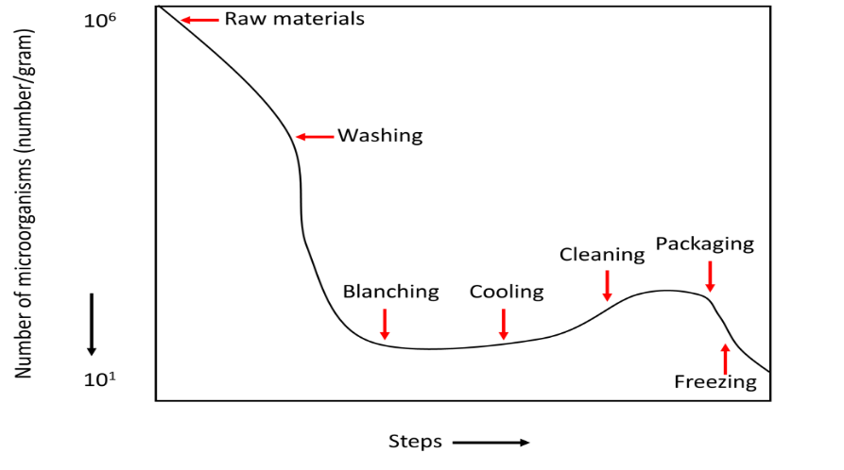
Figure 3 The effect of pretreatments applied in canning on microbial load

3.2. Filling into Cans or Jars
The fruits, which have undergone the necessary pre-processing, are filled into containers without being blanched, and the vegetables after being blanched. Filling is completed by adding the filling liquid prepared in accordance with the product^{[15]}.
- About 1-2% of boiling salted water (brine) is added as a filling liquid for vegetables. In some cases, citric acid, calcium chloride or sugar may be added to the filling liquid.
- For fruits, sugar solution (syrup) with a concentration of 14-18% according to the variety is added. In some fruit cans, the fruit's own juice (no sugar added, unsweetened) can be added as a filling liquid, and sometimes can be made without using a filling liquid (solid pack-dry filling).
- Vegetable oil or sauce is generally used as filling liquid in ready to serve food and canned meats.

In fruit preserves, there is a mass transfer between the fruit and the syrup over time by osmosis, and therefore the brix of the filling liquid decreases over time. To avoid this problem, the syrup brix is kept higher than the desired final brix in the can.

With the use of filling liquid, the spaces between fruits and vegetables are filled, the heat transfer is facilitated in the can during heat treatment, corrosion is partially prevented and the aroma substances of fruits and vegetables are retained.

The water used in the preparation of the filling fluid must be of potable water quality. Especially the presence of some minerals in the water causes discoloration of the food in the can.

The sum of the weights of the solids in the container and the filling liquid gives the net weight. Drained weight, on the other hand, is the weight of the remaining part of the contents of the can after drained on a sieve on its own, and restrictive provisions regarding drained weight are given for all kinds of cans in the legislation.

The boxes are filled with enough fruit or vegetables to provide the desired straining weight. Filling liquid is added so that approximately 10% of the box volume remains empty. The part that is left empty between the contents of the box and the lid is called the "headspace". The headspace is left to balance the expansion of the materials in the can during the heat treatment and to create a vacuum. Due to the pressure created during sterilization, swelling occurs in the bottom and lid parts of cans that do not have enough headspace. In boxes with too much headspace, too much vacuum occurs and the bottom and top cover parts collapse inward. It is therefore necessary to set the headspace at an optimum level (minimum 6%)^{[7,12,15]}.

3.3. Exhaust and Sealing
It is absolutely necessary to remove the air in the food filled in cans and in the headspace. If this process is not done^{[15]};
- Oxidative deterioration occurs in food over time.
- Corrosion starts on the box material.
- After the can is closed, the desired vacuum is not provided.
- Aroma and color substances cannot be preserved to the desired extent.

Exhaust process can be done with 4 different techniques. These are^{[16]}:
- Hot filling: Air is removed by hot filling of the food and filling fluid.
- Thermal method: Air and gases are removed by a preheating process. It is made in exhaust units and the most common is exhaust tunnels.
- Mechanical method: Air and gas in the can are sucked mechanically. Air removal is provided by sealing in vacuum sealing machines.
- Steam injection into the headspace: By giving high temperature steam to the headspace, the gases are removed and immediately closed. When the remaining steam cools, it condenses into water and mixes with the filling liquid, thus providing the desired vacuum.

Semi-automatic and fully automatic machines are used to close (seal) tin cans. The box to be closed is first placed on the lower table, the lid is placed on it, the lower table rises, and the closing process is started. In closing, the hooking of the box closure periphery and the box body claw to each other is called "clamping", and the closure places that occur are called "clamp" and this process is performed on the rollers. In glass jars, there is a gasket between the jar mouth and the lid, thus ensuring hermetic closure^{[15]}.

3.4. Heat Treatment (Pasteurization and Sterilization)
Foods in hermetically (airtight) sealed cans are pasteurized or sterilized by applying different heat treatments according to their properties and conditions. Heat treatments applied in a sterilizer or autoclave at temperatures above 100°C are called "sterilization", and heat treatments applied in a pasteurizer at temperatures above 100°C are called "pasteurization". In general, foods with a pH below 4.5 (fruit, fruit juice, fruit paste, canned tomatoes, tomato juice, tomato paste, canned peppers) are pasteurized, foods with a pH above 4.5 (vegetables, meat and fish, canned ready meals) are sterilized^{[17]}.

Sterilized canned food may contain aerobic or thermophilic microorganisms resistant to high temperatures. Since the living microorganisms cannot find the necessary environment for their live and reproduction in canned food stored under normal conditions, they cannot spoil the canned food. For this reason, sterilization applied in the canning industry is characterized as "commercial sterilization"^{[17]}.

Pathogens in the hermetically sealed can and all microorganisms that may cause deterioration under normal storage conditions are killed by heat treatments. In addition, as the enzymes are inactivated due to the applied heat, the shelf life and stability of the product increase. While achieving all these goals, heat treatment norms should be determined by taking into account the protection of the nutritional value and quality of the food^{[18]}.

Empty cans must also be steam cleaned before filling. While canned foods are subjected to heat treatment, they should be kept at the desired temperature for a certain period of time. For this reason, it is necessary to know in advance the "last heating point (cold spot, position of lowest temperature within a product)” in cans and to determine how long it takes for this point to reach the desired temperature. The location of the cold point in solid and liquid canned foods is given in Figure 4^{[19,20]}.

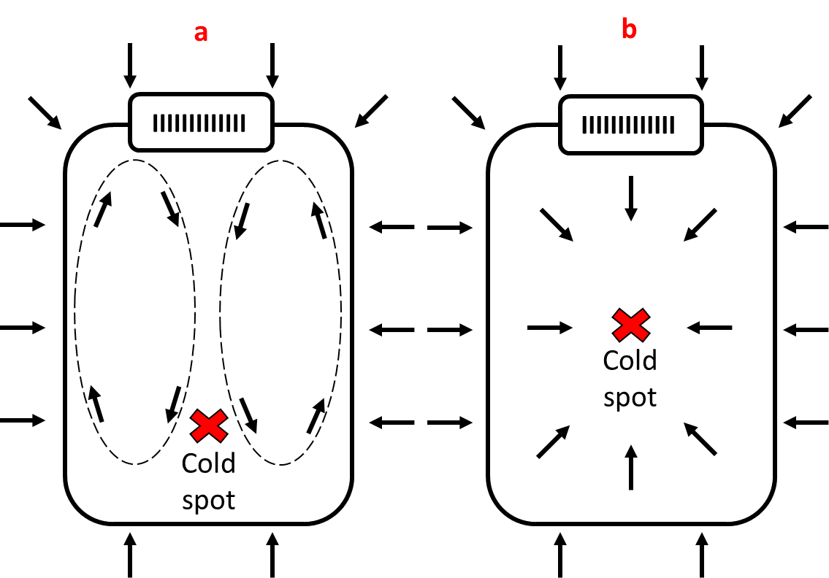
Figure 4 Transfer of heat in liquid or semi-liquid food (a, convection heating) and solid food (b, conduction heating) in a jar during steam processing.

3.5. Storage
The shelf life of canned foods is the period from the time they are produced to the moment of retail sale. The shelf life of cans is limited and specific depending on the variety and storage conditions. However, under normal storage conditions, it is never less than a year.

Even if canned food does not deteriorate microbiologically, they can only be stored until they fall to a certain quality, as their quality gradually decreases during storage. Chemical reactions are the reason for the slow decrease in quality over time. These reactions occur between the components of the food or between the food and the container.

In the storage of durable foods, chemical reactions that develop slowly at low temperatures accelerate as the temperature rises. It is generally accepted that every 10°C increase in temperature causes the rate of these reactions to reach 2 times. For this reason, canned storage should be done above 0°C but as low as possible. However, since this is not practical in practice, it is common practice to store cans at around 10°C^{[10,11]}.

3.6. Deterioration in Fruit and Vegetable Canned Foods
Deterioration in canned foods can be caused by microorganism activities, interactions between the contents of the can and the can, or applications in processing^{[21]}. Deterioration in canned food occurs in 3 ways^{[22-24]}:
- Microbiological spoilage: Flat souring occurs in the form of spoilage caused by thermophilic anaerobic bacteria, deterioration caused by the breakdown of nitrogenous substances, that is, purification, and deterioration due to the acid formation of carbohydrates in foods by the effect of microorganisms. If the microorganism causing gas is the cause of spoilage in the can, gas accumulates in the can and swelling occurs, this event is called “bombing”. Some microorganisms, on the other hand, degrade the product by forming water-soluble gases such as hydrogen sulfide or without generating gas, in this case, there is no swell on lids, but the product becomes sour, the color becomes cloudy, and it becomes inconsumable. Various microbial spoilage occurs in the stages prior to heat treatment, due to leakage, due to improper sealing or application of inadequate heat treatment conditions. In this context, the deterioration caused by C. botulinum, whose spores are very resistant to heat, is very important. C. botulinum causes spoilage in foods by forming toxin, and the poisoning it causes in humans is called “botulism”.
- Chemical deterioration: It is caused by the effect of canned food on the can with the effect of some substances in its structure or added later, and this effect is known as "corrosion". As a result of this, the quality decreases, a health risk occurs, the can is punctured with the progression of corrosion and microbiological endurance ends.
- Physical deterioration: Swelling, collapse and similar deformations occur in the boxes as a result of using the wrong autoclave, insufficient exhaust, overfilling the box or creating excessive vacuum in the can.

Table: Food components causing metal abrasion
Food | Food compound
Vegetables | Sulphur containing amino acids and proteins
 | Oxygen
 | Chlorine
 | Nitrate
 | Oxalic acid
 | Ascorbic acid and pectin degradation products
Fruits | Organic acids
 | Anthocyanins, flavanolls, catechins
 | Hydroxymethyl furfural
 | Sulphur containing compounds
 | Oxygen

