Molecular Transport and Convective Transport

2. Fourier's Law of Heat Conduction
When we placed a slab of solid material of area A between two large parallel plates, which is separated with a distance of L. At first, the solid slab is at a temperature To throughout the material. Afterwards, the lower plate is suddenly brought to a slightly higher temperature T1 and held constant at that temperature. According to the second law of thermodynamics, heat flows spontaneously from the higher temperature “T1”to the lower temperature “To”. At certain time interval, a linear steady-state temperature profile is attained as shown in Figure below.
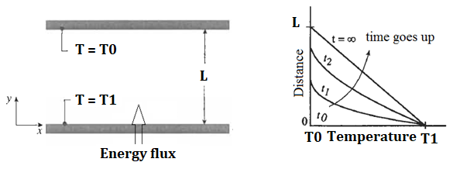
Figure 1. Temperature profile between parallel plates containing solid slab

Experimental results exhibit that the rate of heat flow rate per unit area, which is the energy flux, is proportional to the temperature gradient.
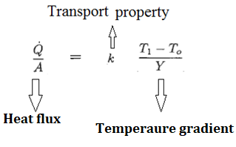

The transport property “k”, which is also the proportionality constant, is the thermal conductivity. The relation given above can be written in microscopic form as shown below.
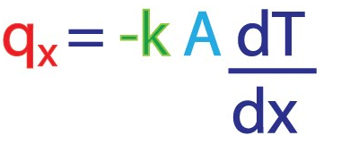
The microscopic form of the given equation is known as Fourier's law of heat conduction. “x” is the direction heat flux.

Example: A solid slab is constructed from 0.15 m thick material having a thermal conductivity of 1.7 W/m.K. Measurements made during steady-state operation reveal temperatures of 1400 and 1500 K at the inner and outer surfaces, respectively. What is the rate of heat loss through the solid slab that is 0.5 m by 1.2 m on a side?

Solution:
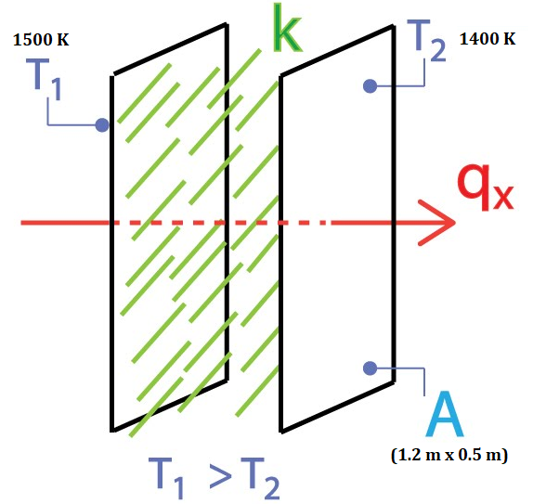
Assumptions:
- Steady-state conditions
- One dimensional conduction through the Wall
- Constant thermal conductivity

qx = k (T2 – T1)/L = 1.7 W/m.K x (1500 – 1400)K / 0.15 m = 1133.3 W/m²

Qx = (qx) x (A) = 1133.3 W/m² x (1.2 x 0.5) m² = 679.98 W

3. Fick's First Law of Diffusion
When we insert two parallel plates, one of which is coated with a material with low solubility within the stagnant fluid, into stagnant fluid. At first, the material on the solid slab starts to dissolve within the fluid and starts to diffuse. The saturation concentration of the material “A” is pAo and A undergoes a rapid chemical reaction at the surface of the upper plate, which means that its concentration is zero at the upper plate. At certain time interval, a linear steady-state concentration profile is attained as shown in Figure below.
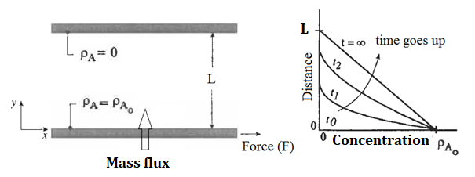
Figure 2. Concentration profile between parallel plates containing a stagnant fluid

Experimental results exhibit that the rate of mass flow rate per unit area, which is the mass flux, is proportional to the concentration gradient.
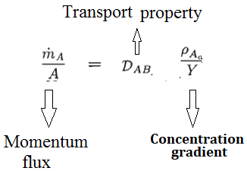

The transport property “D_{AB}”, which is also the proportionality constant, is the diffusion coefficient. The relation given above can be written in microscopic form as shown below.
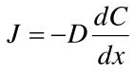
The microscopic form of the given equation is known as Fick’s first law of diffusion.

References:
İ. Tosun, “MODELLING IN TRANSPORT PHENOMENA A Conceptual Approach”, Elsevier, 2002.

