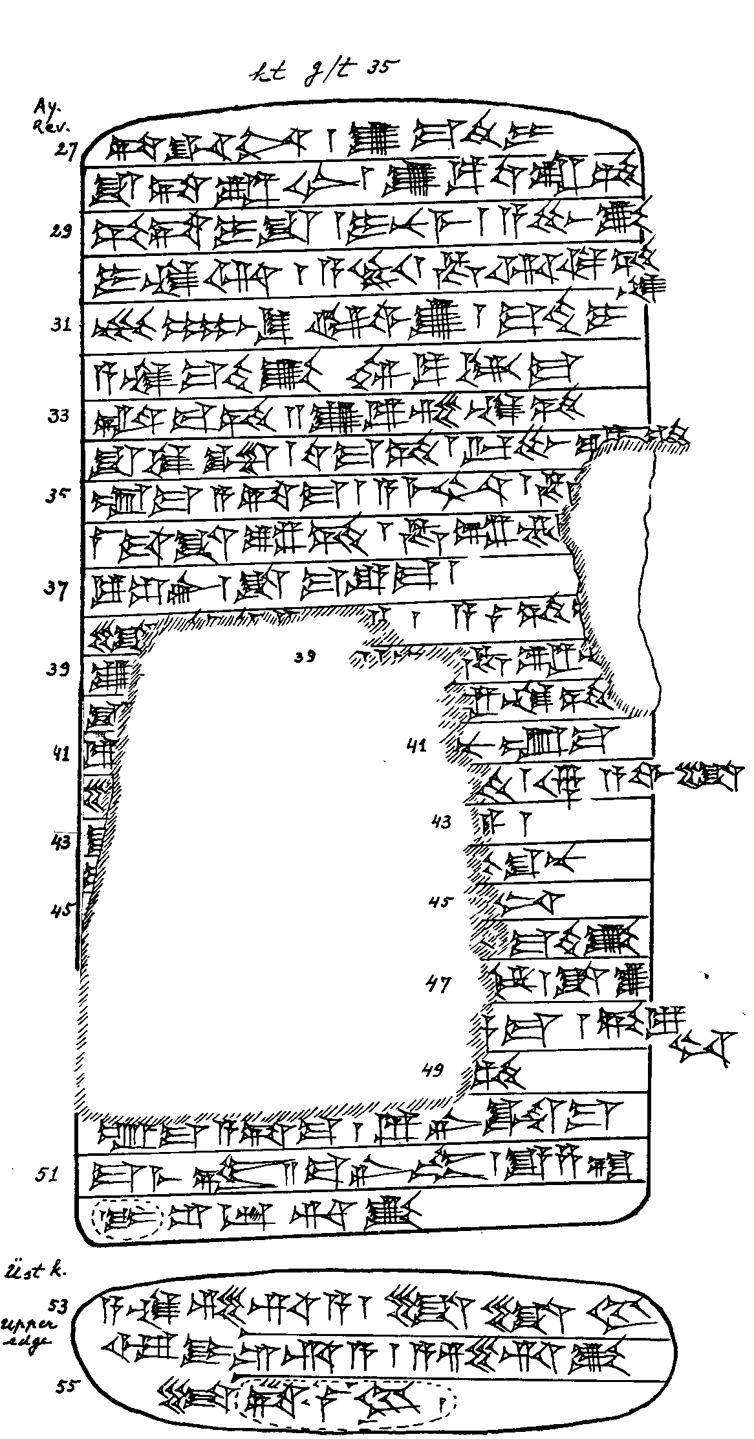
Kt g/t 35
ta-da-nim / u2 ma-ti2-i
is^-ta-ra-ap2 / u2 qu2-ut-ra-am
ub-ta-i-is^ / i-nu-mi3 / a-bu-ka3
30 I-na-ar / a-lam / Ha-ar-sa2-am-na
MU.9.S^E3 il5-wi-u2 / ma-ti2-i
a-na ma-ti2-ka3 im-qu2-tam2-ma
al-pa2-am // u2-lu s,e2-na-am
is^-ki-it / u4-ma-am / tas^-pu-ra-am
35 um-ma a-ta-ma / a-mi3-nim / ha-[ra-nam]
la2 tu3-s^a-ra-am / ha-ra-na[m]
lu-s^e2-er / s^a pa2!-e-ma /
li-[li-ku-nim] / a-la2-am x [x x]
u2 [x x x x] ha-ra-n[am x x]
40 i[s^-tu3 x x x ha-r]a-nam
lu-[s^e2-er x x x a-n]u-um-ma
l[i-x-x-x x x is^]-ti2 / 17 a-wi-li
s^[u x x x x x] x
x [x x x x x x]-x-s^u-nu
45 [x x x x x x]-nim
[x x x x x x] ma-ti2-ka3
[x x x x x x-t]am2 s^a u2-bi-lu=nim
[x x x x x x]-x-ma
[x x x x ta-as^2-pu-ra]-am
50 um-ma a-ta-ma / lu ni-it-ma
ma-mi3-tum // pa2-ni-tum / e-s,a-at
DUMU s^i2-ip-ri-ka3
a-na s,e2-ri-a / li-li-kam
u3 DUMU s^i2-<ip>-ri-a / a-s,e2-ri-ka3
55 li-ta-la2-kam
Ta-ri-ku-ta-na / ki-ma / KU3.BABBAR / ab2-na-tim / ik!-nu-uk-ma
e-ti2-zi-ib / a-ni-a-tum / a-na DINGIR.li dam-qa2-a

