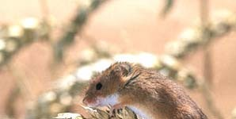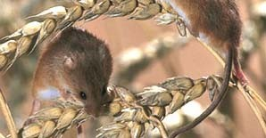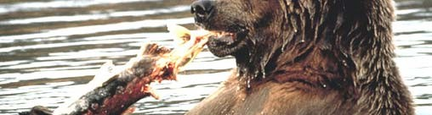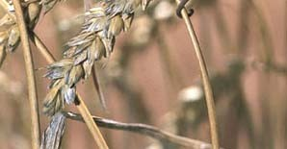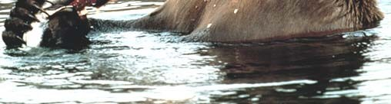
Cellular Respiration

Cells harvest chemical energy from foodstuffs in a series of exergonic reactions. The harvested energy can then be used to power energy demanding processes including endergonic reactions. 1

Metabolism - the sum of all chemical processes carried out by living cells
Catabolism - the chemical reactions that break larger molecules into smaller molecules. It is usually an exergonic process.
Anabolism - the chemical reactions that form larger molecules from smaller molecules. It is usually an endergonic process.
Autotroph - an organism that obtains its energy from sunlight or inorganic chemicals. Plants, photosynthetic protists, and photosynthetic prokaryotes are autotrophs.
Heterotroph - an organism that obtains its energy by
consuming and degrading organic molecules. Some eat other organisms, some parasitize, some degrade the remains of once- living organisms. Animals, Fungi, many protists and most
prokaryotes are heterotrophs. 2

Glucose is the preferred energy source of all organisms and it is the principal product of photosynthesis.
Glucose breakdown can be aerobic (using oxygen) or anaerobic (without oxygen). Anaerobic metabolism of glucose is also known as anaerobic glycolysis or fermentation. Aerobic metabolism of glucose is known as glycolysis and respiration.
Complete aerobic metabolism of glucose produces water and carbon dioxide as products.
C6H12O6 + 6 O2 → 6 CO2 + 6 H2O
Energy is released in this process. The overall ⊗G of glucose breakdown in cells is -720 kcal/mole. Normally about 32% of the energy released is captured through the formation of ATP. The
remainder is released as heat. 3

Aerobic breakdown of glucose consists of four stages
- Glycolysis - a 10 step biochemical pathway where a glucose
molecule (6 C) is split into 2 molecules of pyruvate (3 C). To begin the process 2 ATP must be invested. Energy released from the reactions is captured in the form of 4 molecules of ATP molecules and high energy electrons are trapped in the reduction of 2 molecules NAD to NADH.
The remaining steps are collectively called Respiration.
- Pyruvate oxidation - In a single step a carbon is removed
from pyruvate (3 C) as CO2, leaving 2 of the original carbons attached to Coenzyme-A. The complex is called Acetyl Co-A. In this process one NADH molecule is produced.
- Krebs cycle - A 9 step biochemical pathway that converts all of the remaining carbons from the original glucose into CO2, and yields 1 ATP, and traps high energy electrons in 3 NADH, and 1
4
FADH per Acetyl Co-A.

- 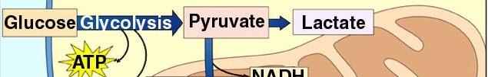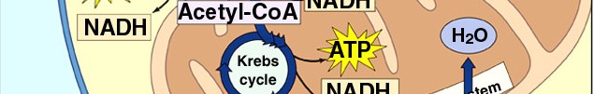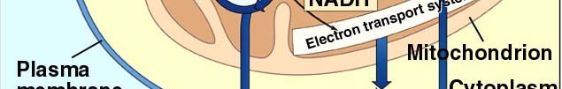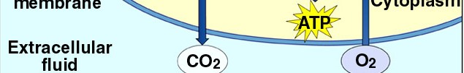Electron Transport Chain - the high energy electrons trapped in NADH and FADH in glycolysis, pyruvate oxidation, and the Krebs cycle are used to produce ATP through chemiosmosis. O2 is the final acceptor of high energy electrons.
In eukaryotes. glycolysis occurs in the cytoplasm, pyruvate oxidation, the Krebs cycle and the Electron Transport System occur in the mitochondrion
In prokaryotes all steps occur in the cytoplasm.

Energy tally - starting with glucose and following all carbons
Glycolysis: Glucose → 2 pyruvate + 2 ATP (net) + 2 NADH

Pyruvate oxidation:
2 pyruvate → 2 Acetyl Co-A + 2CO2 + 2 NADH

Krebs Cycle:
2 Acetyl Co-A → 4 CO2 + 2 ATP + 6 NADH + 2 FADH

Electron transport system (ETS):
2 NADH from glycolysis allow production of 3e or 5p ATP
2 NADH from pyruvate oxidation allow production of 5 ATP 6 NADH from the Krebs cycle allow the production of 15 ATP 2 FADH from Krebs cycle allow the production of 3 ATP

e – eukaryotes, p - prokaryotes 6

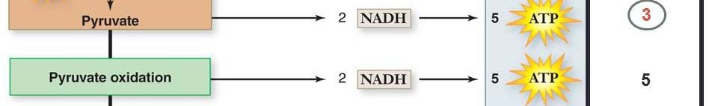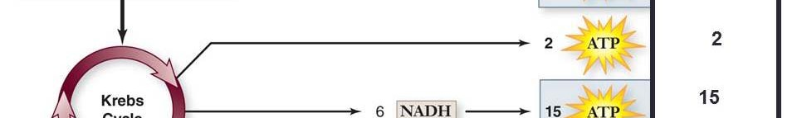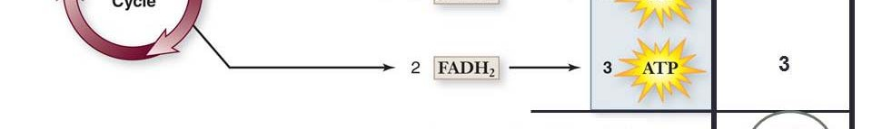

The difference between prokaryotes and eukaryotes will be explained later.
2 ATP are produced in glycolysis and 2 ATP are produced in the Krebs cycle
High energy electrons carried by NADH and FADH are used to produce ATP in the electron transport system.
7

Theoretical Energy Efficiency of Glycolysis and Respiration – for prokaryotes
Glucose contains 720 kcal/ mole
ATP contains 7.3 kcal/mole (in high-energy phosphate bonds) 32 ATP are harvested from each molecule of glucose:
2 from glycolysis 2 from Krebs cycle 28 from ETS
or 32 moles of ATP are harvested from 1 mole of glucose 32 moles of ATP x 7.3 kcal/mole = 234 kcal trapped as ATP
efficiency:
234/720 x 100 = 32% efficiency

8
Actual efficiency is slightly less (more on this later).

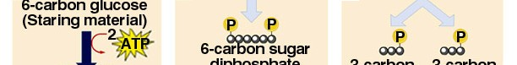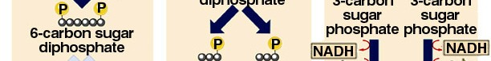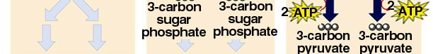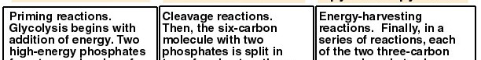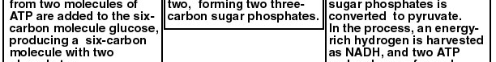

9

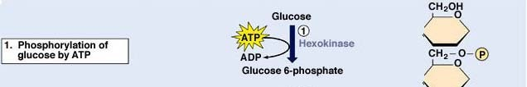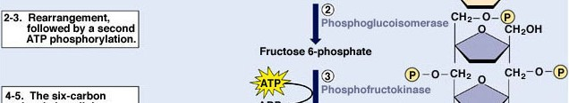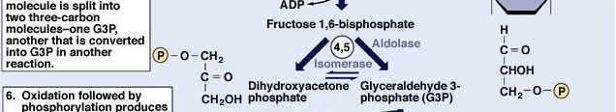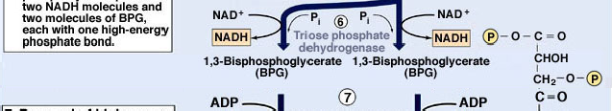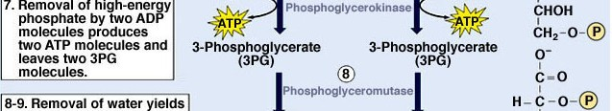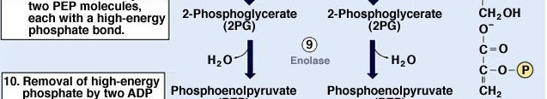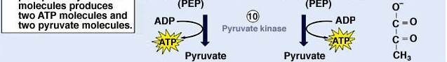

Formation of ATP through the conversion of substrates to products is called substrate level phosphorylation
10

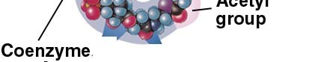Respiration - pyruvate oxidation, the Krebs cycle, and the ETS

Pyruvate, a 3 carbon molecule is oxidized to acetate (producing CO2 and NADH) and combined with Coenzyme-A to form Acetyl Co-A in preparation for sending the remaining carbons of acetate into the Krebs cycle.
In eukaryotes, all steps of respiration occur in the mitochondrion.
11

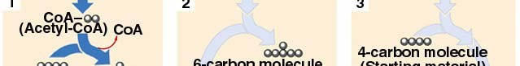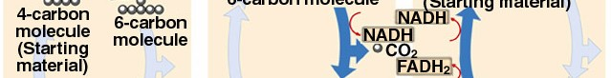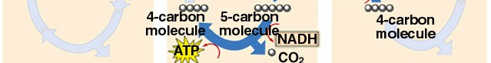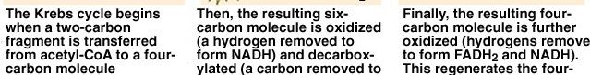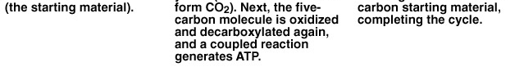

The Krebs cycle occurs in the cytoplasm of prokaryotes and in
the matrix of the mitochondrion in eukaryotes. 12

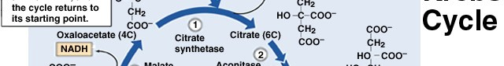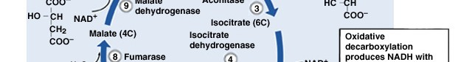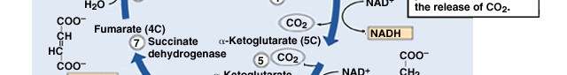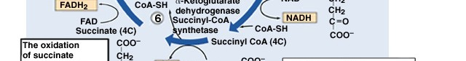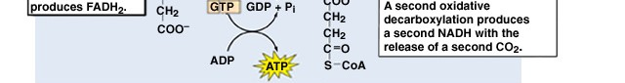

Here is another example of
substrate level phosphorylation. 13

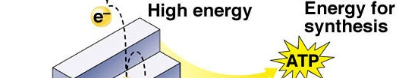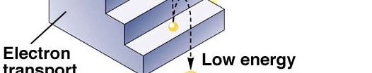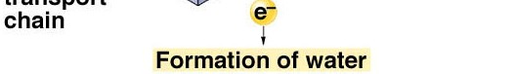High energy electrons carried by NADH and FADH are used to produce ATP in the Electron Transport System.
Electrons are passed through a series of oxidation-reduction reactions. The energy from those transfers is coupled to the production of ATP.
The electrons ultimately are passed to oxygen (protons follow) to produce water. Oxygen is a necessity for this
process. 14

In eukaryotes, the Electron Transport System is located within the inner mitochondrial membrane. High energy electrons passed through the ETS are used to pump protons from the matrix into the intermembrane space. Oxygen is required as the

final electron acceptor.
Without oxygen,
there is no place for

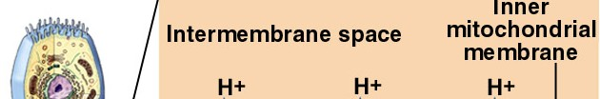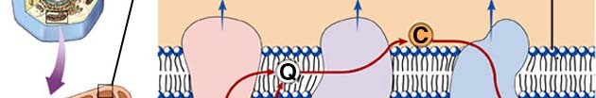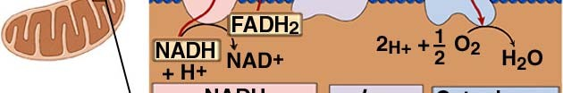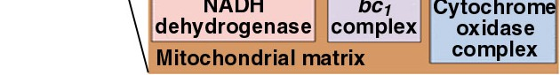NADH and FADH to donate their electrons and no energy can be harvested. 10 protons are
pumped for each NADH and
6 protons for each FADH
When the ETS is active, the intermembrane space has a lower pH than the matrix.15

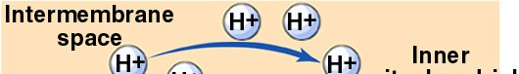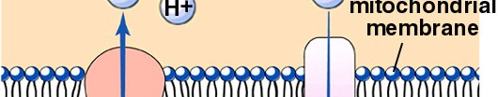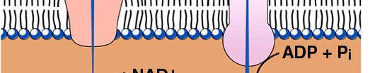

The protons pumped out of the matrix produce a proton gradient between the intermembrane space and the matrix. The proton gradient is used to produce ATP. This is the Chemiosmotic Theory.

ATP synthase couples ATP production to proton flow.
This production of ATP is called oxidative phosphorylation because it requires oxygen. It does not directly involve substrates.

16

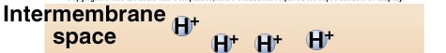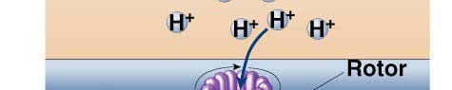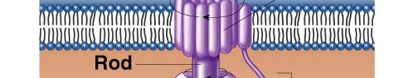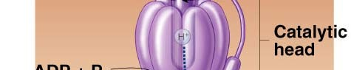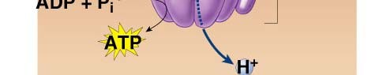

More detail on ATP synthase:

ATP synthase is a large enzyme that acts as a rotary motor.
The ETS creates a proton gradient. Proton flow causes the rotary motor to spin and the mechanical energy of the spinning motor is captured by combining ADP and Pi to form ATP.

17

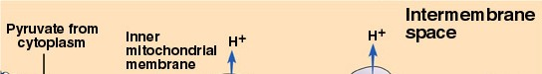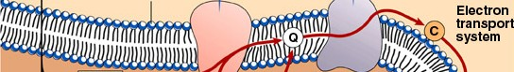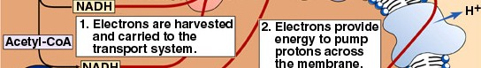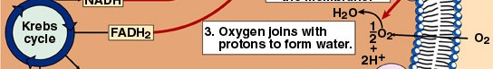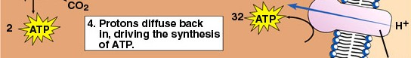

ATP production in the mitochondrion (a summary of respiration):

26

18

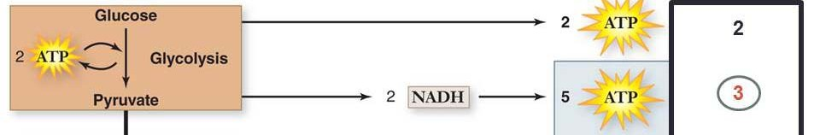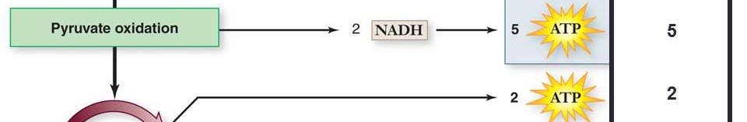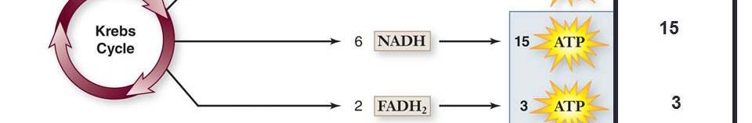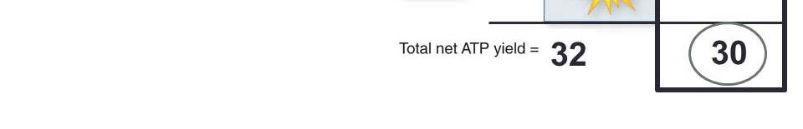
Q: Why do prokaryotes make 2 more ATP than eukaryotes?
A: In eukaryotes, the NADH produced from glycolysis must be transported into the mitochondrion before they can be used to make ATP.
It costs 1 ATP to transport each NADH made in glycolysis.
So, for the 2 NADH that prokaryotes can use to make 5 ATP,
eukaryotes can only harvest a net of 3.
19

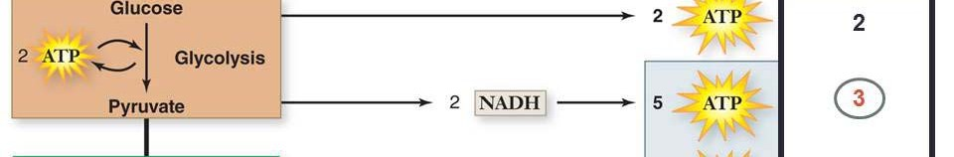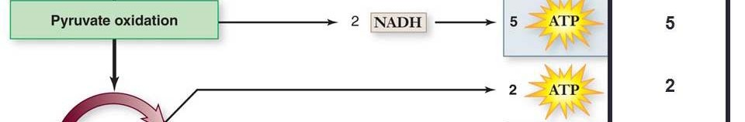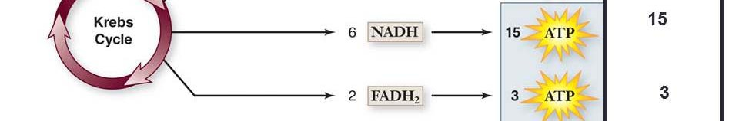
Q: Why is that each NADH can be used to make more ATP than the FADH?

20

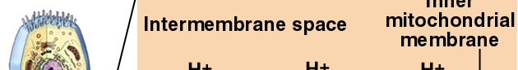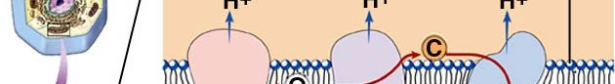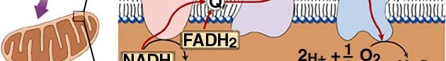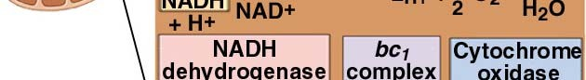

A: The electrons carried by FADH have less energy than the electrons carried by NADH. FADH electrons can be used to pump fewer protons than the electrons from NADH.

21

The theoretical yield of ATP from glucose is 30 or 32 ATP per glucose. The actual number produced is a bit less because of several inefficiencies and complications:
- The inner mitochondrial membrane, and prokaryote plasma membrate is “leaky.” Some protons leak directly through the membrane without passing through ATP synthase and thus do not contribute to ATP production.
- The proton gradient is used for other things besides ATP synthesis. It is used to pump pyruvate from the cytoplasm into the mitochondrial matrix.
The actual yield of ATP is about 26 per glucose. Actual efficiency: (7.3 x 26 / 720) x 100 = 26%

22

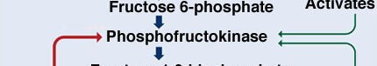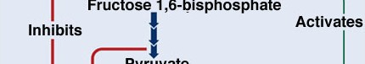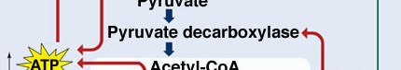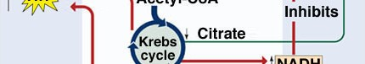
Glycolysis and respiration are regulated through inhibition by high energy end-products (ATP and NADH)
and activation by indicators of low energy levels (ADP). Inhibition and activation both occur at steps early in glycolysis or respiration. Energy is harvested only
when needed.
23

Metabolizing glucose without oxygen: Anaerobic glycolysis or

fermentation
Many organisms live in environments completely devoid of oxygen and still metabolize glucose. Some organisms can switch between metabolizing glucose aerobically and anaerobically depending on oxygen availability. Our own muscles must metabolize glucose anaerobically when we work them vigorously because they deplete oxygen faster than the circulatory system can supply it.
Relatively little ATP can be obtained from fermentation of a

single molecule of glucose,
but the process is very quick.
So,

many glucose molecules can be broken down to provide a large amount of ATP very quickly. If there is no oxygen available, fermentation is the only option for cells to harvest energy.

24

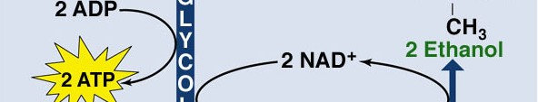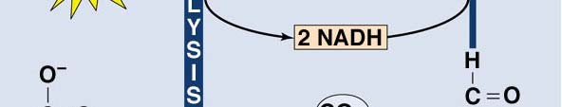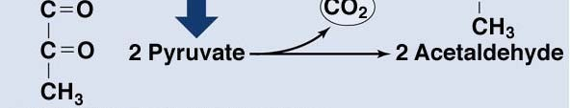Yeast (a fungus), and some prokaryotes, can metabolize glucose anaerobically, harvesting 2 ATP. Since the ETS can’t be used without oxygen, the NADH can’t be used to generate more ATP. Without oxygen the pyruvate can’t be metabolized either because its metabolism depends on NADH being oxidized in the ETS.
Without a mechanism to recycle NADH back to NAD, glycolysis would stop. NADH is recycled to NAD through the production of ethanol from pyruvate.
Ethanol and CO2 are metabolic by-products of the anaerobic metabolism of
glucose. 25

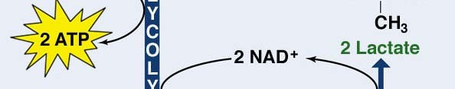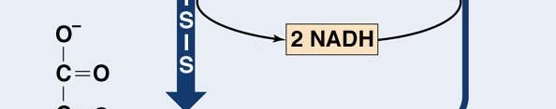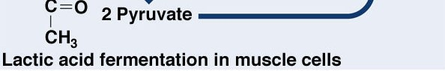Our muscle cells and some microorganisms can metabolize glucose
anaerobically in a slightly different process. To recycle the NADH
they produce lactic acid. The regenerated NAD can used to keep glycolysis and ATP production going even when oxygen is absent.
Lactic acid produced during activity must be reconverted into pyruvate by reducing NAD to NADH when oxygen is available to remove it. The NADH ultimately donates electrons to O2 in the ETS.
Accumulated lactic acid is called oxygen debt because oxygen
must be used to metabolize it after exercise has stopped. 26

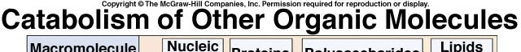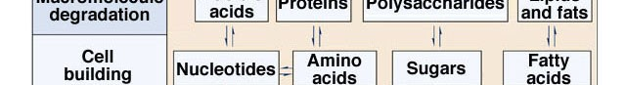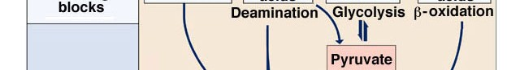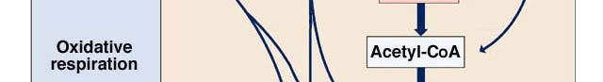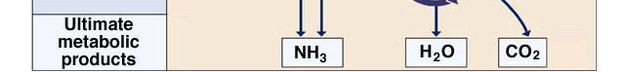All organic molecules metabolized as a source of energy are converted to one of the intermediates of glycolysis or respiration.

27

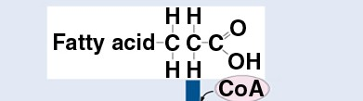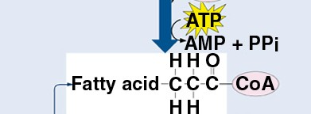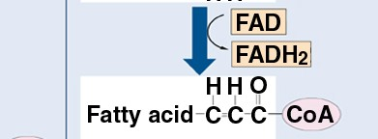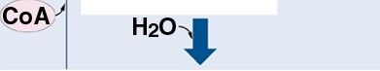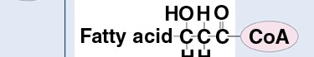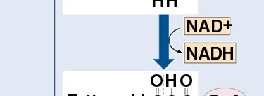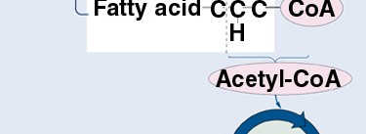Metabolism of fatty acids yields more trapped ATP than metabolism of carbohydrates on a per carbon basis.
The preliminary steps are called β-oxidation
For a 6 carbon fatty acid, 1 ATP must be invested for every 2 carbons to prime the process.
From every 2 carbons of the 6 carbon fatty acid, the yield is 1 FADH and 1 NADH and 1 acetyl Co-A.
The acetyl Co-A can be metabolized in the Krebs cycle and generates 3 NADH, 1 FADH, and 1 ATP, as seen previously.

28

Thus, 2 carbons of a fatty acid generates a

total of 2 FADH, cost of 1 ATP.
4 NADH,
and 1 ATP with a

6 carbons generates 6 FADH, 12 NADH and 3 ATP with a cost of 3 ATP.
The total yield:
6 FADH * 1.5 ATP/FADH → 9 ATP
12 NADH * 2.5 ATP/NADH → 30 ATP
Total yield for 6 carbons from fat = 39 ATP Total yield for 6 carbons from sugar = 30 ATP.

Fats cannot be metabolized anaerobically - fat metabolism requires oxygen.

29

Reference: https://www.nicholls.edu/biol-ds/biol155/Lectures/Glycolysis%20&%20Respiration.pdf

