ANKARA UNIVERSITY GAMA VOCATIONAL SCHOOL
2017-2018 FALL PROFESSIONAL ENGLISH I COURSE
MIDTERM EXAM
- Complete the sentences with the correct form of the verbs and the adverbs of frequency in parentheses. (2x10=20P)

- Julia _________________________ (arrive, usually) on time.
- Tom _________________________ (be, always) on time.
He _________________________ (come, never) late.
- Our teacher __________________________ (be, often) early for school.
He ________________________ (photocopy, usually) the worksheets.
- The school canteen ________________________ (be, usually) crowded, so Michael and I _________________________ (eat, sometimes) in a restaurant.
- The lessons ____________________________ (be, often) difficult, so we _________________________ (study, always) hard.
- Ask him. He _____________________________ (be, always) helpful.

- Fill in the blanks with am, is, are and the correct form of the verbs. (2x5=10P)

- We _____________________________ (have) a good time.
- She _____________________________ (wear) a hat.
- I think John ____________________________ (play) football now.
- He _________________________ (talk) to Michael at the moment.
- Jim and Sarah __________________________ (do) their homework.

- Fill in the blanks with the correct words from the box. (2x4=8P)

Control Transmission system Load Source

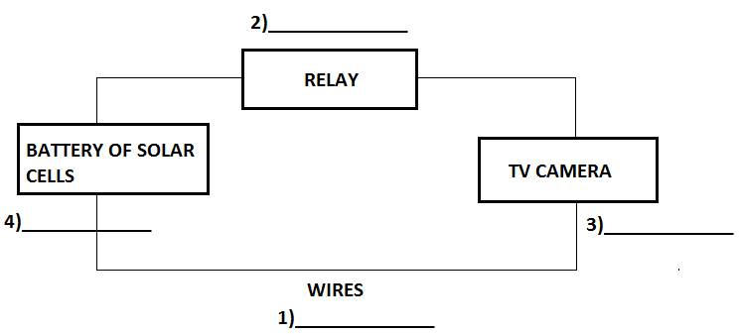
- Translate given paragraph into Turkish. (3x7=21P)
Semiconductors are midway between conductors and insulators. Under certain conditions they allow a current to flow easily but under others they behave as insulators. Germanium and silicon are semiconductors. Mixtures of certain metallic oxides also act as semiconductors. These are known as thermistors. The resistance of thermistors falls rapidly as their temperature rises. They are therefore used in temperature – sensing devices.

- Summarize given text in English. (5-10 sentences) (10P)
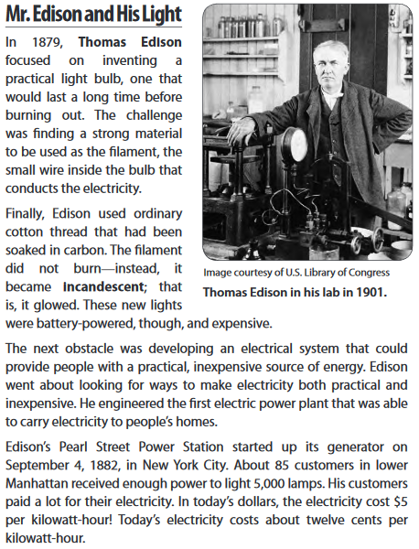
- Read the text and answer the questions.
If we connect a battery across a body, there is a movement of free electrons towards the positive end. This movement of electrons is an electric current. All materials can be classified into three groups according to how readily they permit an electric current to flow. These are: conductors, insulators and semiconductors.
In the first category are substances which provide an easy path for an electric current. All metals are conductors, however some metals don’t conduct well. Copper is a good conductor, therefore it is widely used for cables. A non-metal which conducts well is carbon. Salt water is an example of a liquid conductor.
A material which does not easily release electrons is called an insulator. Rubber, nylon, porcelain and air are all insulators. All insulators will allow some flow of electrons, however this can usually be ignored because the flow they permit is so small.
Semiconductors are midway between conductors and insulators. Under certain conditions they allow a current to flow easily but under others they behave as insulators. Germanium and silicon are semiconductors. Mixtures of certain metallic oxides also act as semiconductors. These are known as thermistors. The resistance of thermistors falls rapidly as their temperature rises. They are therefore used in temperature – sensing devices.
- Replace the words in italics with expressions from the passage which have similar meanings. (2x5=10P)
- The flow of free electrons is an electric current. (_______________)
- Materials in the first group are called conductors. (________________)
- Materials which provide a path for an electric current are conductors. (________________)
- All insulators permit some flow of electrons. (________________)
- Germanium sometimes acts as an insulator and sometimes as a conductor. (_______________)
- Decide if these statements are true (T) or false (F). (2x5=10P)

- Electrons flow from positive to negative. _____
- Copper provides an easy path for an electric current. _____
- All metals are good conductors. _____
- All good conductors are not metals. _____
- Air is a perfect insulator. _____

- The path of electricity from a power plant to a light bulb in your home is given below. Fill in the blanks appropriately. (1x6=6P)
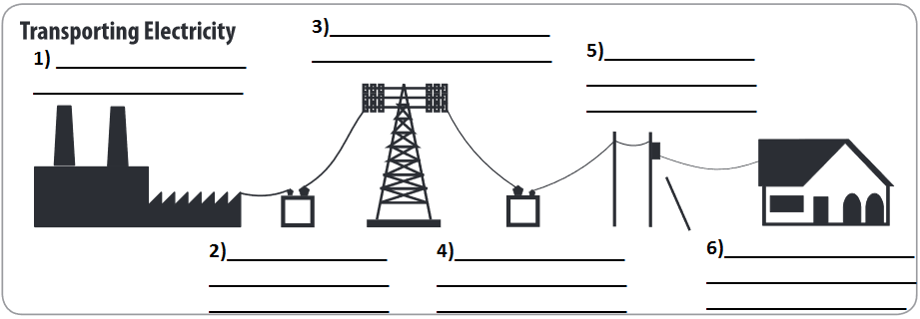
- Summarize the path given above in 5-10 sentences. (5P)
______________________________________________________________________________________________________________________________________________________________________________________________________________________________________________________________________________________________________________________________________________________________________________________________________________________________________________________________________________________________________________________________________________________________________________________________

