Lipid Peroxydation

How does lipid peroxidation start?
Lipid peroxidation starts with an any chemical (free radical) having enough energy to capture a H atom from methylene carbon of the lipid acyl chain.
What is free radical
- An atom or a molecule that contains one or more unpaired electrons in their outer orbital and is capable of independent existence.
(electrons usually associate in pairs in orbitals of atoms and molecules)

When O₂ takes up 1 e- (is partly reduced), very reactive superoxide anion radical is produced and is toxic due to molecular oxygen.
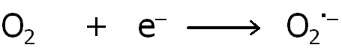
Superoxide (O2^{.-}) leads to the formation of other radicals
O₂^{.-} forms H₂O₂ with dismutation reaction:
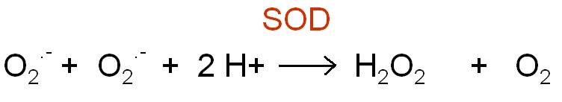
Superoxide dismutase (SOD) is an antioxidant enzyme
H₂O₂ produced is toxic, a nonradical but a reactive oxygen species (ROS).
H₂O₂ leads to the formation of very reactive hydroxyl radical (OH•) in the presence of Fe2+, Cu1+ by Fenton reaction and in the presence of (O2⋅−) by Haber-Weiss reaction.

H₂O₂ is decomposed to nontoxic form by antioxidant enzymes (catalase, peroxidase, glutathione peroxidase
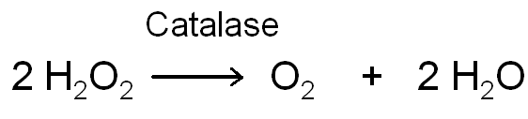
Catalase is found in the peroxisomes of many plant and animal tissues.
Peroxidase is found in plants and erythrocytes.
Glutathione peroxidase (GPx)
GPx is found in many tissue and organelles. Selenium is essential for its activity .
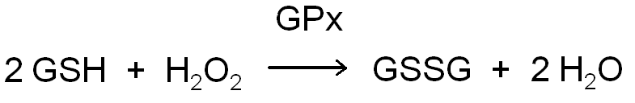
GSH : reduced glutathione
GSSG : oxidised glutathione
GPx decomposes H₂O₂ and various hydro- and lipid peroxides.

Effects of free radicals in biological systems
Normally there is a balance between ROS formation and antioxidant defence.
Besides ROS there are RNS (reactive nitrogen species).
Oxidative Stres is an imbalance between ROS formation and antioxidant defence.

Free Radical Sources
- Cellular
- Environmental
Cellular sources
-Major cellular source is mitochondria.
-Free radical generation in endoplasmic reticulum and nuclear membrane
-During the enzymatic catalysis
-Autooxidation of small molecules
-Arachidonic acid metabolism
-Transition metal ions especially iron and copper.
-In phagocytosis,
-Stress
Exogenous sources
- Radiation
(UV light, x-rays, gamma rays)
-Food additives
-Burning of organic substances
-Atmospherical pollutants
-Chemotheraphy, various drugs
-Chemical agents

Free radical damage in biological systems
Free radicals modify and damage proteins, nucleic acids, carbohydrates and lipids.
Mechanism of damage
- 1. by cross-linking
- 2. by addition reactions
- 3. by scission reactions

Free radicals leed to lipid peroxidation
- The importance of lipid peroxidation is the degredation of lipid peroxides to give aldehydes that cross-link with nucleic acids, proteins and lipids.
Mechanism of lipid peroxidation
Lipid peroxidation starts with any chemical (free radical) that has enough energy to capture a H atom.
- The overall mechanism of lipid oxidation consists of three phases:
  - (1) initiation, the formation of free radicals;
  - (2) propagation, the free-radical chain reactions; and
  - (3) termination, the formation of nonradical products.
The rate of oxidation of these fatty acids increases with the degree of unsaturation
Initiation :
Free radical can abstract a H atom from the C atom of fatty acid that is in between the double bonds (see figure below). 1 e- is left in the fatty acid and becomes lipid radical (L.). Oxygen can be added to the L. radical to form peroxy radicals (LOO.) Propagation:
These radicals may abstract hydrogens from another fatty acid (L’H) to yield the hydroperoxides (LOOH) and changes the other fatty acid to its radical form (L’ . ).
The fatty acid radical (L’ . ) is not a very stable molecule, so it reacts readily with molecular oxygen (see fig 1 a), thereby creating another peroxyl-fatty acid radical. This radical is also an unstable species that reacts with another free fatty acid, producing a different fatty acid radical and a lipid peroxide,
When a radical reacts with a non-radical, it always produces another radical, which is why the process is called a "chain reaction mechanism’’.
The LOO. abstracting a H from a fatty acid, becomes LOOH.
Termination:
The radical reaction stops when two radicals react and produce a non-radical species. This happens only when the concentration of radical species is high enough for there to be a high probability of collision of two radicals. Living organisms have different molecules that speed up termination by neutralizing free radicals and, therefore, protecting the cell membrane. One important such antioxidant is vitamin E (chain breaking antioxidant). Another important antioxidant is vitamin C.

LOOH spontaneously degrade yielding many end products or it is reduced to its alcohol (LOH) by an antioxidant enzyme glutathione peroxidase, which is nontoxic.
Lipofuscin; ceroid, ageing pigments
- The main important aldehyde end product of lipid peroxidation is reactive malondialdehyde (MDA).
MDA binds to proteins, nucleic acids and lipids through the formation of a Schiff base with their amine groups. This macromolecule is called lipofuscin, ceroid or age pigment and can not be degredad or removed. They accumulate by age in the cells.
Consequences of lipid peroxidation
- Hazards in lipid, protein and DNA
Defence against free radicals
(Antioxidants)

Antioxidants are
- endogenous
- exogenous

