5.Hafta- 21-24
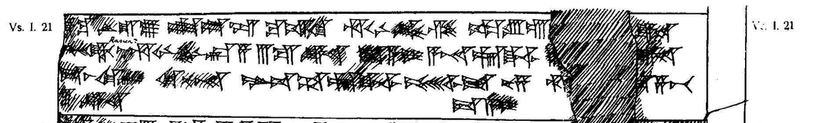

21 [t]ák-ku LÚ.U₁₉.LU SAG.DU-ZU ku-iš-ki hu-u-ni-ik-zi ka-ru-ú [(VI GÍN)] KÙ.BABBAR
22 pé-eš-kir n[u?] hu-u-ni-in-kán-za III GÍN KÙ.BABBAR da-a-i A-NA É.GAL^{LIM} III [(GÍN K)]Ù.BABBAR
23 da-aš-ke-er ki-nu-na LUGAL-uš ŠA É.GAL^{LIM} pé-eš-ši-it nu-za hu[(-u-ni-in-ká)]n-za-pát
24 3 <GÍN> KÙ.BABBAR da-a-i

